Minnesota Pollution Control Agency (MPCA) logo and image of state of Minnesota

Nutrients in water

August 2020

**5-year Progress Report on**

**Minnesota’s Nutrient Reduction Strategy**



**Authors and contributors**

Dave Wall – MPCA

(Lead author and project manager)

Jeppe Kjaersgaard – MDA

(Nutrient management/efficiency)

Matt Drewitz – BWSR

(Agricultural BMPs and BWSR programs)

Marco Graziani, Casey Scott – MPCA

(Municipal and Industrial Wastewater)

Lisa Scheirer, Steve Schmidt – MPCA

(Feedlots)

Rachel Olmanson, Mike Trojan – MPCA

(Stormwater)

Joel Larson, Adam Wilke – U of MN WRC

(Research, education and U of MN work)

Hong Wang, John Barland – Met Council

(River monitoring trends)

Lee Ganske, James Jahnz – MPCA

(River monitoring trends)

Steve Robertson, Mark Wettlaufer – MDH

(Source Water Protection)

Shannon Martin, Lee Engel – MPCA

(Lake clarity)

Sharon Kroening – MPCA

(Groundwater nitrate trends)

David Miller – MPCA

(Healthier Watersheds tracking)

Margaret Wagner, Kevin Kuehner – MDA

(Field edge and small watershed monitoring)

Greg Johnson – MPCA

(Small watershed projects)

Rochelle Nustad – USGS   
(River monitoring trends)

**Steering team**

Katrina Kessler, Glenn Skuta – MPCA

Sam Paske – Met Council

Steve Colvin – DNR

Katie Pratt, Erik Dahl – EQB

John Jaschke, Doug Thomas – BWSR

Tom Hogan – MDH

Dan Stoddard – MDA

Carissa Spencer – NRCS

Mike Schmitt – U of MN

**Editing, and graphic design, and cover photo**

Jennifer Olson, Kaitlin Taylor, Martha Allen, Kellie DuBay – Tetra Tech

(Report assembly/graphs/editing)

Beth Tegdesch, Barb Olafson – MPCA   
(Final formatting)

James Jahnz and Shawn Nelson

(Maps - river monitoring trends)

Karla Lundstrom

(Cover photo)

**Additional report reviewers**

Keith Kloubec – NRCS

Larry Gunderson – MDA

Judy Sventek – Met Council

Reid Christianson – University of Illinois

Jill Sacket Eberhart, Suzanne Rhees,   
Julie Westerlund – BWSR

Marta Shore, Ann Lewandowski – U of MN

Cathy Malakowsky, Aaron Jensen,   
Randy Hukriede, Sharon Kroening – MPCA

Barbara Weisman, Joy Loughry – DNR

Rochelle Nustad – USGS

Table of contents

1 Introduction 1

1.1 Overview of 2014 NRS goals and milestones 1

1.2 Tracking progress toward NRS goals and milestones 2

1.3 What’s in the NRS 5-year progress report 2

2 Programs – Are the NRS strategies progressing? 4

2.1 Progress towards NRS strategies 4

2.1.1 Implementation of overarching recommended strategies 4

2.1.2 Agricultural BMPs 5

2.1.3 Wastewater 9

2.1.4 Miscellaneous sources 9

2.1.5 Protection strategies 10

2.2 Information needed to track progress 13

3 In the water – What can we tell so far? 15

3.1 External factors affecting nutrient water quality trends 15

3.2 River nutrient trends 16

3.2.1 Mid-range (20-year) river nutrient concentration trend results 17

3.2.2 Recent (10-year) nutrient concentration trend results 19

3.2.3 Differences between river phosphorus and nitrogen trends 21

3.3 Small watershed monitoring 26

3.4 Edge of field monitoring 26

3.5 Lake clarity trends 28

3.6 Groundwater nitrate trends 30

4 On our cropland – Are we on track for the needed scale of BMP adoption? 32

4.1 Agriculture BMP adoption scenario goals 33

4.2 Agricultural BMP adoption since 2014 36

4.2.1 Tracking agricultural BMP adoption in Minnesota 36

4.2.2 Nutrient management efficiency (fertilizer and manure) practices 41

4.2.3 Living cover practices 53

4.2.4 Field erosion control practices 58

4.2.5 Tile drainage water treatment and storage practices 63

4.3 Are we on track to meet agricultural BMP milestones? 65

5 Wastewater and other sources – Is progress consistent with NRS direction? 68

5.1 Wastewater 68

5.1.1 Updated existing loading and goals 68

5.1.2 Phosphorus reduction 69

5.1.3 Nitrogen reduction 72

5.2 Miscellaneous sources 76

5.2.1 Feedlots 76

5.2.2 Urban stormwater 79

5.2.3 Septic systems 82

6 What are the next steps for the NRS (2020-2024)? 85

[1) Maximize the multiple benefits of NRS practices by integrating with other water, climate,   
and agriculture resiliency plans and strategies 85](#_Toc40169398)

2) Identify and remove socio-economic barriers to scaling-up BMP implementation 89

3) Update NRS BMP-scenarios 91

4) Optimize wastewater nitrogen treatment 92

7 References 93

Appendices 95

Figures

Figure 1. Major drainage basins in Minnesota. 1

Figure 2. River monitoring site locations at sites with enough information to determine mid-range (approximately 20-year) flow-adjusted phosphorus concentration trends.. 17

[Figure 3. River monitoring site locations at sites with enough information to determine mid-range   
(20-year) flow-adjusted nitrate concentration trends.. 19](#_Toc49943114)

Figure 4. Phosphorus 10-year flow-adjusted concentration trends. 20

Figure 5. Nitrate plus nitrite 10-year flow-adjusted concentration trends. 21

Figure 6. Drainage area to Lock and Dam #3. 22

Figure 7. Annual phosphorus loads in the Mississippi River at Red Wing (Lock and Dam 3) and 5-year rolling average load (orange). 23

Figure 8. Annual NOx Loads in the Mississippi River at Red Wing (Lock and Dam 3) and 5-year rolling average load (orange). 24

Figure 9. Small watershed monitoring. 26

Figure 10. MDA field scale monitoring sites. 27

Figure 11. Map of lake clarity trends in Minnesota. 28

Figure 12. Lake clarity trends in Minnesota. 29

Figure 13. Mean annual total phosphorous in Lake Pepin summarized into a composite concentration from four monitoring stations. 29

[Figure 14. Mean annual chlorophyll-*a* in Lake Pepin summarized into composite concentration   
from the four monitoring stations. 30](#_Toc49943125)

[Figure 15. Groundwater nitrate trends over a 13-year period. Red up-arrow indicates an increase;   
green down-arrow indicates decrease; yellow dot indicates no trend. 31](file:///\\pca.state.mn.us\tdrive\Typing\Tegdesch_Elizabeth.ET\Pub%20Team%20projects\Dave%20Wall\NRS%20progress%20main%20report%20final%202.docx#_Toc49943126)

Figure 16. Private well nitrate testing - MDA Township Testing Program results. 32

[Figure 17. Statewide crop and grass/pasture acreage changes between 2012 and 2018 as identified   
from Crop Data Layer. 33](#_Toc49943128)

[Figure 18. Example agricultural BMP scenario from 2014 NRS to achieve milestones, showing needs   
for additional acreages of new BMP additions. 35](#_Toc49943129)

Figure 19. Example image from LiDAR mapping pilot project. (Source: BWSR) 41

Figure 20. Total new acres for 590 nutrient management efficiency practices enrolled through government support programs from 2014 to 2018. 42

Figure 21. Annual new acres of 590 nutrient management efficiency practices added through government support programs, 2009 to 2018 43

Figure 22. Annual nitrogen sales in fertilizer 1989 – 2017. 44

[Figure 23. Nitrogen fertilizer use efficiency for corn 1992 – 2016 estimated based on statewide   
fertilizer sales and corn grain yield. 44](#_Toc49943134)

[Figure 24. Distribution of nitrogen fertilizer rates from the 2010, 2012 and 2014 surveys for corn   
after corn. 45](#_Toc49943135)

[Figure 25. Distribution of nitrogen fertilizer rates from the 2010, 2012 and 2014 surveys for corn   
after soybean. 46](#_Toc49943136)

Figure 26. Distribution of total nitrogen application on corn fields receiving manure from 2014. 47

Figure 27. Sales trends for the three major nitrogen fertilizer sources. 48

[Figure 28. Estimated number of acres treated with the nitrification inhibitor nitrapyrin each year   
1996 – 2017. 49](#_Toc49943139)

[Figure 29. Percent of respondents that used nitrapyrin with fall applied anhydrous ammonia in   
2012 for the 2013 corn crop 49](#_Toc49943140)

Figure 30. Annual phosphorus sales (as elemental P) during 1989 – 2017. 50

[Figure 31. Frequency of phosphorus level in soil samples from Minnesota for 2001, 2005, 2010 and   
2015 51](#_Toc49943142)

Figure 32. Change in relative frequency of soil phosphorus tests from 2001 to 2015. 51

[Figure 33. Acres affected by new living cover practices funded by non-CRP government programs   
from 2014 to 2018). 54](#_Toc49943144)

[Figure 34. Acres affected by new living cover practices funded by non-CRP government programs   
from 2009 to 2018). 54](#_Toc49943145)

Figure 35. Annual CRP enrollment (1987 to 2018; www.fsa.usda.gov). 55

Figure 36. Cover crop acres estimated using satellite imagery, Fall 2016.. 56

Figure 37. Estimates of grass, pasture, and hay in Minnesota from 2012-18 57

[Figure 38. New acres for field erosion control practices enrolled through government programs,   
2014 to 2018). 59](#_Toc49943149)

Figure 39. New acres of field erosion control practices added through government support programs 2009 to 2018. 59

Figure 40. Average crop residue and conservation tillage by subwatershed in 2017 60

Figure 41. Acres in conservation tillage in Minnesota based on satellite imagery (OpTIS). 61

Figure 42. Comparison of residue cover on all row crops for 2016 (y-axis represents acres). 61

Figure 43. New acres of tile drainage water treatment and storage practices enrolled through government programs, 2014-2018). 64

[Figure 44. New affected acres of tile drainage water treatment and storage practices added   
through government support programs 2009 to 2018. 64](#_Toc49943155)

[Figure 45. Newly affected acreages of agricultural BMPs (2014-2018) implemented through   
government programs in the Mississippi River and Lake Winnipeg Basins toward the NRS   
milestone scenario outlined in the 2014 NRS for completion by 2025.. 66](#_Toc49943156)

Figure 46. Statewide wastewater phosphorous loads (2000-2018). 70

Figure 47. Mississippi River basin phosphorous loading. 71

Figure 48. Lake Winnipeg basin phosphorous loading. 72

Figure 49. Lake Superior basin phosphorous loading. 72

Figure 50. Effluent total nitrogen concentrations for facilities in Minnesota. 73

Figure 51. Statewide wastewater nitrogen loads (2000 – 2018). 74

Figure 52. Mississippi River basin nitrogen loading. 74

Figure 53. Lake Winnipeg basin nitrogen loading. 75

Figure 54. Lake Superior basin nitrogen loading. 75

Figure 55. Regulated MS4s. 80

Figure 56. New and replacement SSTSs over time (2002-2018). 83

Figure 57. Estimated compliance (2007-2018). 84

Figure 58. Completion status of Watershed Restoration and Protection Strategies (WRAPS). 87

Figure 59. Watersheds participating in the One Watershed, One Plan program. 88

Tables

Table 1. Timeline for reaching goals and milestones. 1

Table 2. Progress made towards implementation of overarching strategies. 5

Table 3. Progress made towards agricultural BMP strategies. 6

Table 4. Progress made towards implementing wastewater strategies. 9

Table 5. Progress made towards implementation of strategies to address miscellaneous sources. 10

Table 6. Progress made towards implementation of protection strategies. 11

Table 7. Statistical trend for total phosphorus concentration in the Mississippi River at Red Wing site (Lock and Dam #3) 22

Table 8. Statistical trends for nitrate concentration in the Mississippi River at Red Wing site (Lock and Dam #3) 23

Table 9. Example combined basin scenario from 2014 NRS to achieve milestones. 34

Table 10. Example scenarios from 2014 NRS to achieve milestones in Mississippi River and Red River basins. 35

Table 11. BMPs included in Healthier Watersheds website, reported in the following sections. 39

Table 12. Acres of nutrient management efficiency practices enrolled through government support programs, 2014 to 2018 (MPCA’s Healthier Watersheds BMP tracking system) 43

Table 13. Acres of living cover practices 2014 to 2018 funded from non-CRP government programs (MPCA’s Healthier Watersheds BMP tracking system). 55

Table 14. Acres of perennial crops based on U.S. Census of Agriculture (2012 to 2017). 57

[Table 15. Acres of field erosion control practices enrolled through government support programs,   
2014 to 2018 (MPCA’s Healthier Watersheds BMP tracking system). 60](#_Toc40169477)

Table 16. Minnesota tillage practices (2012 and 2017). 60

Table 17. Drained land in the state of Minnesota (2012 and 2017). 63

Table 18. New affected acres of tile drainage water treatment and storage practices added through government programs, 2014 to 2018. 64

Table 19. Revised existing phosphorus loads from permitted wastewater. 69

Table 20. Revised existing nitrogen loads from permitted wastewater. 69

Table 21. Permits with phosphorus limits (August 2019). 70

Table 22. Permitted flows associated with different phosphorus limits. 70

Table 23. Updated average nitrogen concentrations for treated municipal wastewater. 73

Table 24. Number of land application of manure inspections, 2014-2018. 78

Table 25. Feedlot inspections (facility), 2014-2018. 78

Table 26. Structural BMPs reported by regulated MS4s 81

Table 27. SSTS compliance inspections. 83

Acronyms and abbreviations

% percent

1W1P One Watershed One Plan

AA Anhydrous ammonia

ac acre

ACPF Agricultural Conservation Planning Framework

BMP best management practices

BWSR Board of Water and Soil Resources

CFO concentrated feeding operation

CREP Conservation Reserve Enhancement Program

CRP Conservation Reserve Program

CSP Conservation Stewardship Program

CTIC Conservation Technology Information Center

DAP diammonium phosphate

DEP Daily Erosion Project

DNR Minnesota Department of Natural Resources

EPA U.S. Environmental Protection Agency

EQB Environmental Quality Board

EQIP Environmental Quality Incentive Program

EWG Environmental Work Group

GRAPS groundwater restoration and protection strategies

HSPF Hydrological Simulation Program – FORTRAN

HSPF-SAM HydrologicalSimulation Program – FORTRAN Scenario Application Manager

HUC hydrologic unit code

IPNI International Plant Nutrition Institute

ITPHS imminent threats to public health and safety

L liter

lb N pounds of nitrogen

LiDAR Light Detection and Ranging

MAP mono-ammonium phosphate

MDA Minnesota Department of Agriculture

MDH Minnesota Department of Health

Met Council Metropolitan Council

mg milligram

MG million gallon

Minn. R. Ch. Minnesota Rule Chapter

MPCA Minnesota Pollution Control Agency

MRBI Mississippi River Basin Healthy Watersheds Initiative

MRTN Maximum return on total nitrogen

MS4 municipal separate storm sewer system

MT metric ton

NASS National Agricultural Statistics Service

NPDES National pollutant discharge elimination system

NRCS Natural Resources Conservation Service

NRS Nutrient Reduction Strategy

NWQI National Water Quality Initiative

OpTIS Operational Tillage Information System

ppm parts per million

PTMApp Prioritize, Target, and Measure Application

RIM Re-Invest in Minnesota

SDS State Discharge System

SPARROW SPAtially Referenced Regression on Watershed Attributes

SSTS Subsurface Sewage Treatment Systems

TMDL total maximum daily load

UAN Nitrogen solutions

U of MN University of Minnesota

USDA United State Department of Agriculture

USGS U.S. Geological Survey

WLA wasteload allocation

WLSSD Western Lake Superior Sanitation District

WRAPS Watershed Restoration and Protection Strategies

yr year

# Introduction

Nutrients are important for all living things. However, too many nutrients in water can produce problems like algae growth, low levels of dissolved oxygen, toxicity to aquatic life, and unhealthy drinking water. Excessive nutrients can diminish water quality, both within Minnesota and in downstream waters, including Lake Winnipeg, the Gulf of Mexico, and Lake Superior.

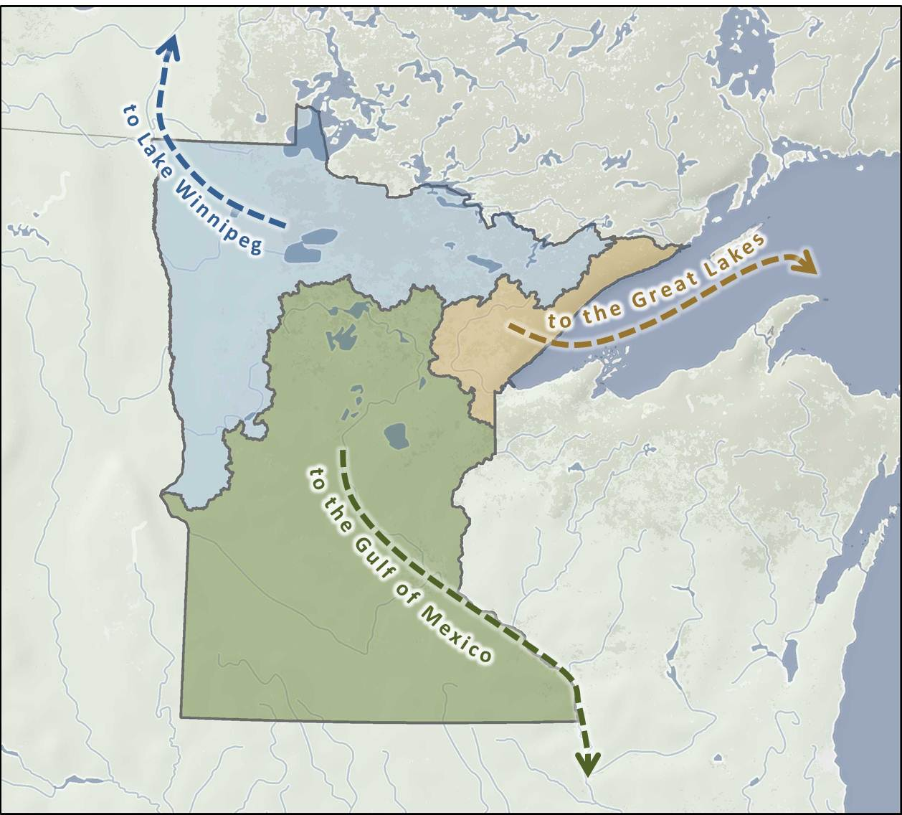

To address the issue of excessive nutrients, 11 Minnesota organizations finalized a state-level Nutrient Reduction Strategy (NRS) in 2014. Minnesota is one of 12 states on the Gulf of Mexico Hypoxia Task Force that developed such a strategy to reduce nutrients entering in-state waters and to achieve fair-share nutrient reductions for the Gulf of Mexico and other downstream waters. Minnesota’s NRS set specific goals for reducing nitrogen and phosphorus and outlined scenarios of changes needed in Minnesota’s rural and urban areas to meet those goals. The 2014 NRS is available at <https://www.pca.state.mn.us/water/nutrient-reduction-strategy>.

Figure 1. Major drainage basins in Minnesota.

## Overview of 2014 NRS goals and milestones

The 2014 NRS set milestones, or interim goals, to assist in tracking Minnesota’s statewide nutrient reduction progress. Each major basin has numeric reduction milestones for phosphorus and nitrogen. For example, the nitrogen milestone for the Mississippi River is a 20% reduction by 2025, with a 2040 target date for reaching a 45% final reduction goal. Nitrogen and phosphorus milestones and final goals vary in the three major drainages in Minnesota (Table 1).

Table 1. Timeline for reaching goals and milestones.

| **Major basin** | **Milestone 2014 to 2025** | **Final Goal 2025 to 2040** |
| --- | --- | --- |
| 1. **Mississippi River** (Also includes Cedar, Des Moines, and Missouri Rivers) | **12%** reduction in phosphorus (33% reduced prior to 2014) | Achieve **45%** total reduction from 1980-96 baseline and meet in-state lake and river water quality standards |
| **20%** reduction in nitrogen | Achieve **45%** total reduction from 1980-96 baseline |
| 1. **Red River** (Lake Winnipeg Basin) | **10%** reduction in phosphorus | Achieve final reductions identified through joint efforts with Manitoba (about 50% from 1998 to 2001) a |
| **13%** reduction in nitrogen |
| 1. **Lake Superior** | Maintain protection goals, no net increase from 1970s | |
| **Groundwater/Source Water** | Meet the goals of the 1989 Groundwater Protection Act | |

a. The 2014 NRS noted that the International Red River Basin Water Quality Committee had suggested revised Red River nutrient reduction goals as high as 50% reductions from baselines. In September 2019, the International Red River Board agreed to pass along the proposed loading targets for the Red River at the US/Canada Boundary onto the International Joint Commission. The new load targets on the Red River at the Minnesota/Canadian Border are 1,400 MT of total phosphorus and 9,525 MT of total nitrogen. These load targets represent 48% and 52% of phosphorus and nitrogen 5-year rolling average loads during the 1998 to 2001 baseline timeframe, respectively. 5-year rolling average loads during recent years have averaged about 2,200 MT for phosphorus and 13,000 MT for nitrogen.

## Tracking progress toward NRS goals and milestones

Tracking progress toward these nutrient reduction goals and making necessary adjustments is a key component of the 2014 NRS. In the 2014 strategy, Minnesota partner agencies committed to progress reports: a 5-year progress report and a 10-year update and NRS re-publishing.

The 5-year progress report was supposed to include progress on the following:

* Implementation activities and strategies
* Best management practice (BMP) adoption assessment
* Water quality outcomes
* Next steps for the 2020 to 2024 period

The 2024 NRS update will examine progress after 10 years of implementation prior to the 2025 milestone. Depending on the progress found at that time, Minnesota partner agencies could potentially make additional adjustments to NRS implementation efforts.

Overarching goals that the Minnesota NRS and this 5-year progress report address include the following:

* **Ensure nitrogen reductions to water are achieved** in the large parts of Minnesota where specific local drivers do not exist for nitrogen reduction, but where local nitrogen delivery incrementally impacts downstream waters.
* **Ensure local phosphorus reductions are collectively adding up** to address eutrophication in downstream large rivers, regional lakes/reservoirs, and waters further downstream, such as Lake Winnipeg and the Gulf of Mexico.
* **Ensure Minnesota adapts to remain well-positioned for long-term nutrient reduction success**, modifying as necessary the state-level programs, partnerships, priorities, provision to local watersheds, and technical practices to achieve large-scale BMP adoption.
* **Maintain commitments to evaluate and communicate** Minnesota’s implementation approaches and progress to both in-state and out-of-state national and international audiences.

## What’s in the NRS 5-year progress report

This document is the 5-year progress report intended to fulfill the reporting objectives set forth in the 2014 NRS. This report evaluates and documents Minnesota’s progress toward reaching NRS goals and benchmarks at the mid-point of NRS implementation to achieve the 2025 milestones, presented above. This 5-year progress report takes the pulse of water quality trends and provides insights into the implementation activities cited in the 2014 NRS as integral to achieving the 2025 milestones. Evaluation of state-level program advancements, BMP scales of adoption, and nutrient trends in waters provide the needed assessment information to gage progress thus far and recommend next steps.

Key questions that are explored as part of this 5-year progress report include:

**Programs – Are the NRS strategies progressing?** This section discusses progress on new or expanded programmatic initiatives identified in the 2014 NRS, in addition to continuation and expansion of existing efforts and programs, to achieve nutrient reduction milestones. This section is not intended to be a full accounting of all nutrient reduction programs and activities, but is a comparison of NRS recommended strategies with associated programmatic advancements made since 2014.

**In the water – What can we tell so far?** This section presents water quality information on nitrogen and phosphorus changes and trends identified from key data sources.

**On our cropland – Are we on track for the needed scale of BMP adoption?** This section provides information on cropland BMP adoption progress implemented through new and existing programs intended to achieve the NRS milestones.

**Wastewater and other sources – Is progress consistent with NRS direction?** A summary of progressfrom wastewater, feedlots, urban stormwater, and septic system sources is provided.

**What are the next steps for the NRS (2020 to 2024)?** This section outlines high priority steps to   
a) increase the potential for successful nutrient reductions prior to the 2025 NRS milestones, and   
b) develop the information needed to strengthen the republished NRS in 2024.

Together, answers to these questions help to tell the story of NRS implementation in Minnesota over the past five years and help set the course for successful NRS implementation for the next five years.

This progress report represents a collective effort by the Minnesota partner agencies who developed the 2014 NRS. Each agency contributed readily available data and information to generate this 5-year progress report, minimizing the resources required to assess the NRS progress to date.

# Programs – Are the NRS strategies progressing?

To make substantial progress in reducing Minnesota’s nutrient loads into waters, Minnesota’s 2014 NRS Chapter 6 recommended many strategies necessary to achieve NRS reduction goals. These recommended strategies included the creation of new programs and continuation of existing programs for agricultural lands, wastewater, septic systems, feedlots, stormwater, and other overarching activities. These programs and initiatives were intended to help achieve the increased level of effort (implementation of agricultural BMPs, wastewater reductions, etc.) necessary to meet the goals and milestones of the 2014 NRS. In addition, Chapter 7 of the NRS identifies the needed information and tools to track implementation, expected nutrient reductions, and changes in water quality from NRS activities.

**Climate change resiliency**

While not a specific recommended strategy in the 2014 NRS, climate change resiliency and planning has become a major focus of state agency action in recent years. Several reports and committees have been created to advance programs related to understanding and mitigating the potential effects of climate change. Many NRS practices not only reduce nutrients but help to mitigate the effects of climate change. Reports related to climate change resiliency and planning since 2014 include but are not limited to:

**Climate Change Trends and Action Plan (BWSR 2019):** <https://bwsr.state.mn.us/sites/default/files/2019-09/ClimateChangeTrends%2BActionPlan_Sept2019.pdf>

**Adapting to Climate Change in Minnesota (Interagency Climate Adaption Team 2017):** <https://www.pca.state.mn.us/sites/default/files/p-gen4-07c.pdf>

**Greenhouse gas reduction potential of agricultural BMPs (MPCA 2019):** <https://www.pca.state.mn.us/air/agriculture-and-climate-change-minnesota>

The following sections summarize the progress made since 2014 towards NRS recommended strategies and the needed information and tools to track NRS implementation. Sections 4 and 5 in this 5-year progress report provide an update on the adoption levels of the specific activities recommended in the NRS.

## Progress towards NRS strategies

Minnesota has made substantial progress towards implementation of most of the strategies found in Chapter 6 of the 2014 NRS. Sections 2.1.1 through 2.1.5 summarize the progress made since 2014 towards the NRS recommended strategies by category: overarching, agricultural, wastewater, miscellaneous sources of nutrients, and protection strategies. Some programs created or expanded since 2014 support multiple strategies and are therefore listed multiple times. Major advances for each strategy are further described in Appendix A which includes associated program web links when available.

The programs highlighted in Appendix A and in the tables below are in various stages of development and implementation. Where quantification of program impacts is known for the 2014 to 2018 period, they are provided in the tables and/or Appendix A. However, quantified existing and projected outcomes are not available for each program at this time.

### Implementation of overarching recommended strategies

Progressing toward the goals and milestones of the NRS requires a significant amount of coordination and communication at a statewide level. Programmatic infrastructure is necessary to support coordination and communication among the various local, state, and federal partners. The first set of 2014 NRS recommended strategies focus on developing and sustaining the necessary infrastructure to support coordinated implementation and communication on progress over time. Minnesota partner agencies

have made substantial progress in implementing these recommendations. Major advances towards the 2014 overarching NRS recommendations are summarized in Table 2. These advances are expanded upon in Appendix A.

Table 2. Progress made towards implementation of overarching strategies.

| **Strategy** | **Major Advances since 2014** |
| --- | --- |
| **Develop a Statewide NRS Education/ Outreach Campaign** | * Governor’s 25% by 2025 initiative resulted in over 3,500 public suggestions from over 2,000 attendees * Interaction between shrimpers and Minnesota farmers * Technical Training and Certification Program established in 2015 * Nitrogen Smart Training Program held 36 educational events from 2016 to 2018 * Annual Statewide Nitrogen and Nutrient Management Conferences reaches approximately 400 attendees each year * Annual Conservation Tillage Conference * Agricultural BMP Guidance, Handbook and updates * Minnesota’s Public Drainage Manual updates * Minnesota Department of Natural Resource (DNR) workshops and training to lake associations and local government regarding BMPs to reduce phosphorus inputs to waters * Continued updates to the Minnesota Water Research Digital Library. Over 2,800 articles and reports at the end of 2018 |
| **Integrate Basin Reduction Needs with Watershed Planning Goals and Efforts** | * Advances in Total Maximum Daily Load (TMDL), Watershed Restoration and Protection Strategies (WRAPS), Groundwater Restoration and Protection Strategies (GRAPS), and One Watershed One Plan (1W1P) development * Over 60% of nutrient impaired waters have approved TMDL plans * 53 WRAPS completed in the state * 14 GRAPS completed by the Minnesota Department of Health (MDH) * Comprehensive watershed plans developed through 1W1P for 12 watersheds, 20 under development * Developed lake and stream protection prioritization guidance for use in WRAPS and 1W1Ps. DNR refined its lake phosphorus sensitivity index and associated cost-benefit analysis. * Watershed Conservation Planning Initiative to increase landowner and producer readiness to implement conservation practices in seven major watersheds * Small watershed activities through Section 319, small watersheds focus program, Mississippi River Basin Healthy Watershed Initiative (MRBI), and National Water Quality Initiative (NWQI) programs * 20 watersheds selected as part of the Section 319 Watersheds Focus Program |

### Agricultural BMPs

To achieve the goals and milestones of the NRS, strategies were identified to support the increased adoption of the agricultural BMPs identified in Chapter 5 of the NRS. These strategies fall into the following categories: Stepping Up Agricultural BMP Implementation in Key Categories; Support for Advancing BMP Delivery programs; Economic Strategy Options; Education and Involvement Strategies; Research Strategies; and Demonstration Strategies. Major advances towards the 2014 agricultural BMP NRS recommendations are summarized in Table 3. These advances are expanded upon in Appendix A.

Table 3. Progress made towards agricultural BMP strategies.

| **Strategy** | **Major Advances since 2014** |
| --- | --- |
| **Stepping Up Agricultural BMP Implementation in Key Categories** | |
| **Work with Private Industry to Support Nutrient Reduction to Water** | * Minnesota Agricultural Water Quality Certification Program initiated in 2015 and thus far certified 900+ farmers and over 600,000 acres of land * Nitrogen Smart Training Program held 36 educational events from 2016 to 2018 * Annual Statewide Nutrient Management Conference * Minnesota Corn Growers collaborative efforts * Forever Green Initiative * Discovery Farms efforts * Watershed Partnerships, such as the Cedar River Partnership |
| **Increase and Target Cover Crops and Perennial Vegetation** | * Forever Green Initiative * A new Minnesota Conservation Reserve Enhancement Program (CREP) began in 2017 * 12,186 acres received funding during the 2017 to 2018 CREP sign-up period * Working Lands Watershed Restoration Feasibility Study and Program Plan * Red River Conservation Easement Program * Nearly 7,000 easements over the lifetime of the Re-Invest in Minnesota Program |
| **Soil Health** | * Minnesota Office for Soil Health initiated in 2018 by University of Minnesota and the Board of Water and Soil Resources (BWSR) * Soil Health Specialist position created and filled |
| **Riparian Buffers** | * Minnesota’s Buffer Law passed in 2015 * Over 99% compliance with Buffer Law along lakes, rivers and streams, and over 90% for public ditches * DNR developed “Innovative Shoreland Standards Showcase” that emphasizes riparian vegetative management standards |
| **Fertilizer Use Efficiencies** | * Nitrogen Smart Training Program held 36 educational events from 2016 to 2018 reaching over 500 farmers and over 100 agronomists * 466 trials covering over 32,000 acres of cropland completed since 2015 through the Nutrient Management Initiative * Nitrogen Fertilizer Management Plan completed in 2015; associated Groundwater Protection Rule passed in 2019 |
| **Reduced Tillage and Soil Conservation** | * Annual Conservation Tillage Conference * Development of Soil Erosion Prediction Tool |
| **Drainage Water Retention and Treatment** | * Minnesota’s Public Drainage Manual updated in 2016 * Multi-purpose Drainage Management Grant Program developed by BWSR * Several state-led drainage demonstration sites |

|  |  |
| --- | --- |
| **Support for Advancing BMP Delivery Programs** | |
| **Coordinated Federal/State/Local/ Planning to Increase BMP Implementation for Key Categories of BMPs** | * Watershed Based Funding Implementation Program pilot began in 2017 and anticipated program finalization in 2021. * Watershed Conservation Planning Initiative’s contribution agreement with the BWSR to increase landowner and producer readiness for implementing BMPs in seven major watersheds * USDA programs including the MRBI and NWQI, RCPP, Conservation Stewardship Program (CSP), EQIP, and Agricultural Conservation Easement Program * Source Water Protection Program for surface waters developed by the MDH in 2017 |
| **Increase Delivery of Industry-Led BMP Implementation** | * Minnesota Agricultural Water Quality Certification Program * 4R Certification Program for Minnesota led by agricultural industry expected to be launched in 2020 |
| **Study Social and Economic Factors Influencing BMP Adoption** | * Social science research at the University of Minnesota’s Center for Changing Landscapes |
| **Create a Stable Funding Source to Increase Local Capacity to Deliver Agricultural BMPs** | * Clean Water Fund provided between $50 and $74 million implementation funding per year over the last 5 years * Watershed Based Funding Implementation Program * Federal 319 Nonpoint Source Pollution Program continuation * A new Minnesota CREP began in 2017 |
| **Economic Strategy Options** | |
| **Nutrient BMP Crop Insurance Program** | * Environmental Initiative is evaluating how cover crops reduce risk to producers and therefore should require less cost for crop insurance |
| **Develop Markets and Technologies for Use of Perennials** | * High value commodity crops for conservation being developed through the Forever Green Initiative with the University of Minnesota * The Forever Green Initiative hired a Supply Chain Development Specialist and Market Development Opportunity Specialist in 2019 |
| **Quantify Public Environmental Benefits of Reducing Nutrient Levels in Water** | * Social science research at the University of Minnesota’s Center for Changing Landscapes * 2018 Nitrate Report: Community Public Water Systems by the MDH * New academic research papers including: * The social costs of nitrogen (Keeler et al. 2016)   Land-use changes and costs to rural households: a case study in groundwater nitrate contamination (Keeler et al. 2014) |
| **Education and Involvement Strategies** | |
| **Targeted Outreach and Education Campaign with Expanded Public-Private Partnerships** | * Nitrogen Smart Training Program * (see also Table 2) |
| **Encourage Participation in the Agricultural Water Quality Certification Program** | * Minnesota Agricultural Water Quality Certification Program initiated in 2015 and certified 900+ farmers representing over 600,000 acres of land |
| **Focus Education and Technical Assistance to Co-Op Agronomists and Certified Crop Advisors** | * Nitrogen Fertilizer and Education Promotion Team led by the Minnesota Department of Agriculture (MDA) * Annual statewide Nitrogen and Nutrient Management Conferences * Nutrient Management Initiative <https://www.pca.state.mn.us/sites/default/files/wq-ws1-29.pdf> * 4R Certification Program under development in Minnesota by private industry |
| **Involve Agricultural Producers in Identifying Feasible Strategies** | * Formation of the Agricultural Water Quality Solutions Workgroup by the MDA and Environmental Initiative * Final recommended framework to establish and fund voluntary Farmer-Led Councils presented to Governor in 2017 * Governor’s 25% by 2025 initiative resulted in over 3,500 public suggestions from over 2,000 attendees |
| **Watershed Hero Awards** | * Agricultural Water Quality Certification awards 10-year certification to farmers for achieving defined standards of water quality protection |
| **Work with SWCDs, MDA, and University of Minnesota Extension to Increase Education and Involvement** | * Annual Statewide Nitrogen and Nutrient Management Conferences * (see also Table 2) |
| **Promote Youth-Based Nutrient Reduction Education** | * While this may have advanced, the authors of this report are not aware of major advancements |
| **Research Strategies** | |
| **Consolidate and Prioritize Research Objectives** | * Minnesota Water Research Digital Library * Minnesota’s Agricultural BMP Handbook updated with new research in 2017 * University of Minnesota research progress on drainage water management, in-field nitrogen management, benefits of reduced tillage, and living cover practices * Forever Green Initiative * MDA Clean Water Research Program * Met Council/University of Minnesota evaluation of sludge incinerator ash as a phosphorus source for crop production |
| **Conduct Research Activities** |
| **Demonstration Strategies** | |
| **Watershed Scale Nutrient Reduction Demonstration Projects** | * Several watershed projects in state including the Root River Field to Stream Partnership |
| **Field Scale BMP Demonstration Projects** | * Field and farm scale monitoring of BMP demonstration projects through Minnesota’s Discovery Farms Program, Root River Field to Stream Partnership, Red River Valley Drainage Water Management Project, and Clay County Drainage Site * BWSR grant and cover crop demonstration program launched in 2019 * Demonstration practices in public water supply recharge areas |

### Wastewater

The Phosphorus Strategy and Rule discussed in the NRS has and will continue to address phosphorus reductions in wastewater. To address nitrogen in wastewater, the NRS provided a series of steps. The steps are intended to build the knowledge base and generate the data necessary to support informed decisions and investments and were intended to be completed in order. Major advances towards the 2014 wastewater NRS recommendations are summarized in Table 4. These advances are expanded upon in Appendix A.

Table 4. Progress made towards implementing wastewater strategies.

| **Strategy** | **Major Advances since 2014** |
| --- | --- |
| **Continued Implementation of the Current Phosphorus Strategy and Rule** | * Phosphorus effluent limit reviews for half of the watersheds in the state * Total phosphorus effluent limits set for 271 facilities * Reductions in phosphorus discharges to all major basins * Regulatory Certainty legislation (for wastewater) |
| **Influent and Effluent Nitrogen Monitoring at Wastewater Treatment Plants (Step 1)** | * Minnesota’s Nitrogen Monitoring Implementation Plan approved in 2014 * Wastewater nitrogen monitoring required at more than 450 facilities |
| **Nitrogen Management Plans for Wastewater Treatment Facilities  (Step 2)** | * MPCA identifying steps to provide more direction for implementing Step 2 of the NRS Wastewater Nitrogen Reduction Strategy |
| **Nitrogen Effluent Limits as Necessary (Step 3)** | * Regulatory Certainty legislation (for wastewater) * MPCA is in the process of evaluating recently completed national scientific studies of nitrate effects on aquatic life toxicity for furthering nitrate standards development. When completed, these limits will inform wastewater permits, but the process is independent of the National Pollutant Discharge Elimination System (NPDES) program. * Currently nine surface water discharge permits with total nitrogen or nitrate limits |
| **Add Nitrogen Removal Capacity with Facility Upgrades (Step 4)** | * This step is contingent on the previous steps |
| **Point Source to Nonpoint Source Trading (Step 5)** | * New trading opportunities being considered throughout state, as interest in water quality trading is expressed |

### Miscellaneous sources

The NRS did not recommend significant new strategies to reduce loads from subsurface sewage treatment systems (SSTS), urban/suburban stormwater, feedlots, and sediment; however, continuation of existing programs was identified as a strategy. Major advances towards the 2014 NRS recommendations for miscellaneous sources are summarized in Table 5. These advances are expanded upon in Appendix A.

Table 5. Progress made towards implementation of strategies to address miscellaneous sources.

| **Strategy** | **Major Advances since 2014** |
| --- | --- |
| **SSTS Strategies** | * Continued implementation of SSTS inspections * SSTSs with direct outlets to land surface estimated at less than 5% of all systems in the state. Several small community systems also fixed * Education and outreach efforts led by the University of Minnesota Onsite Sewage Treatment Program |
| **Feedlot Strategies** | * Continued implementation of feedlot inspection program through state and delegated counties * Increased inspection of land application of manure practices * Improved Feedlot Program inspection checklist and tracking of inspection results * Manure and Water Quality Specialist position created and filled by the University of Minnesota in 2017 * Manure and fertilizer Nutrient use evaluation tool developed by EWG |
| **Nutrient Reduction Associated with Regulated Stormwater Sources** | * Minnesota’s municipal separate storm sewer system (MS4) general permit to be reissued in 2020 – currently 251 MS4s with stormwater permits * Minnesota’s construction general permit reissued in 2018 * Minnesota’s industrial stormwater multi-sector general permit reissuance in 2020 |
| **Stormwater Technical Assistance** | * Continued updates to the Minnesota Stormwater Manual |
| **Stormwater Research and Demonstration** | * Minnesota Stormwater Research Council was formed in 2016 * 2018 Stormwater Research Road Map and Framework * Various research activities being conducted by the MPCA and University of Minnesota |
| **Sediment Reduction Strategies** | * Minnesota Sediment Reduction Strategy completed in 2015 * DNR standardizing approaches to targeting and prioritizing watershed upland sediment reduction and channel restoration and advancing floodplain culvert technologies at road/river crossings * Multiple TMDLs and sediment modeling efforts completed in the past five years, along with research and monitoring advancements |

### Protection strategies

The NRS states that protection strategies are needed in watersheds with anticipated changes in agriculture and land use practices, as well as vulnerable groundwater drinking water supplies. In addition, protection strategies for new nitrogen sources, soil phosphorus increases, and the need to be more protective from increasing precipitation are important elements that WRAPS and local water planning (e.g., 1W1P) should address. Major advances towards the 2014 protection NRS recommendations are summarized in Tqable 6. These advances are expanded upon in Appendix A.

Table 6. Progress made towards implementation of protection strategies.

| **Strategy** | **Major Advances since 2014** |
| --- | --- |
| **Protecting the Red River from Nitrate Increases** | * Flood control and water retention efforts by the Red River Watershed Management Board * Red River Valley Drainage Water Management Project |
| **Lake Superior Nutrient Load** | * While this may have advanced, the authors of this report are not aware of major advancements apart from what has been previously noted about progress with misc. sources. |
| **Groundwater Protection Strategies** | * Nitrogen Fertilizer Management Plan completed in 2015; associated Groundwater Protection Rule adopted by MDA in 2019 * Fall fertilizer and frozen soil application restrictions set to start Fall 2020 * Development of a vulnerable groundwater area map * Agricultural BMP Practices Booklet for Groundwater |

**Summary of Progress Made Towards NRS Strategies**

**Why important**

* The NRS identified needs for numerous state, local, private industry, and federal program advances, recognizing that a multi-pronged approach was going to be needed to achieve large-scale progress toward milestones.
* To understand progress with NRS implementation, state-level program advances need to be assessed, in addition to evaluating the actual changes on the land and in the water.

**Findings**

* Minnesota has advanced almost every major program area identified in the NRS for implementing nutrient reductions. Considerable progress has been made in establishing and/or advancing over 30 programs; described in more detail in Appendix A.
* Some of the programs have documented nutrient progress on hundreds of thousands of acres. The effects of other programs are more difficult to quantify and/or need much more time to reach their full potential to reduce nutrients in water.
* The sufficiency of program advancements to ultimately achieve the large-scale changes needed to meet milestones was not quantified. While program advancements are making a difference, the magnitude of needed change is so high that current program implementation approaches alone may not be enough to reach NRS goals.

**Follow-up**

* Ongoing improvement and continued implementation of state-level programs is needed for long-term success:
  + The Agricultural Water Quality Certification Program has grown considerably (now with more than a half million acres) and shows much more potential.
  + The Forever Green program has recently received increased funding to further develop marketable cover crops and perennials.
  + Public/private partnerships have recently been initiated and need time to expand and multiply.
  + Private industry 4R certification has been designed for Minnesota but will not begin until later in 2020.
  + WRAPS have now been completed for 53 watersheds and comprehensive local watershed plans completed in multiple watersheds. Time is needed to implement these plans and complete others, with an increasing emphasis on achieving multiple benefits and protecting both local and downstream waters.
* Greater state investment in program implementation is necessary for success with key strategies such as:
  + Building soil health with cover crops, reduced tillage, and perennial crops;
  + Municipal wastewater treatment for total nitrogen reduction; and
  + Programs to promote construction of wetlands and other water storage for tile-drainage water retention and treatment.

## Information needed to track progress

Minnesota has also made significant progress in developing tracking mechanisms that help to account for progress made towards NRS goals and milestones, as provided in Chapter 7 of the NRS. Additional information on advances made in tracking mechanisms is provided in Section 4.2.1.

#### **BMP implementation and evaluation**

* Minnesota’s Clean Water Legacy Act requires that MPCA report actions taken in Minnesota’s watersheds to meet water-quality goals and milestones (Minn. Stat. §114D.26, subd. 2). To meet this requirement the MPCA developed the “Healthier watersheds: Tracking the actions taken” webpage on the MPCA website. Water quality protection and restoration BMP adoption levels implemented through government support programs can be found at the HUC-8 and HUC-12 watershed scales at: <https://www.pca.state.mn.us/water/best-management-practices-implemented-watershed>. This information is also aggregated and graphed for major river basins and statewide so that it can be used to evaluate progress toward the 2014 NRS goals. The statewide and major drainage basin BMP numbers and graphs can be found at [Nutrient Reduction Strategy BMPs - adoption through government programs](https://public.tableau.com/profile/mpca.data.services#!/vizhome/MinnesotaNutrientReductionStrategyBMPSummary/MinnesotaNutrientReductionStrategyBMPSummary).
* Satellite aerial imagery analysis projects initiated through a partnership between BWSR and the University of Minnesota within the past five years are beginning to provide a more comprehensive view of soil conservation practices. This project is moving from prototype development into production mode in 2020 and 2021. Information from these projects, integrated with information from other sources such as the U.S. Census of Agriculture, can provide insights into the cumulative progress of living cover and field erosion control adopted through government programs and private adoption.
* Various other sources of information are available to help track activities occurring on private lands, including the U.S. Census of Agriculture and nitrogen fertilizer use farmer surveys, along with fertilizer sales records.

#### **Improved watershed and BMP targeting planning tools**

Multiple advancements have been made to aid watershed and conservation planners with identifying priority practices, scales of needed adoption, priority geographic areas and expected effects on nutrient and sediment load reductions to waters. Hydrological Simulation Program – FORTRAN (HSPF) models have been developed for most of the major watersheds in the state. Prioritize, Target, and Measure Application (PTMApp), HSPF Scenario Application Manager (HSPF-SAM), and Agricultural Conservation Planning Framework (ACPF) are three examples of new modeling tools that simulate nutrient and sediment reductions associated with BMP implementation. HSPF-SAM now includes updated BMP nutrient reduction efficiencies, using new information that was not available for the 2014 NRS. These tools and several other watershed planning tools and models are described at <https://bwsr.state.mn.us/water-quality-tools-and-models>.

**Water quality monitoring evaluation**

Minnesota dramatically increased its river and stream monitoring programs beginning in 2007. Ongoing nutrient load monitoring through the Watershed Pollutant Load Monitoring Network occurs on every major river throughout the state. The Minnesota Pollution Control Agency (MPCA) began a new monitoring program for large rivers in 2013, starting with the Mississippi River from its headwaters to St. Anthony Falls. Another river was started in each of the following years. The MPCA is working with the other border states to develop uniform monitoring and assessment processes. Trends in river nutrients are discussed in Section 3 of this progress report. More information on MPCA’s monitoring programs is available at: <https://www.pca.state.mn.us/water/water-monitoring-and-assessment>.

**Summary of Progress Made on Information Tracking**

**Why important**

* Tracking and gauging progress on the land and in the water is needed so that adjustments can be made over time to improve NRS implementation.
* Time lags exist between program development, watershed planning, BMP adoption and outcomes in water. Tracking each step allows estimation of the potential for success well before observing outcomes in the water.
* Tracking NRS implementation increases Minnesota’s accountability to in-state and downstream stakeholders.

**Findings**

* Significant progress has been made on ways to evaluate BMP adoption, including the development of the Healthier Watersheds tracking system, advances in satellite imagery to map BMPs, along with previously established tracking via surveys, regulatory reports, sales records, and other records.
* Improved watershed BMP targeting and planning tools, including HSPF-SAM and PTMApp, are increasingly used throughout Minnesota.
* Watershed Pollutant Load Monitoring occurs on every major river in Minnesota.

**Follow-up**

* Continued monitoring and tracking efforts are needed, including continuation and improvement of:
  + Long-term water monitoring programs to assess and re-assess long-term trends.
  + Government program BMP acreages shown in the “Healthier Watersheds” website.
  + Research and expansion of satellite imagery and other techniques to track the combination of BMPs adopted privately and through government programs.

# In the water – What can we tell so far?

Nutrient water quality trends over time in Minnesota’s waters are important metrics used to assess outcomes related to NRS efforts. While nutrient water quality trends provide useful indications of progress toward final outcomes, for a variety of reasons these types of trends are often challenging and complex when trying to associate results with NRS activities. This section presents an analysis of nutrient water quality trends and an overview of other water nutrient monitoring efforts in Minnesota.

## External factors affecting nutrient water quality trends

Many factors affect nutrient water quality trends. External factors, such as land use changes, climate, drainage, and human and livestock population trends can influence nutrient delivery in a watershed or basin. As new BMPs are adopted, these other influences can either increase or decrease the expected nutrient reductions in waters. As a result, these factors might overshadow the effects of adopted BMPs in reducing nutrients.

Understanding external influences on water nutrient trends provides important context for comprehensively and objectively evaluating overall progress toward NRS milestones and goals. A summary of recent changes for key external factors is provided below. Additional information on each factor is provided in Appendix B.

* **Population.** Increases in human population influence domestic wastewater generation, as well as the amount of impervious surface cover and associated surface runoff. Minnesota’s population increased 6.1% from 2010 to 2018, totaling 5,629,416 people. Livestock and poultry populations can influence the amount of manure generated. These populations changed slightly between 2012 and 2017, with hogs and pigs seeing the highest increase of 11% (NASS).
* **Precipitation.** The amount and timing of precipitation influences how much water soaks into the ground or runs off directly into lakes, rivers, and wetlands. Annual precipitation has increased at an especially high rate since 2007 in southern Minnesota. In addition, Minnesota experiences more frequent mega rains (over 6 inches of rain across 1,000 or more square miles) in recent years compared to decades past.
* **River flow.** Increases in river flow can cause increased streambank and bluff erosion, which is the largest source of sediment in many rivers. Since soil phosphorus is attached to the eroded sediment, the flow increases can also result in total phosphorus increases. During the past 20 years, streamflow in the Minnesota River increased by 68% at Jordan and 75% near the river’s mouth at Fort Snelling. It is particularly challenging to achieve nonpoint source river nutrient load decreases during periods of river flow increases.
* **Land use.** Changes in urban, agricultural, and wetland acreagesaffect both runoff water quantity and quality. Developed lands, often characterized by an increase in impervious surfaces, increased by 14.3% from 2010 to 2017 (Blann 2019). Total acres of agricultural land use in Minnesota has remained relatively constant over time; however, the type of crops have changed in past decades to fewer acres of small grains and alfalfa and correspondingly more corn and soybean acres.
* **Irrigation and drainage.** Minnesota’s irrigated acres increased by 16.7% from 2012 to 2017 and is up 20.8% since 2007; yet the total amount of irrigated lands remains less than 3% of the total cropland in Minnesota. Minnesota gained 6,550 wetland acres (an increase of 0.060%) from 2009 to 2014. Artificial drainage changes the ways that water and nutrients move through the soil and into surface waters, affecting the amount of nitrate and phosphorus delivered to

waters. According to the 2017 U.S. Census of Agriculture, tile-drained lands increased in Minnesota by 25% between 2012 and 2017, with over 8 million acres of Minnesota land tile-drained, equivalent to approximately half of the total statewide corn and soybean lands.

## River nutrient trends

River nitrate and phosphorus trends analysis is one of several ways that Minnesota tracks long-term progress toward the NRS nutrient reduction goals. Measuring ambient nutrient levels in rivers over long periods of time provides information on the combined effects of changing land uses, management practices, and other factors. Improvements made on the land can sometimes take a significant amount of time—in some instances, decades or more—before these changes become observable water quality changes in rivers. This is especially true where dissolved nutrients such as nitrate flow downward through the soil and into groundwater before slowly flowing underground toward streams.

**Understanding flow-adjusted versus non-flow-adjusted approaches**

Looking at multiple parameters and using more than one statistical approach results in more complex findings, but the results tell a more complete story about river nutrient trends.

*Flow-adjusted approaches* use statistical analysis techniques to separate the water quality effects caused by human changes on the land and in cities from those caused by short-term variability in precipitation and river flow.

*Non flow-adjusted approaches* use statistical analysis techniques that do not try to take flow variability into account. Instead, it shows the actual trends which reflect a combination of human changes in urban and rural areas along with variations in precipitation and river flow.

To gain a more complete understanding of river nutrient trends, Minnesota partner agencies compiled and assessed available water quality data at multiple sites, over different time periods, using both flow-adjusted and non-flow-adjusted statistical analyses. The river nutrient water quality trend analysis primarily focuses on approximate 10-year (recent) and 20-year (mid-range) timeframes. The analysis includes a 40-year (long-term) time frame for certain major rivers with longer monitoring records. Mid-range trends indicate changes since the end of baseline periods established for the Mississippi and Red Rivers. Recent trends provide an indication of short-term changes that follow Minnesota’s Clean Water Fund establishment. A 5-year trend (since completing the 2014 NRS) would not necessarily yield meaningful results due to limitations in accurately assessing such short periods of time with water trend statistical methods. Therefore, this analysis did not attempt to assess 5-year statistical trends, but instead includes 5-year rolling average nutrient loads.

To make best use of previous and ongoing efforts to statistically assess river nutrient trends, the analysis incorporates trends generated through the work of three partner organizations as follows:

* **U.S. Geological Survey (USGS)**: Red River Basin (mid-range trends).
* **Metropolitan Council (Met Council)**: Major rivers entering and leaving the Twin Cities Metropolitan area (mid-range and long-term trends), based on recent updates to the work reported by Met Council (Met Council 2018). Met Council updated their work reported in [www.metrocouncil.org/river-assessment](http://www.metrocouncil.org/river-assessment) to also include the years 2016 to 2018 and new river nutrient load trend analyses.
* **MPCA**: In-depth analysis of a few major rivers with associated long-term monitoring results, along with a more simplified analysis of all other rivers monitored by the MPCA for the past 10, 20 and 40 years.

Trends from the past 10, 20 and 40 years show that statewide phosphorus concentrations have generally been decreasing and nitrate concentrations have generally been increasing. However, regional differences exist and many of the sites and timeframes have too much variability to show statistically significant trends.

The discussion below summarizes the mid-range (~20-year) trends conducted by all three organizations and the short-term (~10-year) trend work conducted by the MPCA. Appendix Cincludes a complete discussion of the river nutrient trend analysis results and methods from the USGS, Met Council, and the MPCA.

### Mid-range (20-year) river nutrient concentration trend results

This section presents river trend analysis results for phosphorus and nitrate concentrations.

#### Phosphorus

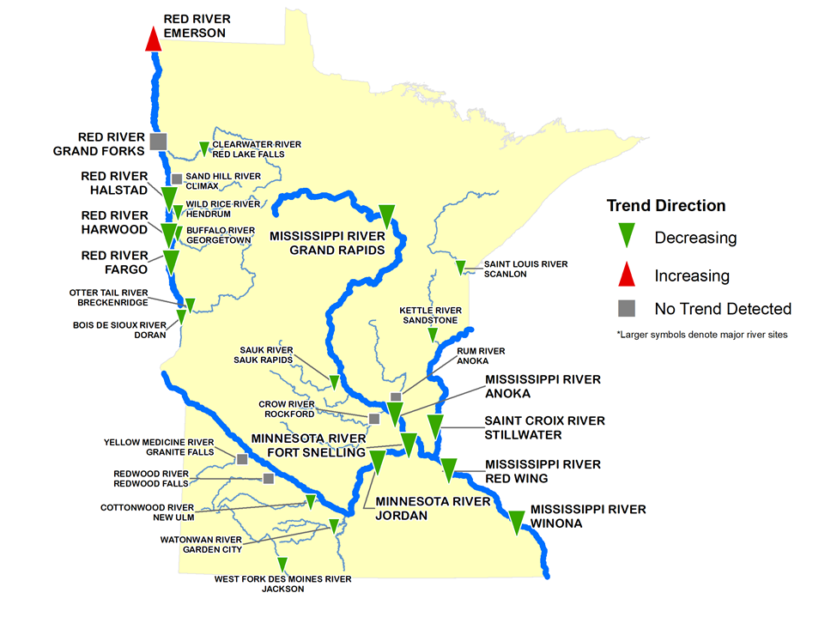Mid-range flow-adjusted phosphorus concentration trends were determined at major river sites and near the outlets of certain tributaries (Figure 2). A majority of the sites (21 of 28) show decreasing trends ranging from 15% to 55%. Six of the 28 sites had no significant trend detected. The only increase (27%) occurred at Emerson, Canada, at a point on the Red River that is immediately downstream of where the Pembina River (North Dakota and Manitoba watershed) enters the Red River. The Pembina River was found to have increasing phosphorus concentrations during this same period of time (Nustad and Vecchia 2020).

Figure 2. River monitoring site locations at sites with enough information to determine mid-range (approximately 20-year) flow-adjusted phosphorus concentration trends. QWTREND was used to assess trends at mapped sites above, except that the flow-adjusted bootstrapped Seasonal Kendall test was used at tributaries to the Minnesota River, the Sauk River and Kettle River.

Phosphorus concentrations in the Red River have decreased since 2000 in the upstream reaches of the River.

The Mississippi River sites near the Twin Cities had flow-adjusted phosphorus concentration decreases of 21% to 26% over the past two decades, with decreases by as much as 50% detected further downstream at Winona, upstream from the state border with Iowa.

The Minnesota River, a high nutrient-loading tributary to the Mississippi River, has had 20-year phosphorus decreases of about 17%. However, at Jordan, Minnesota, this decrease shifted since about 2009 and appears to be increasing, as described in further detail in Appendix C.

Decreasing phosphorus concentrations do not always translate into statistically significant decreasing loads. This is the case in southern Minnesota where increased precipitation and river flows during the past two decades have increased nonpoint source phosphorus runoff amounts, thereby somewhat offsetting the great progress Minnesota has made through changes in urban and rural areas. At most of the Mississippi River sites in Minnesota a statistically significant downward trend in the phosphorus loads during the past 20 years was not found, except when flow-adjusted statistical techniques were used. Near the state border at Winona, the actual phosphorus loads appear to have decreased, but just not enough to be statistically significant.

#### Nitrogen

The predominant form of nitrogen added to waters from human activities is nitrate-N, which is typically measured in laboratories in combination with nitrite-N (e.g. nitrite+nitrate-N). Therefore, this report focuses on nitrite+nitrate trend results, typically referred to as “nitrate.” Total nitrogen trend analyses generally showed similar patterns and trend directions as nitrate, although less statistically significant in some instances. Total nitrogen includes all of the nitrite+nitrate-N, organic nitrogen, and ammonium.

Mid-range flow-adjusted nitrate concentration trend determinations showed increasing trends at half of the sites (14 out of 28) and only 3 of 28 sites showed a decreasing trend (Figure 3). Eleven of the 28 sites had too much variability to confidently determine a significant change. Nitrate concentration increases in the major rivers ranged from 21% to 55%, with nitrate concentrations more than doubling in some tributaries. The only decrease in southern Minnesota over the 20-year period was in the Minnesota River at Fort Snelling. A more in-depth analysis of this site showed a 15% nitrate concentration decrease from 2005 to 2018, but with an increase between 1979 and 2004 that caused an overall long term increase of 21% (1979 to 2018).

The Mississippi River sites near the Twin Cities showed 20-year nitrate concentration increases in the range of 25% to 34%. Just downstream of the Twin Cities, at the Mississippi River in Red Wing, nitrate *loads* increased by 62%, which is a much greater increase than the 25% flow-adjusted nitrate *concentration* increase. Increases in both nitrate concentrations and increases in river flow explain the larger load increase as compared to the flow-adjusted concentration increase. Further downstream at Winona, there is too much variability in river flow and nitrate levels for the 20-year nitrate load trends to be statistically significant.

The Minnesota River, a major tributary to the Mississippi and the largest contributor of nitrate, has had mixed 20-year nitrate trends. Nitrate concentration trends (flow-adjusted) at Jordan, Minnesota have shown increases since 2012. The Minnesota River at Fort Snelling has decreasing nitrate concentrations since 2005. The Minnesota River is heavily tile-drained with shorter lag times between practice changes and observed effects in the river. Other tributaries to the Mississippi River are more heavily influenced by groundwater baseflow, which can have a much longer lag time than tile flow. The Minnesota River also has much higher nitrate concentrations than the Mississippi River, therefore requiring much more nitrate additions to the river to cause an increase as compared to the Mississippi River.

With a few exceptions, the Red River Basin has had increasing nitrate trends during the past 20 years in both the Red River main stem and Minnesota tributaries to the Red River. At the state border with Canada, the Red River nitrate trend was not considered statistically significant.

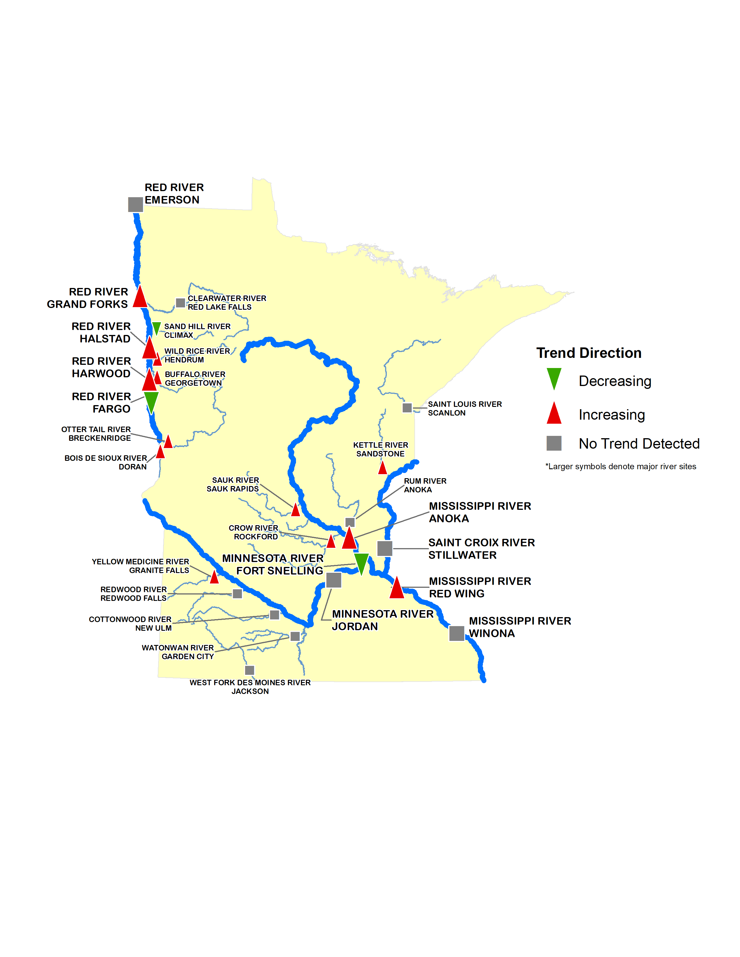

Figure 3. River monitoring site locations at sites with enough information to determine mid-range (20-year) flow-adjusted nitrate concentration trends. QWTREND was used to assess trends at these sites, except that the flow-adjusted bootstrapped Seasonal Kendall test was used at tributaries to the Minnesota River, the Sauk River and Kettle River.

### Recent (10-year) nutrient concentration trend results

The MPCA conducted trends analyses from 2008 to 2017 to evaluate trends occurring during more recent years. This period of time is more closely associated with potential NRS effects as compared to the 20-year trend analyses. Another reason to separately focus on the recent, 10-year, timeframe is because many more sites are available for trend analysis. The MPCA greatly increased river monitoring beginning in 2007 to 2008. One drawback of the shorter-term timeframe is that the fewer years of data tends to reduce the likelihood of observing statistically significant trends.

#### Phosphorus

Using flow-adjusted approaches, 10-year phosphorus concentrations were found to be decreasing at 48% (24 of 50) of river sites, with all other sites showing no detectable trend (Figure 4). No sites had an increasing phosphorus concentration trend for this 2008 to 2017 period. The majority of the 10-year decreases were found in the eastern part of the state, with the western and northwestern parts of the state showing mostly non-significant trends. Results were similar when the 10-year phosphorus concentration trends were assessed without using a flow-adjusted approach. When not using flow-adjusted techniques, a few decreasing trends shifted to no-trend, and one site showed an increase.   
In-depth analysis of recent phosphorus trends for major rivers is available in Appendix C.

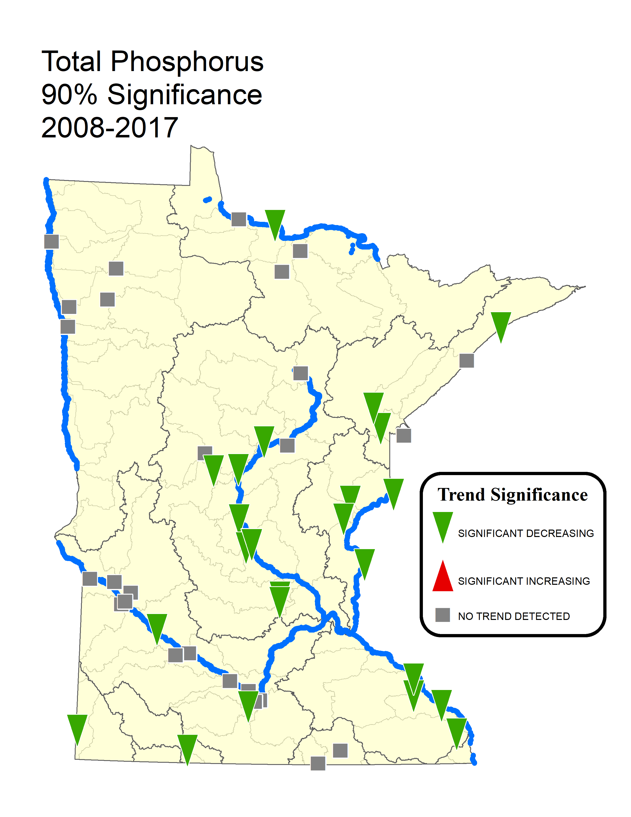

Figure 4. Phosphorus 10-year flow-adjusted concentration trends.

#### Nitrogen

Using flow-adjusted techniques for the 10-year period, 37% of sites (14 of 38) that had detectable nitrate levels showed increasing nitrate concentration trends, with the others showing no detectable trend. When using trend analysis techniques that do not adjust for the variability in flow, a higher fraction of sites showed increasing trends (50%), with the others showing non-significant trends. None of the 10-year nitrate trends showed a decrease. The majority of 10-year nitrate concentration trend increases were found in the central and southwestern parts of the state (Figure 5).

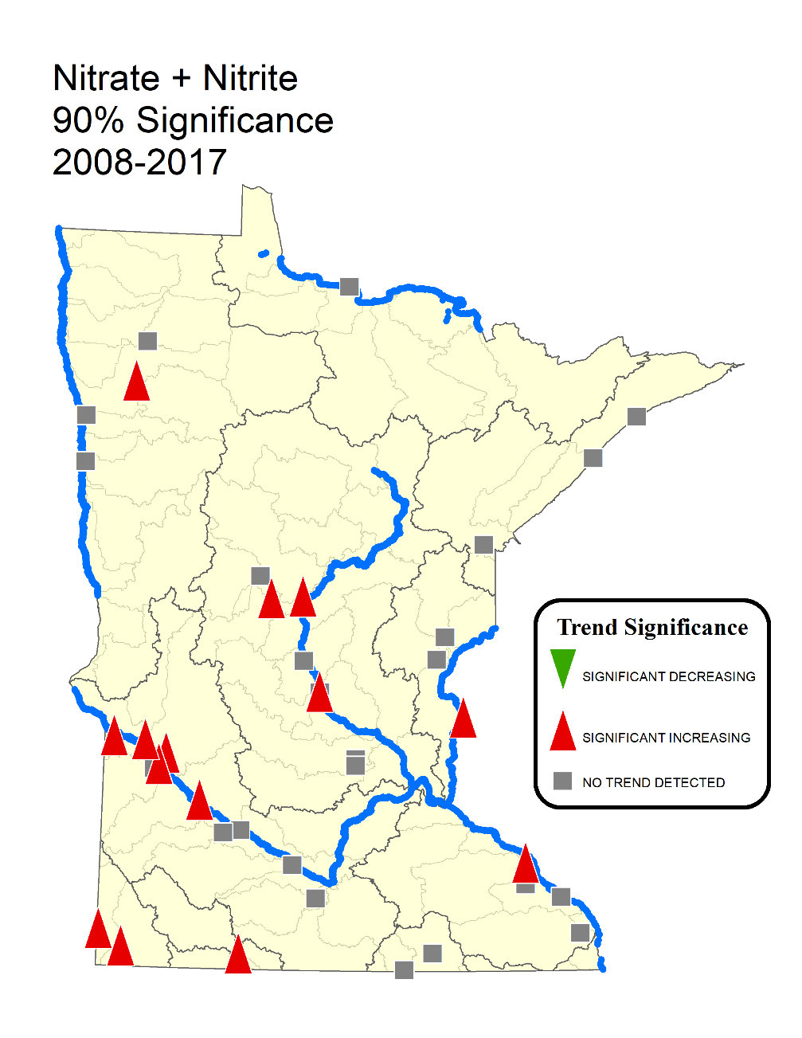

Figure 5. Nitrate plus nitrite 10-year flow-adjusted concentration trends.

### Differences between river phosphorus and nitrogen trends

The differences between generally decreasing phosphorus concentration trends and generally increasing nitrogen concentration trends can be explained by differences between nutrient sources, pathways from sources to waters, and Minnesota’s progress made toward reductions.

Wastewater discharges, one of the most influential sources of phosphorus in the state (Barr 2004), have decreased by over 70% in the past 20 years. While wastewater nitrogen discharges contribute less than 10% of the nitrogen load to waters, they have increased slightly over the same 20-year timeframe due to both increased population and a limited number of cities that remove total nitrogen from their wastewater.

Row crop agriculture has been the largest source of nitrogen over time. The documented progress in reducing cropland nitrogen losses is not as evident as progress made to reduce cropland phosphorus losses. The substantial adoption of cropland soil and water conservation practices over the years has had a much greater impact on reducing cropland phosphorus than nitrogen. Phosphorus is transported in overland runoff, which can be easier to control, as compared to nitrogen losses that occur largely through subsurface drainage tile lines and groundwater pathways. Since the number of acres that are tile-drained and planted to row-crops in Minnesota has increased over time, those changes may have offset some gains made in improved nitrogen fertilizer and manure management.

Another nutrient source, urban stormwater runoff, is a higher contributor of phosphorus than nitrogen. Minnesota has made significant progress in managing urban stormwater during the past two decades through the state’s stormwater permitting program implemented at the municipal level. Additionally, phosphorus fertilizer restrictions have been enacted for lawns and turf.

Lag times are another possible contributing factor for differences in the phosphorus and nitrogen trends. In places where nitrogen is transported to streams and rivers predominantly via groundwater, the lag time between cropland BMP adoption and river improvement can be considerably longer for nitrogen as compared to overland runoff of phosphorus.

#### **Nutrient trends at Mississippi River at Red Wing (Lock and Dam #3)**

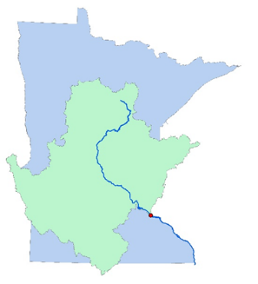

Figure 6. Drainage area to Lock and Dam #3.

Minnesota’s long-term monitoring site on the Mississippi River at Red Wing (also known as Lock and Dam #3) is important for evaluating nutrient reduction progress throughout much of the state. The location is downstream of the Upper Mississippi River Basin, the Minnesota River Basin, the St. Croix River Basin and the Twin Cities Metropolitan area (Figure 6). This site represents an integrated sample of much of the nutrient pollution that ultimately leaves the state in the Mississippi River. Therefore, nutrient trends at the Red Wing site are key to tracking changes resulting from NRS implementation. It is important to note that not all nutrients reaching this location end up leaving the state; the Red Wing site is upstream of Lake Pepin and other Mississippi River backwaters where some of the nutrients are either temporarily or permanently lost from the river.

Met Council results from a statistical analysis in Table 7 shows flow-adjusted phosphorus concentration reductions of 21% and 40% over the past 20 and 40 years, respectively.

Table 7. Statistical trend for total phosphorus concentration in the Mississippi River at Red Wing site (Lock and Dam #3)

|  |  |  |  |  |  |
| --- | --- | --- | --- | --- | --- |
| **Trend Period** | **Concentration (mg/L)** | **Change in Conc (%)** | **Change Rate (mg/L/yr)** | ***p*** | **Trend** |
| 1976 – 2018 | 0.17 – 0.10 | -41% | -0.0016 | < 0.0001 |  |
| Overall Trends | | | | | |
| 20 years  (1999 – 2018) | 0.12 – 0.10 | -21% | -0.0013 | – |  |
| 40 years  (1979 – 2018) | 0.17 – 0.10 | -40% | -0.0017 | – |  |

Phosphorus loads at Red Wing show high year-to-year variability (Figure 7). While the 5-year rolling average shows a phosphorus load decrease from 1994 to 2008, a non-flow adjusted analysis of load trends does not show a statistically significant change for either mid-range or long-term periods. This is likely a function of increased average and maximum flow in the river over the past 20 years. While the water has lower phosphorus concentrations, there is more water flow; therefore, the phosphorus load changes are not statistically significant.

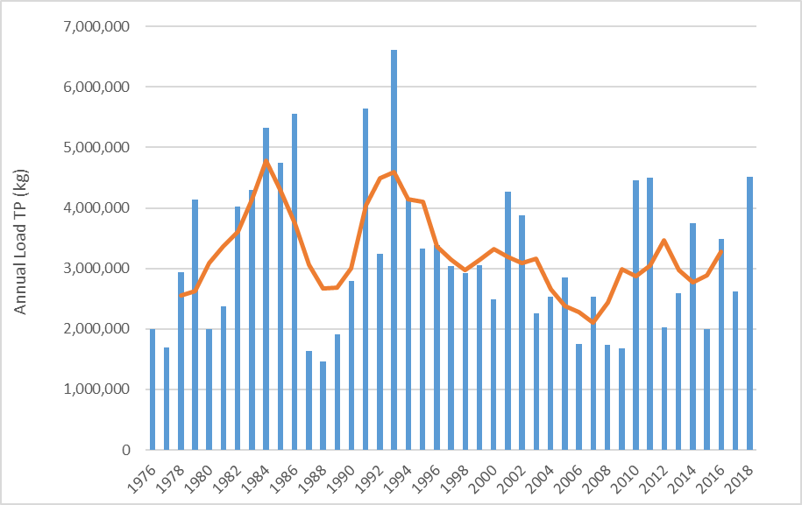

Figure 7. Annual phosphorus loads in the Mississippi River at Red Wing (Lock and Dam 3) and 5-year rolling average load (orange).

Results of the flow-adjusted statistical analysis for nitrate in Table 8 show that flow-adjusted nitrate concentrations in the Mississippi River at Red Wing increased by 25% and 154% over the past 20 and 40 years, respectively. Nitrate concentrations increased markedly from 1976 to 1982, followed by a more gradual increase between 1983 and 2018.

Table 8. Statistical trends for nitrate concentration in the Mississippi River at Red Wing site (Lock and Dam #3)

|  |  |  |  |  |  |
| --- | --- | --- | --- | --- | --- |
| **Trend Period** | **Concentration (mg/L)** | **Change in Conc (%)** | **Change Rate (mg/L/yr)** | ***p*** | **Trend** |
| 1976 – 1982 | 0.58 – 1.39 | 142% | 0.12 | < 0.0001 |  |
| 1983 – 2018 | 1.39 – 2.03 | 46% | 0.018 | < 0.0001 |  |
| Overall Trends | | | | | |
| 20 years  (1999 – 2018) | 1.62 – 2.03 | 25% | 0.020 | – |  |
| 40 years  (1979 – 2018) | 0.80 – 2.02 | 154% | 0.031 | – |  |

Non flow-adjusted loads very greatly from year to year, but overall show increases since 1976 (Figure 8). A statistical analysis of these non-flow-adjusted nitrate load trends showed 62% and 53% increases during the past 20 and 40 years, respectively (Figure 8). This is not surprising since loads reflect the combination of concentrations and river flow, and both have increased. Flows have especially increased during the past 20 years. Both nitrate and total nitrogen loads show a similar pattern over time. More details on the analysis for the Red Wing site, as well as other major river basins, is available in Appendix C.

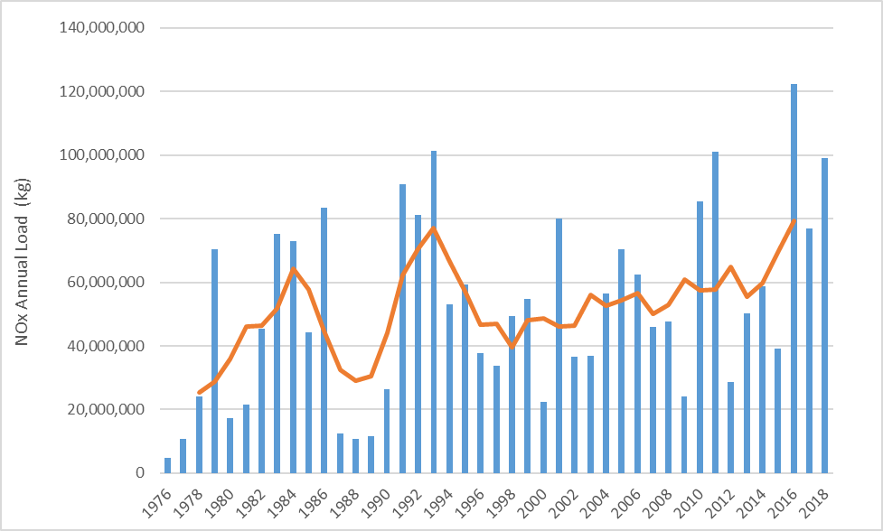

Figure 8. Annual NOx Loads in the Mississippi River at Red Wing (Lock and Dam 3) and 5-year rolling average load (orange).

**Summary of Minnesota’s Progress in Rivers**

**Why important**

* The NRS aims to achieve measured water nutrient reductions and track our progress toward that outcome.
* Reducing nutrient *concentrations* is important for local water health and drinking water.

Reducing nutrient *loads* (total amounts flowing down the river) is important for downstream lakes, reservoirs and the Gulf of Mexico.

* It is important to evaluate water nutrient trends over at least 10 to 20 years because nutrient concentrations and loads are highly variable from year-to-year with changing weather patterns, and because the changes across the landscape can take long periods of time to show observed effects in rivers.
* Changes during the past five years since completion of the NRS (2014-18) have a large effect on the outcomes of the 10 and 20-year trends evaluated for this progress report. However, trends over just a 5-year period is typically too short of time to draw meaningful conclusions about the effects of nutrient-reducing strategies.
* Changes in river nutrients are affected by many factors, in addition to newly adopted BMPs. Flow-adjusted methods are important for assessing trends independent of river flow variability, allowing a more direct evaluation of the effects of human activities.

**Findings**

* Phosphorus concentrations have generally decreased and nitrate-nitrogen and total nitrogen concentrations have generally increased over the past 10 and 20 years. However, river flow and nutrient concentration variability makes it difficult to confidently show trend directions at many of the monitoring locations.
* *Phosphorus concentration* trends over the past approximate 20 years show mostly decreases (improvements) around the state, with reductions ranging from 15% to 55%. Over the past 10 years, phosphorus concentrations have decreased at nearly half (42%) of 57 monitoring sites evaluated, with all other sites showing no significant trend. This shows that our efforts to reduce phosphorus in recent years have been making a difference.
* *Nitrate concentration* trends over the past approximate 20 years show increases of 20 to 60% in most major rivers. However several sites have no trend detected, and a couple sites showed decreases. Over the past 10 years, nitrate concentrations increased at over one-third of the sites and had no statistically significant trend at the rest. This suggests that efforts to reduce nitrate thus far are either insufficient and/or not enough time has elapsed for the full effects of our efforts to be seen in rivers.
* Increasing precipitation in southern Minnesota over the past two decades has been offsetting the benefits of our phosphorus-reducing activities. As a result, phosphorus load reductions are not statistically significant (i.e. no-trend) in most southern Minnesota rivers, unless statistical methods are used to adjust for river flow variability.

**Follow-up**

* Continued monitoring will be important to more confidently assess ongoing nutrient changes and the long-term effects of our collective state efforts to reduce river nutrients.
* Follow-up study is needed to help identify the factors contributing to nutrient increases in certain river stretches and decreases in others.

## Small watershed monitoring

The use of small watershed implementation and monitoring programs are very important in Minnesota’s NRS approach. The lessons learned from nearly 40 years of nonpoint source pollution management across the nation show the need for long-term, small-scale watershed efforts to increase the likelihood that changes in water quality will occur and be measured. Measured improvements from implementing BMPs in small watersheds can provide other watersheds with information about successful techniques to improve water quality.

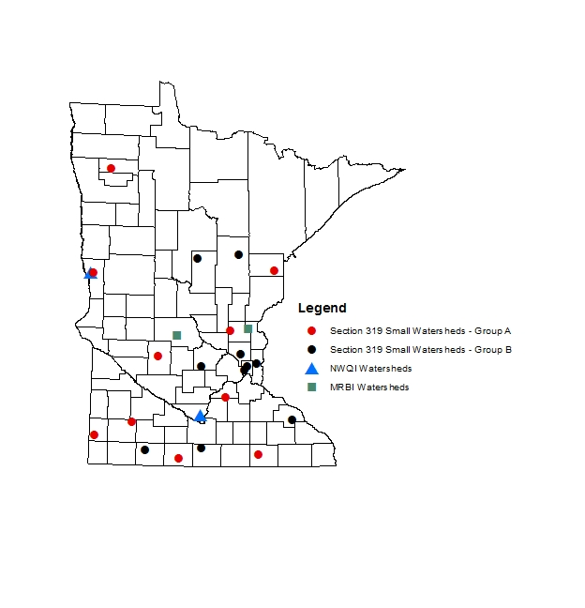While larger-scale (major river basin and hydrologic unit code [HUC-8] major watersheds) monitoring programs provide important overall assessments of water quality conditions and long-term trend analyses, they generally do not provide the data necessary to evaluate changes in water quality attributable to specific sets of management practices. As the watershed size increases, so does the amount of BMP implementation needed to detect changes, the likelihood of undocumented changes occurring, and the length of time required to achieve and measure changes in water quality. A small watershed framework with a strong monitoring component enables Minnesota partner agencies to more clearly connect implementation changes on the land to trends in water quality.

The Natural Resources Conservation Service (NRCS) implements both the NWQI and the MRBI in Minnesota. These water quality efforts focus on priority HUC-12 and larger watersheds and have funded efforts such as recent work in the Seven Mile Creek watershed, including effectiveness monitoring. Monitoring and implementation in smaller watersheds are funded through the NWQI, MRBI, and Section 319 Small Watersheds Focus Program (Figure 9). These small watershed programs support small-scale, long-term efforts and provide measurable changes that can be replicated for larger watersheds. Information about these efforts and other small watershed monitoring efforts are described in Appendix A.

Figure 9. Small watershed monitoring.

## Edge of field monitoring

Edge-of-field monitoring allows us to better understand the factors influencing nutrient delivery to waters. Minnesota is fortunate to have many edge-of-field monitoring programs supported by the agricultural community. The MDA oversees many of these monitoring efforts, which include the Discovery Farms, Root River Field to Stream Partnership, and the Red River Valley Drainage Water Management Project, and others (Figure 10).

Data from on-farm, edge-of-field monitoring sites are used to assess nitrogen, phosphorus and sediment loss at the field scale and to evaluate the effectiveness of conservation practices. Data are also used to support farmer-to-farmer learning and encourage the adoption of conservation practices that protect water resources. In addition, data from edge-of-field projects on small acreages throughout the state are used to improve larger scale models which can show nutrient reduction scenario estimates throughout various watersheds. Example models that have been calibrated with edge-of-field monitoring include: HSPF, Soil and Water Assessment Tool, Agricultural Policy/Environmental eXtender Model, PTMApp, Adapt-N, and the Runoff Risk Advisory Forecast Tool. Without these data, the tools used in the impaired waters process would not be as accurate or refined for conditions in Minnesota.

Key lessons learned across the edge-of-field monitoring locations, as reported by MDA:

* On average, 40-47% of the total surface runoff volume occurs when the soil is frozen.
* Over 50% of the annual phosphorus and sediment losses often occur during 1-2 rain events each year.
* 70-78% of the sediment loss occurs during May and June on fields that lack established crop cover.
* Across the Discovery Farms Minnesota network, nitrogen losses are typically four times higher from subsurface drainage lines compared to surface runoff. Phosphorus losses are typically nine times higher from surface runoff compared to subsurface drainage.

More information on these efforts is provided in Appendix A and <https://www.mda.state.mn.us/environment-sustainability/farm-projects>.

Small watershed and edge-of-field work should continue during the next five years and results should be carefully studied before making NRS updates.

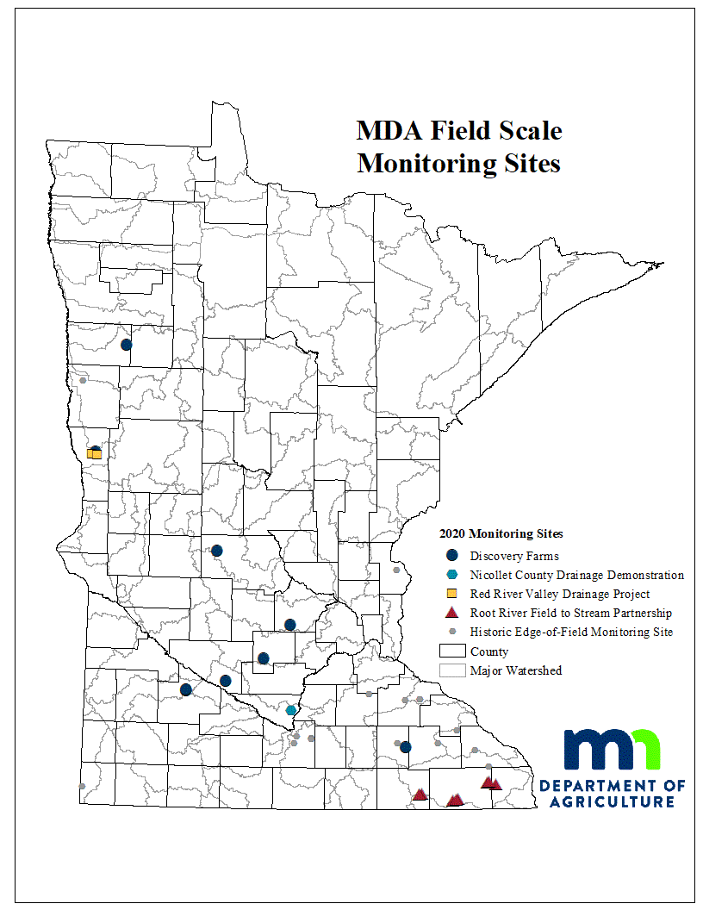

Figure 10. MDA field scale monitoring sites.

## Lake clarity trends

In addition to river nutrient trends, MPCA analyzed lake water clarity trends as one indicator of changes in Minnesota lakes nutrient conditions. While phosphorus can affect lake clarity, it is important to keep in mind that other factors contribute to changes in lake clarity.

Timeframes for this lake clarity trends analysis varies, with the shortest length of monitoring being 2010 to 2018, and the longest 1973 to 2018. A total of 4,796 lakes statewide contained some monitoring data, 1,646 of which met the minimum data requirements and were included in this analysis. Minimum data requirements for lake trend analysis was at least eight years of data and 50 observations.

To be considered an *improving* or *degrading* water clarity trend, a lake must experience a Secchi disk change greater than ½ foot/decade. A lake demonstrating either an improvement or reduction in water clarity that is equal to or less than ½ foot/decade is classified as having *no change* in water clarity trend. A lake that meets the minimum data requirements, but has a non-significant statistical result (i.e., the p value is less than 0.05), is considered to have *no trend* detected at this time.

Of the 1,646 lakes analyzed for trends, 29% were observed to be improving, while 11% saw degrading water quality over the 2010 to 2018 period (Figure 11 and Figure 12). In other words, lakes are getting clearer in nearly three times as many lakes as those showing worsening water clarity. While the larger number of lakes with improving clarity is encouraging, this analysis did not confirm that the improved clarity is the direct result of decreasing phosphorus loads into those lakes. Determining the causes for the improved clarity requires additional study and will vary from one lake to another.

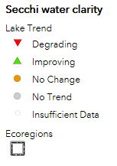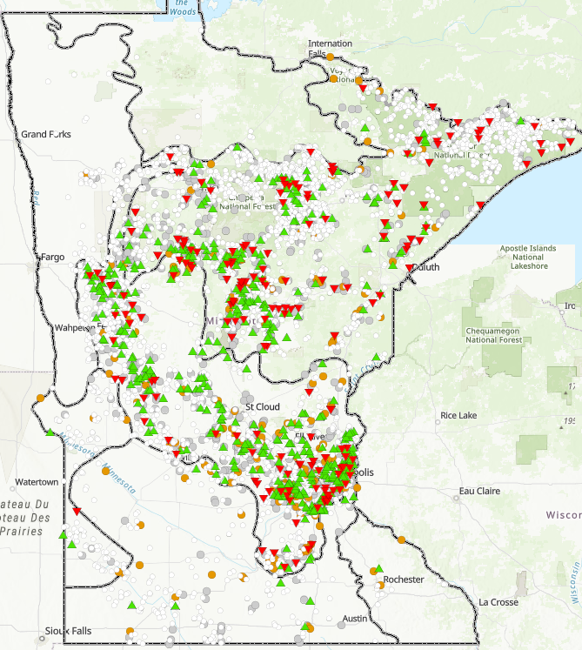

Figure 11. Map of lake clarity trends in Minnesota.

<https://www.pca.state.mn.us/water/transparency-trends>

Figure 12. Lake clarity trends in Minnesota.

**Lake Pepin phosphorus**

Lake Pepin receives nutrients from most of the Mississippi River Basin drainage in Minnesota and has battled eutrophication for many years. Since the mid-1990s, the USGS Long-Term Resource Monitoring Program has served as the principal source of data for Lake Pepin. MPCA used water quality data collected at four USGS sampling stations to characterize average total phosphorus and chlorophyll-*a* concentrations for the most recent 10-year period (2008 to 2017). Chlorophyll-*a* is an indicator of algae growth driven partly by phosphorus. Over the most recent 10-year period, there is a decreasing trend in both phosphorus concentration and chlorophyll-*a* (Figure 13 and Figure 14). The improvement in Lake Pepin water quality coincides with Mississippi River decreases in total phosphorus concentrations.

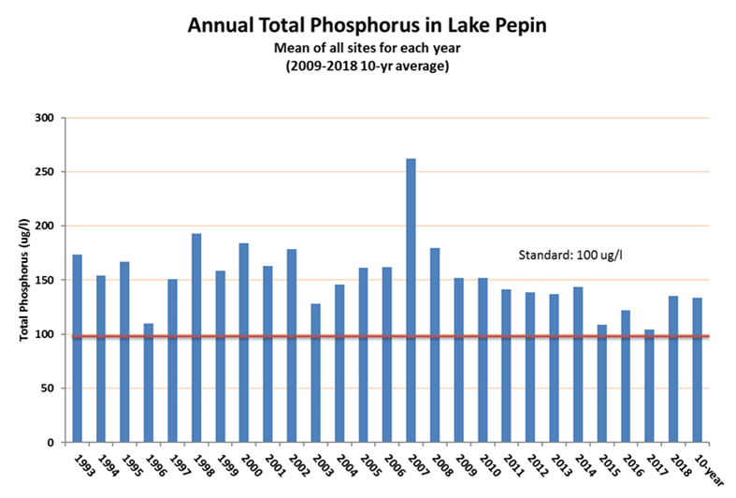

**Figure 13. Mean annual total phosphorous in Lake Pepin summarized into a composite concentration from four monitoring stations.**

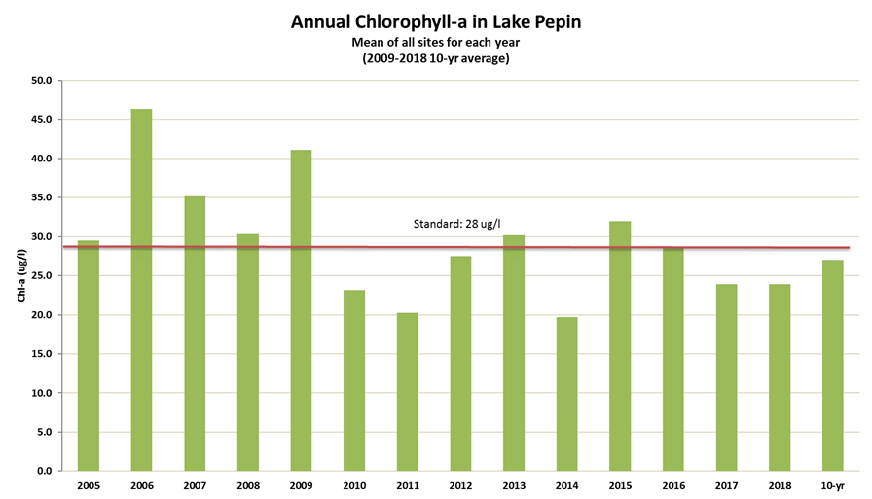

Figure 14. Mean annual chlorophyll-*a* in Lake Pepin summarized into composite concentration from the four monitoring stations (MPCA 2019a).

## Groundwater nitrate trends

Groundwater nitrate is a concern for well water consumption in many parts of Minnesota and as a contributor of nitrate to surface waters. Groundwater baseflow nitrate contributions to rivers depends on the geology, groundwater flow pathways, and time of transport between groundwater recharge area and re-emergence into rivers. River nitrate concentrations and loads often represent a broad-scale mixing of multiple waters, including surface water runoff, groundwater baseflow, and agricultural and urban drainage waters. Some groundwater nitrate can reach surface waters before the nitrate is lost to the atmosphere (as nitrogen gas through denitrification processes). Therefore, studying trends in groundwater nitrate can help inform progress evaluation of river and stream nitrogen goals.

Wells constructed into an aquifer can provide an indication of nitrate concentrations at a discrete point and depth within the groundwater system. Since well water nitrate concentrations often vary greatly within short distances both horizontally and vertically, many wells are often needed to characterize groundwater nitrate concentrations and trends in a given area. The Minnesota Geological Survey recently reported on how greatly hydrogeologic controls affect groundwater nitrate load contributions to surface waters in southeastern Minnesota ([https://conservancy.umn.edu/handle/11299/162612](https://gcc01.safelinks.protection.outlook.com/?url=https%3A%2F%2Fconservancy.umn.edu%2Fhandle%2F11299%2F162612&data=02%7C01%7Cdavid.wall%40state.mn.us%7Ca527ee2ccd744f96843708d7bed2e6d6%7Ceb14b04624c445198f26b89c2159828c%7C0%7C0%7C637187687156272444&sdata=CHs4cpj2ugnDesI9i1LIS7DrmWcpt8Jt3qb9ob4K5l8%3D&reserved=0)). It is important to recognize such limitations and complexities in well-water sampling when evaluating groundwater nitrate trends.

The MPCA and MDA each maintain their own ambient groundwater-monitoring network that, when combined, covers a variety of conditions across the state. The MPCA’s ambient groundwater monitoring primarily targets aquifers in urban parts of the state, and most of the MDA’s monitoring is performed in agricultural areas. A recently released *Condition of Minnesota’s Groundwater Quality* report included a nitrate trend analysis from 117 wells monitored from 2005-2017 by MPCA and MDA (MPCA 2019b).

Statistical analysis of these 117 wells in the upper-most aquifers showed 74 (63%) of the individual wells with no statistically significant change in nitrate concentrations, 19 sites (16%) having significant increases, and 24 sites (21%) having significant decreases in nitrate concentrations (Figure 15). The sites with significant upward or downward trends were scattered throughout the state and generally did not appear to be located within any specific region or land use setting. The report provides some clues about changes in groundwater nitrate levels in recent years but is largely inconclusive about nitrate trends, overall.

Additionally, MDA recently reported on well water nitrate trends results from two Volunteer Nitrate Monitoring Networks in Minnesota (Kaiser et al. 2019). Southeastern Minnesota well water nitrate showed no statistically significant trend between 2008 and 2019 with 5778 samples taken. However, the Central Minnesota Sands private well network showed a slight downward trend between 2011 and 2019 with 3768 samples taken.

MDA also manages a broader domestic well monitoring program and tested 30,769 domestic wells in geologically vulnerable agricultural areas between 2013 and 2018.

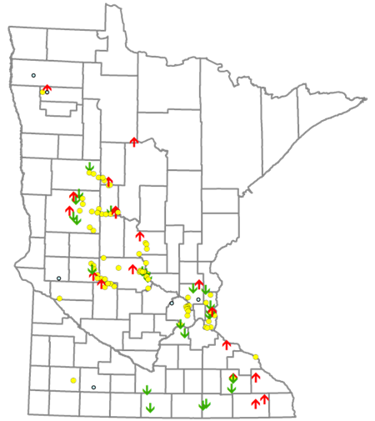

Figure 15. Groundwater nitrate trends over a 13-year period. Red up-arrow indicates an increase; green down-arrow indicates decrease; yellow dot indicates no trend.

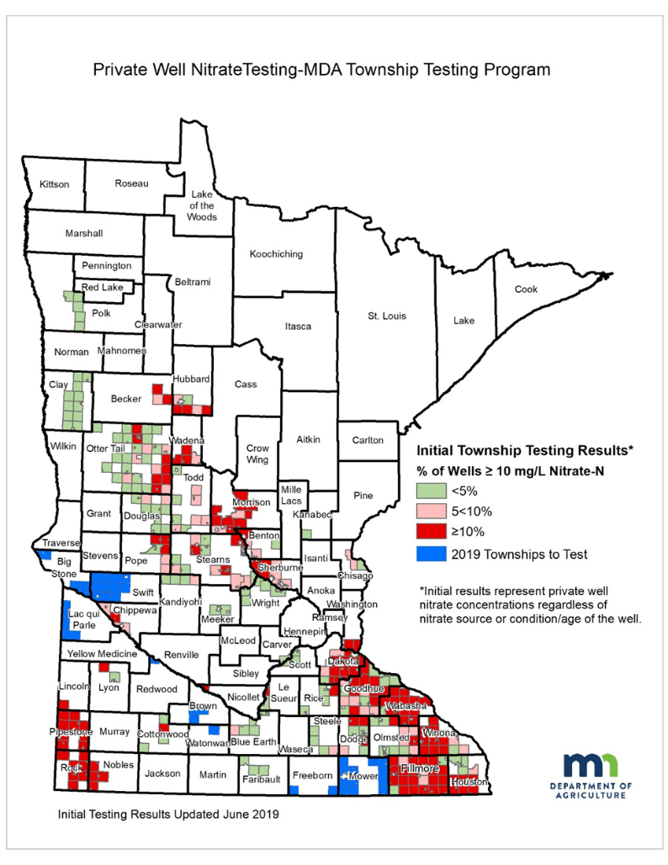The ongoing township groundwater testing program has provided an increased understanding of the locations and magnitude of high nitrate wells in Minnesota (Figure 16). The results show that 9.2% of the wells in these vulnerable areas had nitrate-N exceeding the 10 mg/l Health Risk Limit. Well water nitrate concentrations are particularly high in southeastern, southwestern and central Minnesota. More info at <https://www.mda.state.mn.us/township-testing-program>.

# 

Figure 16. Private well nitrate testing - MDA Township Testing Program results.

# On our cropland – Are we on track for the needed scale of BMP adoption?

This section examines agricultural BMP adoption from 2014 to 2018 in the same four general categories of practices outlined in the 2014 NRS scenarios. It addresses the example BMP adoption scenarios put forth in the 2014 NRS, the methods and assumptions for assessing BMP adoption, and discussion of BMP adoption for the following categories of practices:

* Crop nutrient management efficiency (fertilizer and manure)
* Living cover
* Field erosion control
* Drainage water treatment and storage

Several sources of data are used as indicators of the general scale of agricultural BMP adoption in the state of Minnesota through a) government supported programs and b) overall BMP adoption reflecting a combination of government-supported and private adoption. These BMPs are just one important

factor affecting overall change on the land and in the water. Cropland changes over time (Figure 17, population trends, climate and land use changes, and river flow are additional factors that affect nutrients. Recent changes in these factors are described in Appendix B.

Figure 17. Statewide crop and grass/pasture acreage changes between 2012 and 2018 as identified from Crop Data Layer (CDL).

## Agriculture BMP adoption scenario goals

To guide Minnesota’s progress toward the 2014 NRS nutrient reduction goals, the 2014 NRS included example cropland BMP scenarios. These scenarios serve as examples of the level of BMP adoption needed to achieve the nutrient reduction goals and milestones in major river basins, when combined with point source nutrient reductions and other reductions. BMP scenarios included identification of BMPs and adoption rates which were intended to maximize the combination of BMP effectiveness, cost and practice acceptability.

Several million acres of needed BMP additions were identified in the Mississippi River and Red River Basins (Table 9 and Figure 14). For both basins, “total BMP acres” assumes that nitrogen and phosphorus reduction BMPs are on the same lands. For example, cover crop acres to achieve nitrogen reduction are the same cover crop acres that will achieve phosphorus reduction. However, when local watershed prioritization for phosphorus and nitrogen reduction are in different areas, the total needed acreages may be higher than shown in Table 9 and Figure 18. More acres of agricultural BMPs are needed to meet the milestones in the Mississippi River Basin than the Red River Basin (Table 10).

**Nutrient reduction milestones and final goals for downstream waters**

*Phosphorus*

* 12% reduction for the Mississippi River Basin (thus meeting the overall 45% reduction needed to meet the goal)
* 10% milestone reduction in Minnesota’s Red River portion of the Lake Winnipeg Basin on the way to a 50% reduction goal

*Nitrogen*

* 20% reduction as a milestone on the way to a final 45% reduction goal for the Mississippi River Basin
* 13% milestone reduction for the Red River Basin on the way to a 50% reduction goal

In general, the approach for nitrogen reduction from cropland includes increasing fertilizer and manure use efficiency by optimizing nutrient management, treating tile drainage waters, and implementing living cover BMPs such as cover crops and perennials. Phosphorus reductions from cropland are based largely on optimizing fertilizer and manure application, subsurface banding or injection of fertilizer/manure, reducing soil erosion, and adding riparian buffers and other living cover on the landscape.

Table 9. Example combined basin scenario from 2014 NRS to achieve milestones.

|  |  |  |  |
| --- | --- | --- | --- |
| **Agricultural BMP categories** | **Combined Basin Total (Mississippi River and Red River Basin)** | | |
| **Nitrogen BMP acres** | **Phosphorus BMP acres** | **Total BMP acres** b |
| Field Erosion Control | 0 | 4,900,000 | 4,900,000 |
| Increasing Fertilizer Use Efficiencies a | 6,800,000 | 2,200,000 | 6,800,000+ |
| Drainage Water Retention and Treatment | 620,000 | 0 | 620,000 |
| **Increase and Target Living Cover** | | | |
| Perennials | 440,000 | 440,000 | 440,000 |
| Cover crops | 1,900,000 | 1,400,000 | 1,900,000 |

a. Table 5-15 in the 2014 NRS shows a statewide total acreage for nitrogen fertilizer management of 80% of corn acres, or 11,900,000 acres of the 14,875,000 statewide acres of corn/soybean rotations. The BMP used in the 2014 NRS scenario was to decrease the industry average fertilizer rate on those 11,900,000 acres. It is useful to translate the industry average acreages to the actual number of acres that could be more optimally managed for nitrogen fertilizer. A fertilizer use survey report published by the MDA around the time the NRS was finalized showed that 57% of corn following soybean lands could lower rates to align with University of Minnesota recommended economically optimum nitrogen rates (MDA 2014). Using these findings, the total number of acres that could achieve nitrogen fertilizer reductions based on the 2012-2014 timeframe would be 6,783,000 corn/soybean acres (57% of 11,900,000 acres). Note that 2016 and 2019 increases in University of Minnesota recommended nitrogen rates lower this fraction of cropland receiving excess nitrogen fertilizer compared to the 57% reported for 2012. These BMP acreages should be adjusted in future NRS revisions to account for both updated fertilizer use surveys and the changing University of Minnesota recommended rates.

b. The total BMP acres assumes that nitrogen and phosphorus reduction BMPs are on the same lands. In most cases, this is expected to provide a conservative estimate of total acreage. Where local watershed prioritization for phosphorus and nitrogen reducing BMPs are in different areas, the total needed acreages will be higher.

Table 10. Example scenarios from 2014 NRS to achieve milestones in Mississippi River and Red River basins.

|  |  |  |  |  |  |  |
| --- | --- | --- | --- | --- | --- | --- |
| **BMP categories** | **Mississippi River** | | | **Red River** | | |
| **Additional BMP acres needed at the time of NRS (2014)** | | | | | |
| **Nitrogen** | **Phosphorus** | **Total** | **Nitrogen** | **Phosphorus** | **Total** |
| **Field Erosion Control** | 0 | 4,500,000 | 4,500,000 | 0 | 400,000 | 400,000 |
| **Increasing Fertilizer Use Efficiencies a** | 6,100,000 | 2,200,000 | 6,100,000+ | 700,000 | 0 | 700,000 |
| **Drainage Water Retention and Treatment** | 600,000 | -- | 600,000 | 20,000 | -- | 20,000 |
| **Increase and Target Living Cover** | | | | | | |
| Perennials | 400,000 | 400,000 | 400,000+ | 40,000 | 40,000 | 40,000+ |
| Cover crops | 1,200,000 | 800,000 | 1,200,000+ | 700,000 | 600,000 | 700,000+ |

a. See footnote “a” in Table 9. Note: The total acres in the Mississippi River Basin that are needed for Increased Fertilizer Use Efficiency BMPs is expected to exceed 6,100,000.

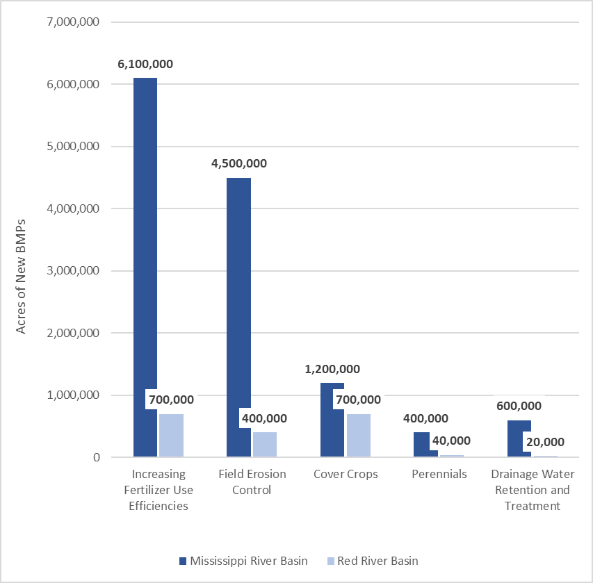

Figure 18. Example agricultural BMP scenario from 2014 NRS to achieve milestones, showing needs for additional acreages of new BMP additions.

The 2014 NRS focused on BMP scenarios to achieve the nitrogen milestones rather than the nitrogen final goals (e.g., 20% reduction in nitrogen in the Mississippi River Basin). The NRS acknowledged that Minnesota did not have a realistic way of showing how the 45% reduction could be achieved using the current state of scientific advancement. However, two hypothetical scenarios were described to indicate what it would potentially take in the future to achieve a 45% reduction in nitrogen from cropland sources in the Mississippi River Basin. Both scenarios assumed that research would advance the success of cover crops in Minnesota, enabling increases in cover crop establishment and success rates. The two hypothetical scenarios included:

**Scenario 1** **for final goals** – Use same adoption rates as for the milestone except that cover crops are established on 80% of corn grain, soybean, dry bean, potato, and sorghum acres and improving the success rate on cover crop establishment from 40% to 80%.

**Scenario 2 for final goals** – Increase adoption rates of the BMPs used for the milestone to 100% of suitable acreages for those BMPs, and additionally increase cover crops from 10% to 60% of the corn grain, soybean, dry bean, potato, and sorghum acres and improve establishment success from 40% to 60%.

These 45% reduction scenarios indicate that the total amount of land with cover crops or perennials would ultimately need to increase by an estimated 10 to 12 million acres from the current living cover acreages (note: total row crop acres in Minnesota are approximately 16 million acres).

## Agricultural BMP adoption since 2014

Progress toward these hypothetical 2014 NRS scenarios has been evaluated based on trends in the adoption of agricultural BMPs from 2014 to 2018. The following sections describe the data tracking process and provide summaries of key trends for four categories of agricultural BMPs: nutrient management efficiency practices, living cover practices, field erosion control practices, and tile drainage water treatment and storage practices.

### Tracking agricultural BMP adoption in Minnesota

Minnesota partner agencies estimate statewide agricultural BMP adoption rates by examining a combination of BMPs adopted through government-supported programs and indicators of overall adoption rates based on satellite imagery, surveys, regulatory inspections, sales data and private industry data.

* **Government programs** that provide BMP-funding assistance have kept records of the new BMPs funded through these programs since approximately 2004. A tracking system managed by the MPCA, referred to as “Healthier Watersheds BMP tracking system,” includes the BMPs tracked by each of the major government programs. In addition, the United States Department of Agriculture (USDA) Farm Service Agency tracks Conservation Reserve Program (CRP) acreages and reports the data annually on a statewide basis.
* **Satellite imagery** provides snapshots in time of certain BMPs used at the time the photos were taken. These images can be used to estimate cover crops, reduced tillage, terraces, water and sediment control basins, grassed waterways, strip-cropping and other structural practices. Satellite imagery can also be used to estimate various land-covers and crops in place, such as hay and grasses.
* **Surveys** by the National Agricultural Statistics Service (NASS) have been used to gauge Minnesota fertilizer use periodically since 2010. Additionally, the U.S. Census of Agriculture surveys taken every five years provide information about cover crops and conservation tillage starting in 2012.
* **Regulatory inspections** of manure spreading practices regulated by the MPCA and delegated counties provide some clues about the adoption of various manure spreading BMPs, but do not provide a statistical representation of statewide manure spreading practices.
* **Sales and private industry records** forfertilizer statewide, when combined with crop harvest data, provide an indication about nutrient use efficiencies at a state scale. Soil phosphorus test results can also be used to inform nutrient management progress but are not currently collected in a manner that provides statistical representation of soil phosphorus trends.

#### Government programs

Minnesota’s Clean Water Legacy Act requires that MPCA report actions taken in Minnesota’s watersheds to meet water-quality goals and milestones (Minn. Stat. § 114D.26, subd. 2). To meet this requirement the MPCA developed the “Healthier watersheds: Tracking the actions taken” webpage. Water quality protection and restoration BMP adoption levels can be found at the HUC-8 and HUC-12 watershed scales at: <https://www.pca.state.mn.us/water/best-management-practices-implemented-watershed>. For use in evaluating progress toward the 2014 NRS, the Healthier Watersheds information is aggregated into major river drainage basins and four categories of BMPs consistent with the NRS, and can be found at: [https://public.tableau.com/profile/mpca.data.services#!/vizhome/MinnesotaNutrientReductionStrategyBMPSummary/MinnesotaNutrientReductionStrategyBMPSummary](https://gcc01.safelinks.protection.outlook.com/?url=https%3A%2F%2Fpublic.tableau.com%2Fprofile%2Fmpca.data.services%23!%2Fvizhome%2FMinnesotaNutrientReductionStrategyBMPSummary%2FMinnesotaNutrientReductionStrategyBMPSummary&data=02%7C01%7Cdavid.wall%40state.mn.us%7C7dc1eae4861b4fb9231b08d7bba39e0a%7Ceb14b04624c445198f26b89c2159828c%7C0%7C0%7C637184183706432952&sdata=OzY0oWr3O9SLUI8y0VBPWTHRTn1VdWj7EBPCQNRwvZo%3D&reserved=0) .

The programs providing BMP information for the Healthier Watersheds tracking system include:



* USDA– NRCS
  + Environmental Quality Incentives Program (EQIP)
  + CSP
  + Agricultural Conservation Easement Program – Wetland Reserve Easement
  + Emergency Watershed Protection Program – Floodplain Easement
  + Emergency Wetlands Reserve Program
  + Farm and Ranch Lands Protection Program
  + Grassland Reserve Program
  + Wetlands Reserve Program
* Minnesota BWSR
  + Easement Programs
    - CREP
    - RIM
    - Wetland Reserve Program
    - Army Compatible Use Buffer Program
    - Riparian Buffer Conservation Easements
  + Grant Programs
    - Disaster Recovery Assistance Program
    - Clean Water Fund (CWF) Grants
    - State Conservation Cost-Share
    - Native Buffer Grant Program
    - Natural Resources Block Grant
  + Other programs as reported in the eLINK tracking system
* MDA
  + Agriculture BMP Loan Program
  + Minnesota Agricultural Water Quality Certification Program
* MPCA
  + Federal Clean Water Act Section 319 Program
  + Clean Water Partnership Program

Specific information provided on the “Healthier watersheds: Tracking the actions taken webpage” is provided below.

**Reporting period:** The BMP data in this analysis covers the period 2004-2018, except for CSP which goes back to only 2010 and only separates out enhancement BMPs during the past couple years.

**Year of BMP:** Represents the best available date for BMP installation. When installation dates are not available, the funding year is used.

**Joint state/federal cost-share:** All BMPs in the BWSR grant tracking system (eLINK) that report federal match (except for the 319 Program) are categorized only with federal program acreages. These practices are not reported under state-funded categories to prevent potential double counting. The majority of the joint state/federal practices are accounted for by the NRCS - EQIP Program. Less than 5% of the eLINK BMPs are associated with federal allocations.

**Location of BMP (HUC-12):** BMPs that do not have HUC-12 location data associated could not be attributed to a specific drainage area. These BMPs are included in statewide BMP aggregations but are not included with basin or watershed-specific information.

**New BMPs:** 5-year tallying of acres for this report assumes that once a BMP is installed that it will continue to operate within this 5-year reporting period. In practice, some of the BMPs that are initially funded through government programs will not continue to be implemented after government funding ceases. Therefore, the cumulative BMP elements in this report represent a high-end or overestimate of actual ongoing cumulative practices through government assistance programs.

**Multi-year contracts:** The EQIP Program funds many BMPs such as reduced tillage, cover crops, and nutrient management under three-year contracts. For such cases, the BMP is attributed to the first year under contract and is assumed to be in operation for the remainder of the reporting period.

**Agricultural BMP Loan Program:** Acres under this program are assigned to individual loans and may overlap if a borrower has multiple loans for the same BMP within the reporting period. In addition, loan-funded equipment could be used on the same acres that receive federal cost-share under a program like EQIP.

**Acres assumptions:** When specific adoption acreages were not listed by the government program, estimates of treated acres were derived from statewide averages and literature review related to the practice or closely related practice.

The methods to refine specific acreage estimates of newly adopted practices during any given year may be modified in the future to best meet both state and federal program purposes. While this may result in differences between the acres in this report and future website reported acreages, the general magnitude of government program supported practice adoption acreages over a multi-year period described in this report is not expected to change in a way that would significantly affect this report’s conclusions.

Data from the Healthier Watersheds website (NRS version), in addition to federal tracking of CRP acreage, are used to track BMP adoption categories (Table 11). The government program BMP tracking system developed in Minnesota generally aligns with the Nonpoint Source Workgroup recommendations stemming from the Gulf of Mexico Hypoxia Task Force at: <https://www.epa.gov/sites/production/files/2018-05/documents/nps_measures_progress_report_1-_may_2018.pdf>.

Table 11. BMPs included in Healthier Watersheds website, reported in the following sections.

|  |  |  |  |
| --- | --- | --- | --- |
| **Nutrient Management Efficiency** | **Living Cover** | **Field Erosion Control** | **Tile Drainage Water Treatment and Storage** |
| Nutrient management | Conservation Cover  Conservation Crop Rotation  Conservation Easement  Cover Crop  Critical Area Planting  Filter Strip  Forage and Biomass Planting  Riparian Forest Buffer  Riparian Herbaceous Cover  Windbreak/Shelterbelt Establishment | Alternative Tile Intake  Contour Buffer Strips  Field Border  Grassed Waterway  Mulching  Residue and Tillage Management, No-Till/Strip Till  Residue and Tillage Management, Reduced Till  Residue and Tillage Management, Ridge Till  Sediment Basin  Stripcropping  Terrace  Water and Sediment Control Basins | Denitrifying Bioreactor  Drainage Water Management  Saturated Buffer  Wetland Restoration |

#### Satellite imagery

Satellite aerial imagery projects initiated by the BWSR within the past five years are beginning to provide a more comprehensive view of soil conservation practices, specifically crop residue and cover crops. The BWSR, the University of Minnesota, and Iowa State University have been working together since 2016 to develop a long-term program to systematically provide cover crop, crop residue, land cover and soil erosion data in Minnesota counties with at least 30% agricultural land use. The goal is to quantify and track this information on multiple scales and to calculate estimated average annual and daily soil loss due to wind and water erosion.

Reduced tillage and cover crop practices are often used without government assistance and are not always tracked through government assistance program databases. The BWSR contracted with the University of Minnesota to provide more comprehensive snapshots of crop residue cover levels and cover crop practices in Minnesota. Data from this project will be important for gauging the statewide NRS goals, as well as measuring changes at the local sub-watershed level. This project is moving from prototype development into production mode in 2020 and 2021.

For collection of spring crop residue levels and fall cover crop adoption, remote sensing techniques utilizing Sentinel 2 and Landsat 8 satellite imagery are used. Data has been collected and analyzed by the University of Minnesota from 2016 through 2019. To provide quality assurance and control of the data, ground truth data is collected in the field to verify and validate the remote sensing model. Digital images of residue are collected to provide precise residue measurements in a limited number of locations. This data is used to calibrate the model and thus improve the accuracy of the model outputs for Minnesota.

One of the major components of Minnesota’s crop residue and cover crop satellite imagery project is to deploy the Daily Erosion Project (DEP) web application in Minnesota. The DEP application provides data on the following parameters in an easy to use geospatial interface at <https://www.dailyerosion.org/>: precipitation, runoff, soil erosion (detachment), soil erosion (hillslope soil loss), along with wind erosion to be added in the future. The DEP will be utilized to help track soil loss by water and wind erosion on an annual basis and Minnesota will have ability to look at trends in the data over time. Data from this project will be useful in looking at regional, county, and watershed scale comparisons. No direct link between erosion and nutrients are provided by this work, however, in the future these connections may be explored.

Similar to Minnesota’s satellite imagery project, The Conservation Technology Information Center (CTIC) partnered with [Applied GeoSolutions](http://www.appliedgeosolutions.com/) and [The Nature Conservancy](https://www.nature.org/en-us/) on the development, testing and application of the Operational Tillage Information System (OpTIS). OpTIS is an automated system to map tillage, residue cover, winter cover, and soil health practices using remote sensing data. OpTIS-based data are currently available for the years 2005 through 2018 for the U.S. Corn Belt, and results can be found at: <https://www.ctic.org/optis>.

Satellite data can also be used to identify and map the locations of structural practices. Structural BMPs (sediment basins, terraces, waterways, etc.) are being mapped throughout Iowa using Light Detection and Ranging (LiDAR) digital elevation model data and aerial imagery interpretation. Using similar methods to Iowa, the BWSR undertook a pilot project in 2018 to assess the workload that would be needed to conduct such an inventory in Minnesota. A total of 23 HUC-12 watersheds were mapped in this project: 18 in the Blue Earth River Watershed, 2 in the Yellow Medicine Watershed, and 3 in the Buffalo Red Watershed. The Blue Earth Watershed was chosen because of the proximity to Iowa and the ability to compare Minnesota and Iowa information using Iowa’s mapping protocol. The Yellow Medicine and Buffalo Red watersheds were selected because of their proximity to glacial ridges and a high density of structural BMPs.

Structural agricultural practices identified from satellite images included:

* Water and sediment control basins
* Grade stabilization structures
* Grassed waterways
* Terraces
* Ponds and dam structures

Figure 19 from the pilot project clearly shows the diversity of adopted structural BMPs. Collecting BMP data from LiDAR provides a more accurate picture of the structural BMPs on the landscape. In the pilot area, the LiDAR BMP mapping project identified 1,420 structural practices, while the BWSR eLINK database identified 226 structural practices. The eLINK data includes practices that have state funding and does not include many practices funded under Federal programs or by landowners directly. In the future, mapping structural practices statewide would allow better tracking of structural BMP adoption. However, the mapping of these practices does not indicate how well the practices are being maintained or their ability to continue providing the intended soil and water protection.

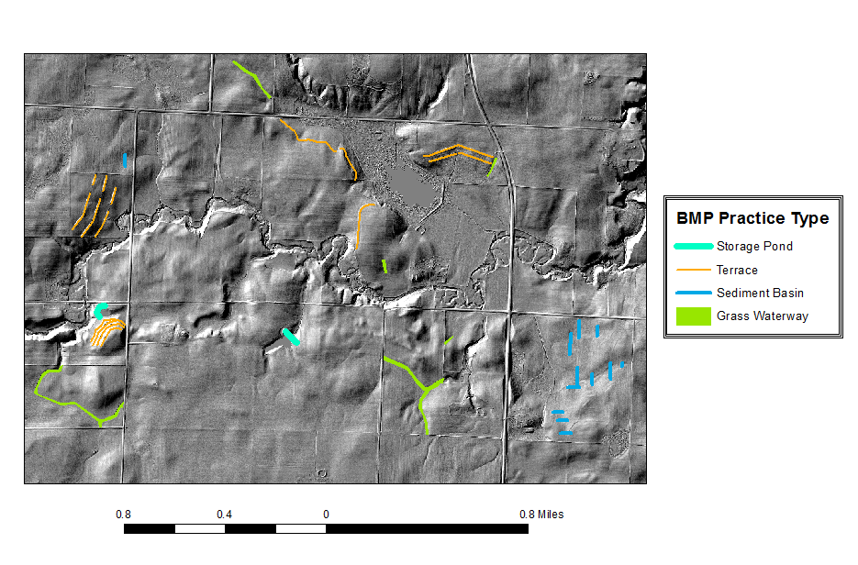

Figure 19. Example image from LiDAR mapping pilot project. (Source: BWSR)

#### Surveys, regulatory reports and inspections, and sales and private industry records

In April 2019, the USDA NASS released the 2017 U.S. Census of Agriculture: <https://www.nass.usda.gov/Publications/AgCensus/2017/index.php>. This Census is taken every five years to look at trends in all aspects of agriculture production for both animal and cropland agriculture. The results most relevant to this assessment of BMP adoption include the 2012 and 2017 census findings on conservation tillage and cover crops in Minnesota.

Nitrogen fertilizer-use farmer surveys are periodically conducted across Minnesota, with findings summarized in reports by the MDA. A survey instrument was developed specifically for the surveys which were conducted over the phone by enumerators from NASS. Reports from the surveys are available at: [www.mda.state.mn.us/nutrient-management-surveys](http://www.mda.state.mn.us/nutrient-management-surveys).

### Nutrient management efficiency (fertilizer and manure) practices

As discussed in the 2014 NRS, increasing the efficient use of fertilizers and manure is a fundamental strategy for reducing nutrient movement to waters.

Nutrient management efficiency practices selected for phosphorus and nitrogen reduction analysis in the 2014 NRS include applying recommended fertilizer rates, proper placement and timing of application, nitrification inhibitors, reducing soil phosphorus levels, and livestock feed management. Adoption levels of fertilizer and manure use-efficiency practices implemented from 2014 to 2018 were assessed using data from government tracking systems as well as overall indicators of adoption derived from fertilizer sales, nitrogen fertilizer use efficiency indices, and farmer fertilizer use survey data. While government programs can help to foster good nutrient management, the NRS suggests that private industry has the largest role to ensure the most efficient fertilizer and manure management practices.

#### Progress of nutrient management efficiency practice adoption through government programs

Nutrient management practices under NRCS’s conservation practice 590-standard focus on managing the amount (rate), source, placement (method of application), and timing of nutrients and soil amendments; 59,550 new acres of 590-standard nutrient management were newly enrolled through federal and state programs between 2014 and 2018 (Figure 18 and Table 12). Since 2014, annual new acres affected by government-support programs shows a marked decrease when compared to the preceding five years, and has not risen above 15,000 acres since 2013 (Figure 21). Existing data sources do not indicate how many acres continue with nutrient management BMPs after the contracts end (typically after three years). Additionally, the average acreage added annually under contract per year dropped substantially to 13,569 from 2014 to 2018 (compared to 107,640 acres per year during the previous 5-year period), due largely to NRCS EQIP enrollment reductions for this practice (Figure 21).

**2014 NRS recommended agricultural BMPs**

Increase fertilizer use efficiencies, emphasizing:

1. Nutrient management through reduction of nitrogen losses on corn following soybeans
2. Switch from fall to spring fertilizer applications (or use nitrification inhibitors)
3. Application of phosphorus in accordance with precision fertilizer and manure application techniques, including applications based on soil test results and University of Minnesota recommendations

**Manure management on feedlots**

When manure is part of the added nutrients to cropland, total manure and fertilizer additions are regulated by the MPCA and delegated county authorities through the Minnesota Feedlot Rules Chapter 7020. State and county inspections of manure spreading practices and records provide some insight into manure spreading BMP use. More information on feedlots and manure management on feedlots is provided in Section 5.

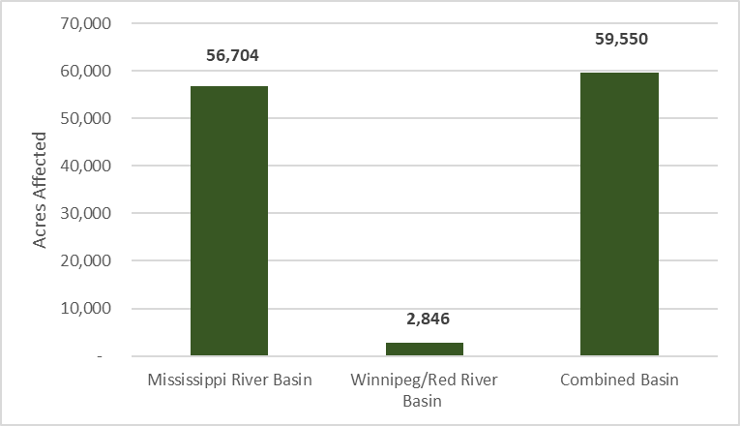

Figure 20. Total new acres for 590 nutrient management efficiency practices enrolled through government support programs from 2014 to 2018 (MPCA’s Healthier Watersheds BMP tracking system).

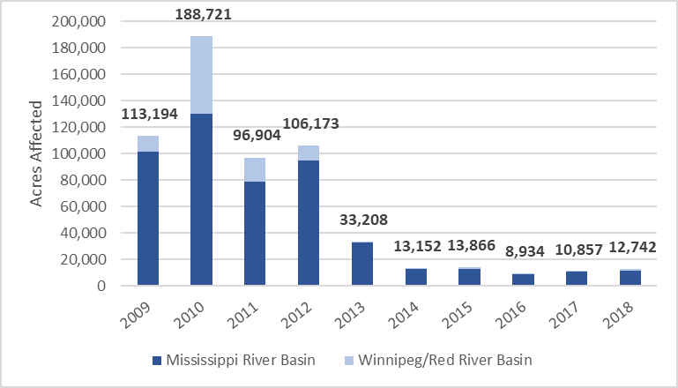

Figure 21. Annual new acres of 590 nutrient management efficiency practices added through government support programs, 2009 to 2018 (MPCA’s Healthier Watersheds BMP tracking system - NRS version).

Table 12. Acres of nutrient management efficiency practices enrolled through government support programs, 2014 to 2018 (MPCA’s Healthier Watersheds BMP tracking system)

|  |  |  |  |
| --- | --- | --- | --- |
|  | **Nutrient management**  **(CP 590)** | **Other nutrient management efficiency practices**  **(CP 102 and 104 plans)** | **Nutrient management efficiency practices – total acreage** |
| **Mississippi Basin** | 56,704 | 10,300 | 67,004 |
| **Red River Basin** | 2,846 | 936 | 3,782 |

#### Additional progress indicators of nitrogen management

Indicators that help describe nitrogen management on cropland include fertilizer sales, application rates, timing of fertilizer application, and use of nitrification inhibitors. These indicators are described below. Additional detail on changes to University of Minnesota recommended nitrogen fertilizer rates for corn, or the Maximum Return to Nitrogen (MRTN), since 2014 is provided in Appendix D.

**Fertilizer sales**

Fertilizer sales are tracked by the MDA. The sales data are not tracked in such a way to precisely know the sales in specific watersheds but are more useful at a statewide level. Grain production information when combined with fertilizer sales can provide indications of state-level fertilizer use efficiencies. Statewide, nitrogen fertilizer sales reached a peak in 2012, when grain prices were high and corn acres were elevated. Since 2012, fertilizer sales have trended downward slightly (approximately 1.3% per year) (Figure 22).

The nitrogen sales since 2014 are about 15% higher than the 25-year average. The average decadal sales in the 1990s were 593,000 tons per year, which was comparable to the 2000s at 588,000 tons per year. During the 2010s, sales have hovered near 700,000 tons per year. Fertilizer tonnage reporting prior to 2010 may have underrepresented actual sales during some years and the inter-annual variation may be due to reporting inaccuracies rather than actual variation in sales.

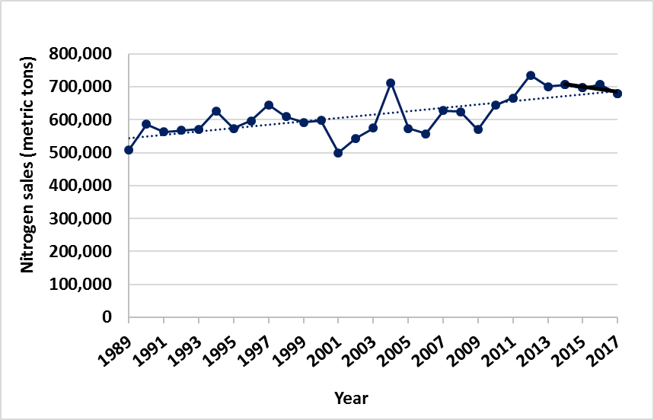

Figure 22. Annual nitrogen sales in fertilizer 1989 – 2017.

An index of nitrogen use efficiency is calculated by dividing total crop harvest yields by fertilizer sales. This index increased from 1992 to 2010, suggesting increased efficiency in nitrogen use, but has recently been lower or equivalent to the 2010 index (Figure 23). Nitrogen use on corn is used in the following example because approximately 75% of the fertilizer tonnage is used on corn acres. Corn yield gains have increased faster than the increase in nitrogen fertilizer application.

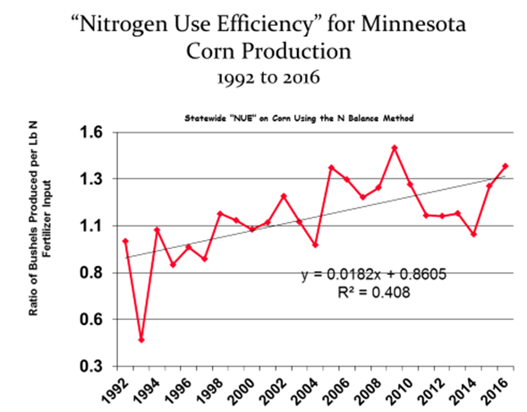

Figure 23. Nitrogen fertilizer use efficiency for corn 1992 – 2016 estimated based on statewide fertilizer sales and corn grain yield.

**Application rates**

Adherence to University of Minnesota guidelines on nitrogen rates for corn depends on the preceding crop. For example, on corn following corn, approximately 9% of the fields had application rates greater than 25 pounds nitrogen/acre (lb. N/ac) above the MRTN. For corn following soybean, that number is 25%. Excess nitrogen applications above the MRTN are higher yet when corn follows alfalfa in the rotation, or when manure is being applied. The fertilizer use rate information in this section is based on survey data collected by NASS and reported by MDA: <https://www.mda.state.mn.us/nutrient-management-surveys>.

*Corn following corn*

The statewide average nitrogen fertilizer application rate for corn following corn was 161, 160 and 153 lb. N/ac based on the 2010, 2012 and 2014 surveys, suggesting a possible slight decreasing trend in application rates. The data are based on 665, 589 and 414 fields for 2010, 2012 and 2014, respectively. A summary of fertilizer rates for corn following corn from the surveys is shown in Figure 24. None of the fields were reported to have received manure for two years or more prior to the cropping year represented by the survey. Also shown in Figure 24 are the approximate University of Minnesota nitrogen fertilizer rate ranges for 2006, 2016 and 2019 (for the 0.10 ratio of fertilizer cost to corn value). Across the three surveys, 55%, 63% and 77% of the fields were at or below the University of Minnesota’s recommended rates from 2006, 2016 and 2019, respectively.

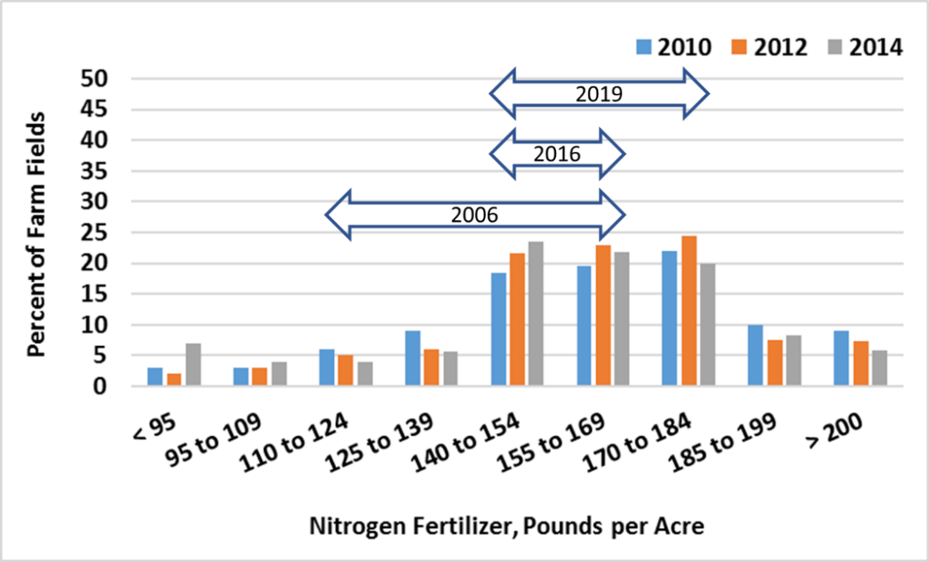

Figure 24. Distribution of nitrogen fertilizer rates from the 2010, 2012 and 2014 surveys for corn after corn. The nitrogen fertilizer rate ranges suggested by the University of Minnesota in 2006, 2016 and 2019 are approximated with the double-arrows.

*Corn following soybean*

The statewide average nitrogen fertilizer application rate for corn following soybean was 148, 144 and 144 lb. N/ac based on the 2010, 2012 and 2014 surveys (Figure 25). None of the fields were reported to have received manure for two years or more. Across the three surveys, 19%, 22% and 42% of the fields were at or below the University of Minnesota’s recommended rates from 2006, 2016 and 2019, respectively. Across the three surveys, 48%, 37% and 15% of the fields had more than 25 lb. N/ac applied in excess of the University of Minnesota’s recommended rates from 2006, 2016 and 2019, respectively.

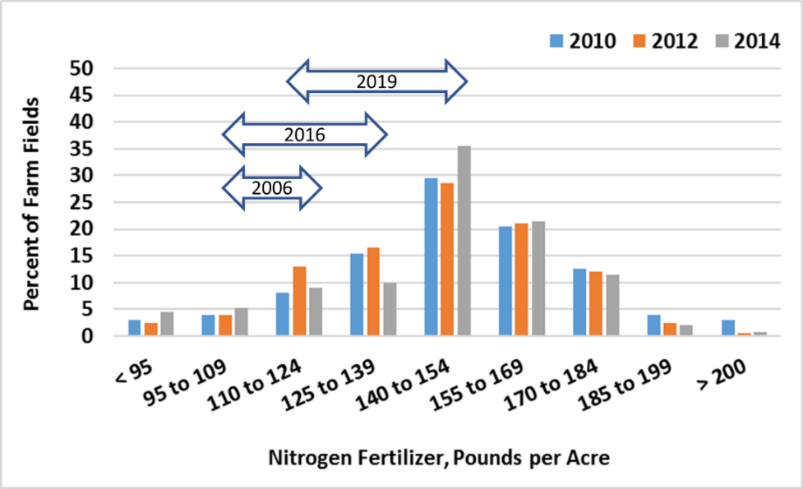

Figure 25. Distribution of nitrogen fertilizer rates from the 2010, 2012 and 2014 surveys for corn after soybean. The nitrogen fertilizer rates suggested by the University of Minnesota in 2006, 2016 and 2019 are approximated with the double-arrows.

*Corn following small grain*

The statewide average nitrogen fertilizer application rate for corn after small grains (wheat, barley, and rye) was 122, 127 and 119 lb. N/ac based on the 2010, 2012 and 2014 surveys. Across the three surveys, over 90% of the fields were at or below the University of Minnesota’s recommended MRTN of 155 lb. N/ac.

*Corn following manure*

The statewide average nitrogen application rates for corn receiving manure were 173, 196 and 184 lb. N/ac based on the 2010, 2012 and 2014 surveys. This includes nitrogen sources from both manure and commercial fertilizer. The manure was field-applied either the previous fall, in the spring or within the growing season. The distribution of total nitrogen application rates on corn receiving manure from the 2014 survey is shown in Figure 26. The nitrogen inputs include manure and inorganic fertilizer. The average nitrogen inputs were 120 and 67 lb. N/ac from manure and fertilizer, respectively. Nearly half of the fields with manure received total nitrogen additions exceeding 200 lb./ac. The maximum of the range recommended for manured fields with corn following corn is 215 lb./ac (0.05 ratio U of MN published rates in 2019), and the maximum of the recommended range for corn following soybeans is 165 lb./ac. The survey did not determine how the manured-field nitrogen rates were different for these rotations.

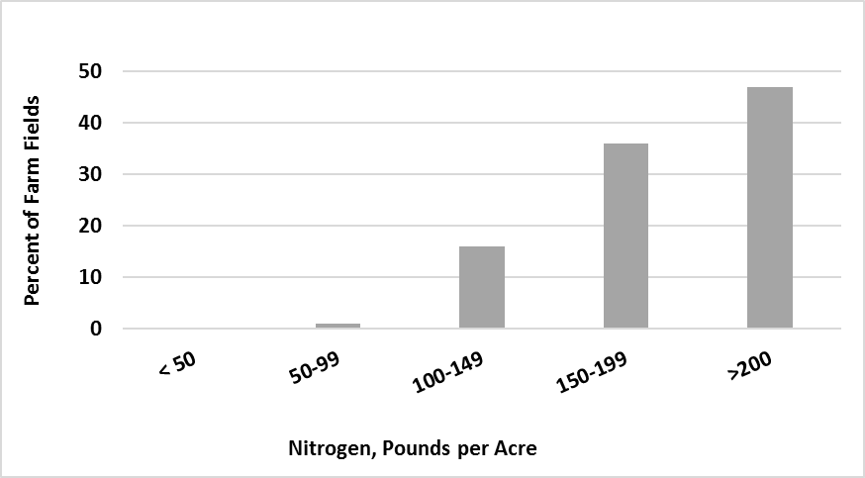

Figure 26. Distribution of total nitrogen application on corn fields receiving manure from 2014.

**Nitrogen inputs include manure and supplemental nitrogen.**

**Timing of fertilizer application**

The risk of inorganic nitrogen loss typically increases as the time from application to crop uptake increases. For this reason, it is common to use higher nitrogen rates (additional 10-30 lb./ac) for fall application compared to spring applications in the same region. Even under optimal weather conditions, some fall-applied nitrogen will usually be lost either through leaching or denitrification by the time the crop starts uptake.

According to the 2014 survey, approximately 27%, 63% and 10% of nitrogen is applied in the fall, spring (either pre-plant or at planting), or in a split or side-dress application, respectively. The vast majority of the fall-applied acres are in the western and the south-central BMP Regions (Bierman 2011), where fall application of nitrogen fertilizer is a recommended BMP.

Anhydrous ammonia (AA) is considered a good nitrogen source for crop production and is generally the best option for fall application of nitrogen fertilizer. It is less likely to be lost compared to other nitrogen sources since AA immediately after injection converts to ammonium which is retained on the soil cation exchange sites. The injection of AA also causes a temporary inhibition of soil microbes (IPNI 2012). This delays the conversion of ammonium to nitrate which further reduces the risk of leaching losses. Urea is another good nitrogen fertilizer source. In the soil, urea is converted to ammonium, but lacks the nitrification inhibition properties of AA and is more prone to volatilization and leaching losses if not managed properly. Nitrogen solutions (UAN) contain nitrogen in the urea, ammonium and nitrate forms. Because these forms of nitrogen can be readily lost to volatilization or leaching if not managed properly, UAN is frequently banded or injected at planting, used for in-season nitrogen applications or added to irrigation water.

Anhydrous ammonia sales have dropped substantially over the past 25 years (Figure 27). Reasons for the decrease are safety concerns, increasing regulations, and cost. Additionally, it is a difficult product to manage within precision type applications and in no-till systems. Urea sales have steadily increased and have taken up much of the marketplace sales reductions in AA.

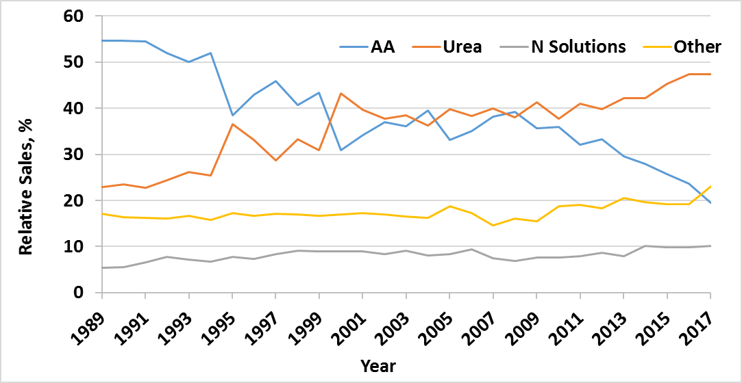

Figure 27. Sales trends for the three major nitrogen fertilizer sources. AA is anhydrous ammonia. Other sources include custom dry blends of fertilizer.

A complicating factor for timing of nitrogen fertilizer application is secondary nitrogen sources. Secondary nitrogen sources typically include ammonium-containing products for phosphorus and sulfur application, such as MAP (mono-ammonium phosphate), DAP (diammonium phosphate) or ammonium sulfate. In 2014 (most recent data), MAP and DAP account for 13% of the nitrogen applied from fertilizer. An additional 7% comes from other sources including sulfur fertilizer products. Approximately one-third of these products are typically applied in the fall, which is consistent with University of Minnesota BMPs. For areas with high loss potential, including areas with coarse textured soils or high rainfall, the University of Minnesota BMPs does not recommend fall nitrogen applications, regardless of source (including MAP and DAP).

**Use of nitrification inhibitors**

In areas of the state with high nitrogen fertilizer loss potential, it is a University of Minnesota recommended BMP to use nitrification inhibitors to help minimize nitrate losses. Nitrification inhibitors delay the conversion of ammonium to nitrate thereby minimizing the risk of nitrogen leaching losses. There are several nitrification inhibitors available with different modes of action. While many of these products have been rigorously tested and their performance has been verified through independent research, other products lack this testing under neutral research conditions. It continues to be a challenge, therefore, to accurately assess the benefit of some of the products that claim to be nitrification inhibitors.

Currently the state does not have a sales tracking program to collect information about the use of nitrogen enhancement or inhibitor type products in Minnesota. However, because the organic compound nitrapyrin, a commonly used nitrification inhibitor sold under such trade names as “N-Serve” and “Instinct” is considered a restricted use pesticide, its sales numbers are reported (Figure 28). When corn prices were peaking around 2010 to 2012, nitrapyrin sales (statewide) increased dramatically, but have leveled off at around 550,000 pounds per year since 2014. Using the labeled application rate of approximately 0.5 lb. of active ingredient per acre, the MDA estimates around 1,100,000 acres are treated each year with nitrapyrin alone, corresponding to approximately one-eighth of all corn acres.

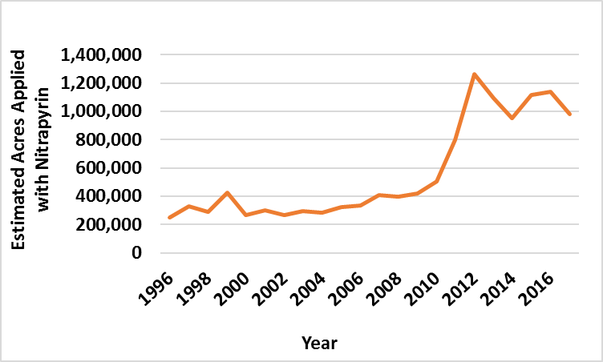

Figure 28. Estimated number of acres treated with the nitrification inhibitor nitrapyrin each year 1996 – 2017.

**Estimates are based on annual sale reports and the label application rate of one-half pound of active ingredient per acre.**

There are regional differences in the use of nitrogen inhibitors. In regions of the state with higher leaching potential such as coarse textured soils or high rainfall amounts, fall application of nitrogen fertilizer is not a recommended BMP. For the southcentral BMP region of the state, which is a transition between the wetter eastern region and the drier western regions, the recommended practice for fall application is using anhydrous ammonia with N-Serve (nitrapyrin). The loss potential in the northwest, southwest and west-central regions is lower compared to the other BMP regions further to the east. For this reason, the BMPs do not suggest nitrification inhibitor use in western Minnesota. For fall applied anhydrous ammonia in 2012 for the 2013 corn crop, 60% and 12% of survey respondents in the south central region indicated all and some of fall-applied AA included nitrapyrin, respectively. Corn acres treated with nitrapyrin were low in the northwest and southwest/west-central regions (Figure 29).

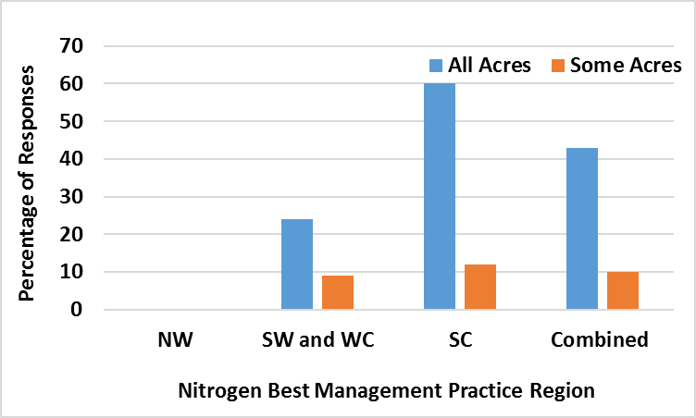

Figure 29. Percent of respondents that used nitrapyrin with fall applied anhydrous ammonia in 2012 for the 2013 corn crop. NW = northwestern MN; SW = southwestern MN; WC = west central; SC = south central MN; Combined = all regions.

#### Additional progress indicators of phosphorus management

Phosphorus fertilizer sales and soil phosphorus tests provide indicators of changes in phosphorus management. Phosphorus sales have remained nearly flat since 2014. Sales decreased in 2014 and 2015 and have slowly been rebounding since then (Figure 30). The average annual sale of phosphorus fertilizer increased by approximately 25% between 1989 and 2010.

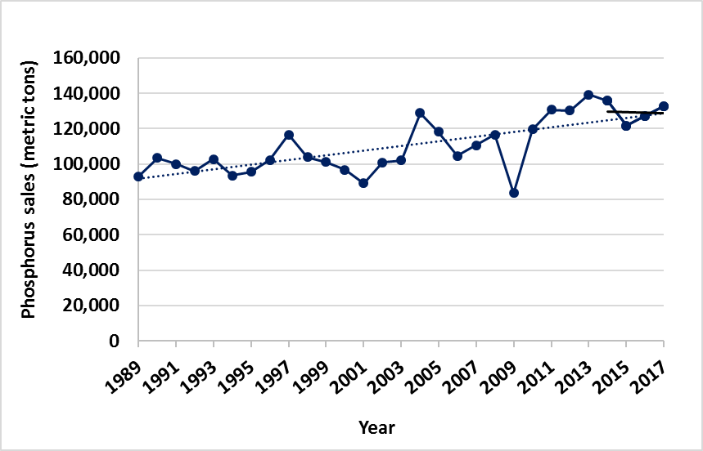

Figure 30. Annual phosphorus sales (as elemental P) during 1989 – 2017.

The phosphorus application rates suggested by the University of Minnesota Extension are based on the expected crop yield and soil phosphorus levels determined through soil sample analysis. Figure 31 shows the distribution of Minnesota phosphorus soil test levels tracked by the International Plant Nutrition Institute (IPNI) for samples collected in 2001, 2005, 2010 and 2015 (IPNI 2019). Soil test levels between 20-25 ppm (Bray P1) are normally considered optimum for corn production. No additional phosphorus application is typically suggested above 25 parts per million (ppm) (University of Minnesota Extension 2019). The change in relative frequency from 2001 to 2015 in Figure 32 shows a trend towards higher soil phosphorus levels. For example, more fields show high levels of phosphorus (above 25 ppm) in 2015, as compared to other earlier years. However, considering that the tested fields are not selected from a random sampling, statistically valid conclusions are not possible.

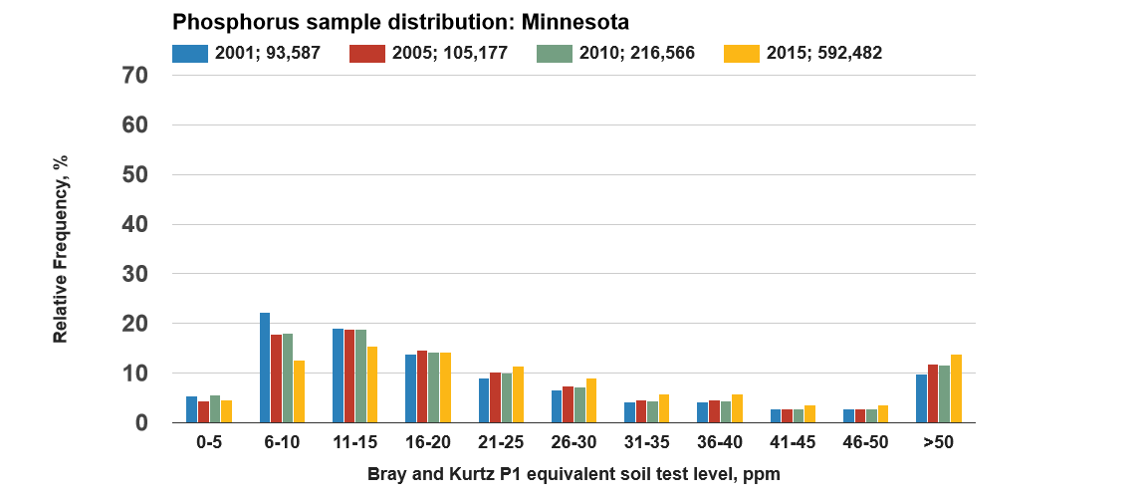

Figure 31. Frequency of phosphorus level in soil samples from Minnesota for 2001, 2005, 2010 and 2015. Soil test levels between 20-25 ppm are normally considered optimum for corn production.

**Source: IPNI 2019.**

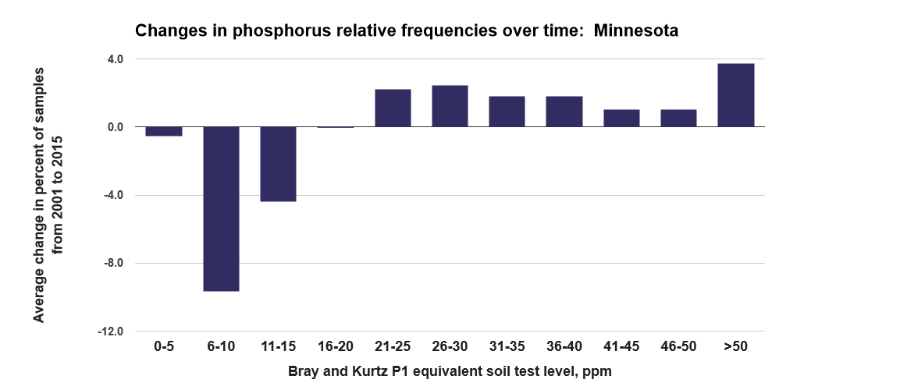

Figure 32. Change in relative frequency of soil phosphorus tests from 2001 to 2015. Source: IPNI 2019.

**Summary of Minnesota’s Progress on Nutrient Management Efficiency**

**Why important**

* Nutrient management efficiency gains are among the most economically profitable ways to achieve nutrient reductions. The NRS scenario is to improve nutrient management efficiency on roughly 6.8 million acres.
* This type of change is often accomplished outside of government program funding, and it is important to consider a variety of progress indicators apart from government programs.

**Findings**

* Government-funded fertilizer/nutrient management practice (i.e., 590 standard) acreages have decreased considerably in recent years.
* Fertilizer use surveys for corn lands showed fairly constant nitrogen rates from 2010 to 2014, with over 35% of corn/soybean rotation fields having received nitrogen rates exceeding the upper end of the recently increased University of Minnesota corn N rate recommendations.
* Statewide, nitrogen and phosphorus fertilizer sales have leveled off during recent years and have started to decrease but remain higher than sales during years prior to 2012. Phosphorus fertilizer sales are 25% higher now than in 1989.
* Nitrogen fertilizer use has shifted in recent years to forms that are more challenging to prevent losses to water, especially when applied during the fall.
* Soil phosphorus test results are showing more fields testing very high. It is unknown if this is an actual increase or otherwise just represents an increasing emphasis to re-test fields previously found to have high soil phosphorus.
* None of the indicators of nutrient management practice adoption show changes during the past five to ten years expected to yield measurable nutrient reductions to surface waters at a large scale.

**Follow-up**

* More work is needed to identify improved fertilizer and manure use BMP metrics to track progress with such practices as subsurface banding of phosphorus and split application of nitrogen.
* Continue programs that create greater awareness of the connections between nitrogen fertilizer efficiency, farm profitability and water quality protection.
* Gain a better understanding of the current potential for improving nutrient use efficiency and how to overcome barriers for making such improvements.
* Minnesota’s new Groundwater Protection Rule should move the state toward greater nitrogen fertilizer efficiencies in geographic areas with vulnerable groundwater. The lessons learned from these areas can be applied to other geographic areas.

### Living cover practices

As discussed in the 2014 NRS, the additional use of vegetative cover during fall and spring months provides protection from soil erosion during times of the year when crops are not in place or of sufficient size. Perennials and cover crop roots capture nitrate that is moving through the soil, preventing it from leaching to tile waters or groundwater. These practices can also improve soil health by increasing soil organic matter, and thereby hold more water in the soil and reduce runoff.

**2014 NRS recommended agricultural BMPs**

Increase and target living cover, emphasizing**:**

1. Cover crops on fallow and short season crops such as sweet corn, corn silage, peas, small grains, and potatoes
2. Perennials in riparian zones and on marginal cropland
3. Research and development of marketable cover crops to be grown on corn and soybean fields
4. Research and development of perennial energy crop(s)

Living cover practices selected for phosphorus and nitrogen reduction analysis in Chapter 5 of the 2014 NRS include cover crops, perennial buffers, forage and biomass planting, perennial energy crops, and conservation easements and land retirement. Other living cover agricultural BMPs, including conservation cover, conservation crop rotation, critical area planting, and filter strips, can be used to achieve similar benefits. Adoption levels of living cover practices since 2014 were assessed using information tracking systems of practices installed through government program support, along with overall indicators of adoption provided by the U.S. Census of Agriculture and satellite imagery.

#### Progress of living cover practice adoption through government programs

Statewide living cover acres tracked by the MPCA’s Healthier Watersheds website and those acres enrolled in the CRP, together provide a summary of living cover practices being adopted through government programs.

Estimated non-CRP government program acreages affected by newly funded living cover practices (adopted and tracked through the state and federal government programs) are shown in Figure 33 and Table 13. A marked increase in acreage occurred from 2015 to 2017, coinciding with additional NRCS cover crop funds through EQIP. The recently added cover crop acreages are considerably higher than added acreages of perennials. The total acres of non-CRP living cover practices installed varies greatly from year to year (Figure 34).

Many increases in living cover practices resulted from concerted local watershed efforts. For example, the Cannon River Watershed Partnership contracted with farmers for cover crop planting on 11,870 acres in the Cannon River Watershed. For more information on the cover crop program and for an interactive map of cover crop installations see: <https://crwp.net/conservation/cover-crops/>

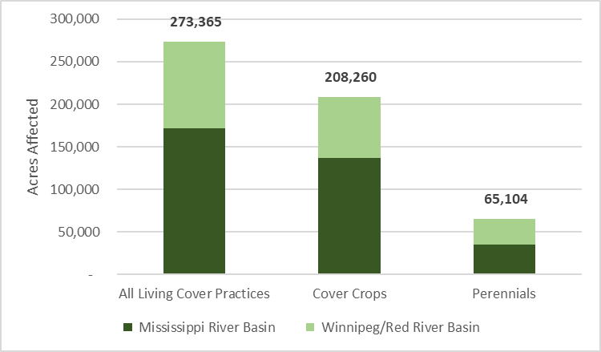

Figure 33. Acres affected by new living cover practices funded by non-CRP government programs from 2014 to 2018 (MPCA’s Healthier Watersheds BMP tracking system).

*Perennials include conservation cover, conservation crop rotation, conservation easements, critical area planting, filter strip, forage and biomass planting, riparian herbaceous cover, and windbreak/shelterbelt establishment.

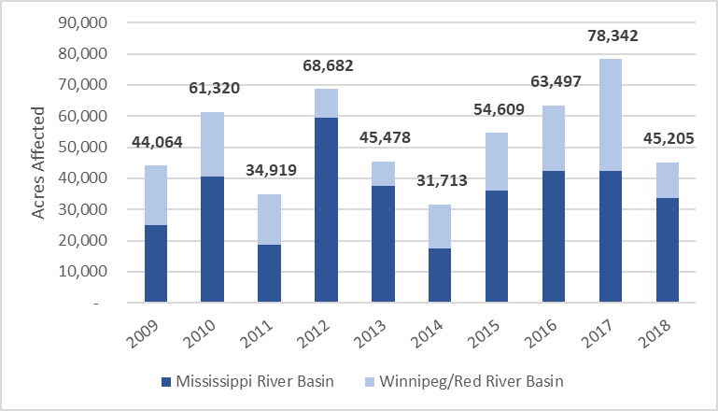

Figure 34. Acres affected by new living cover practices funded by non-CRP government programs from 2009 to 2018 (MPCA’s Healthier Watersheds BMP tracking system).

Table 13. Acres of living cover practices 2014 to 2018 funded from non-CRP government programs (MPCA’s Healthier Watersheds BMP tracking system).

|  |  |  |  |
| --- | --- | --- | --- |
|  | **2014-2018 Cover crops** | **2014-2018 Perennials a** | **Living cover practices (non-CRP) – total acreage affected** |
| **Mississippi Basin** | 136,673 | 35,319 | 171,992 |
| **Red River Basin** | 71,588 | 29,785 | 101,373 |

a. Perennials include conservation cover, conservation crop rotation, conservation easements, critical area planting, filter strip, riparian forest buffer, riparian herbaceous cover, forage and biomass plantings. This table does not include CRP perennials.

The CRP has historically supported much of the planted perennials in agricultural areas of the state. The CRP is a voluntary program that helps agricultural producers safeguard environmentally sensitive land. CRP participants plant long-term, resource-conserving covers to improve water quality, control soil erosion, and enhance wildlife habitat. In return, Farm Service Agency provides participants with rental payments and cost-share assistance.

Minnesota agricultural land enrolled in USDA’s CRP peaked in the 1993 to 1995 and 2007 to 2008 periods, with about 1.8 million acres under contract each year during those timeframes (Figure 35). Minnesota CRP enrolled acreage has dropped from 2008 to 2015 and leveled off with a 2018 enrollment of 1.14 million acres. CRP enrollment during the 2014 to 2018 period averaged 1.17 million acres, 28% lower than the long-term 1987 to 2013 average enrollment. Between 2014 and 2018, the number of CRP acres enrolled decreased by 163,000 acres. Most of this recent drop occurred between 2014 and 2015, with relatively stable CRP total enrollment between 2015 and 2018.

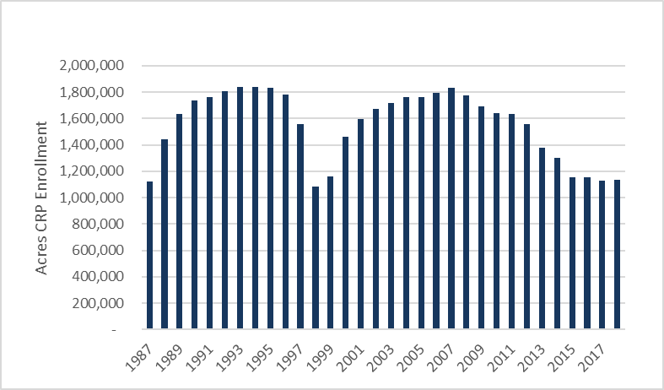

Figure 35. Annual **CRP enrollment (1987 to 2018; www.fsa.usda.gov).**

#### Additional progress information on living cover practice adoption

Information from farmer surveys and satellite imagery can provide additional information on the overall adoption trends for living cover practices.

**Cover crops – non-government programs**

Two main information sources exist to estimate overall state-level cover crop planting and establishment acreage estimations: the U.S. Census of Agriculture and satellite imagery. The U.S. Census of Agriculture provides survey results of cover crop acreages planted. Both the University of Minnesota (working in partnership with BWSR) and The CTIC OpTIS have been evaluating successful growth of cover crop acreages through satellite imagery. Actual acres of cover crops that emerge or germinate are typically less than the acres planted.

Based on the U.S. Census of Agriculture, between 2012 and 2017, cover crops planted in the state of Minnesota increased by more than 171,000 acres for a total of 579,147 acres in 2017, a 5-year increase of 41%, showing cover crop planting on just under 3% of all cropland in Minnesota. By comparison, government programs supported the addition of 260,954 acres of cover crops over that same 2012 to 2017 timeframe. Some of the cover crop acres tracked through government programs may have dropped out of the program after contract periods ended.

Satellite imagery analysis conducted by the University of Minnesota and BWSR provides an indication of cover crop acreages over southern Minnesota. Example outputs in Figure 36 show cover crops by county growing in fall of 2016, with a total of 214,000 acres. The 2016 outputs can also be viewed for major and minor watersheds. Estimates for cover crop acreage in the fall of 2017 and 2018 were limited because of difficult harvest conditions and early (November) onset of snow cover during those growing years in parts of Minnesota. These conditions made it difficult to get consistent results for cover crops using remote sensing satellite imagery. The University of Minnesota is currently exploring additional techniques to use other satellite-derived data products from synthetic aperture radar, which is less sensitive to cloud cover. This Minnesota-specific assessment with considerable in-state field validation shows promise for assessing long-term cover crop acreage trends.

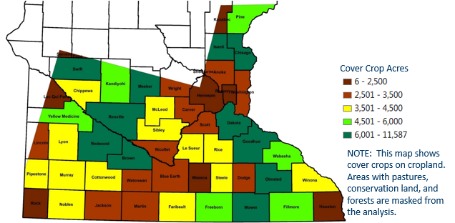

Figure 36. Cover crop acres estimated using satellite imagery, Fall 2016. (University of Minnesota Soil, Water and Climate Department, and BWSR).

Satellite imagery analysis conducted through the CTIC OpTIS program at the CTIC at Purdue University show that 1.2% of corn and soybeans, on average, had vegetative cover in the winter time between 2005 to 2013 (cover crops, winter annuals or perennials). This percentage has remained about the same in the past five years (2014 to 2018), averaging 1.0%. Cover crops on small grains have been increasing and show up on over 11% of small grains statewide. According to the OpTIS program, established cover crop and winter annual crop acreages between 2014 to 2018 averaged 154,883 acres in Minnesota.

Continued work in the next five years will be undertaken to better understand the differences between these datasets and compare the methodologies and assumptions so that the most accurate and cost-effective way of estimating cover crop changes over time can be used.

The various cover crop measurements in Minnesota are not directly comparable. Based on the combined information, it appears that cover crop acreages are increasing, with total planted acres exceeding a half-million and total established cover crops exceeding 200,000 acres during at least some recent years. Depending on the climate conditions and other factors, not all planted acres of cover crops become well-enough established to be detected through the satellite imagery techniques.

**Perennials**

Trends in large-scale perennial changes can be approximated using satellite-derived land cover datasets, specifically the Cropland Data Layer (CDL) as well as farmer surveys. The U.S. Census of Agriculture shows a decrease in hay (defined as forage and including hay and all haylage, grass silage, and greenchop) between the years 2012 to 2017, indicating a 3.4% decrease (Table 14). The U.S. Census of Agriculture also summarizes information related to land currently under conservation easements, indicating an 11% decrease.

Land cover data between the years 2012 to 2018 were also summarized to determine trends in grasses, pasture, and hay. The total statewide CDL estimates of grass/pasture plus hay/haylage has gradually increased by 6.7% (300,000 acres) between the years 2014 to 2018 as shown in Figure 37. Hay/haylage acreages decreased and grass/pasture increased, with a net gain in the combination of perennials.

Table 14. Acres of perennial crops based on U.S. Census of Agriculture (2012 to 2017).

|  |  |  |  |
| --- | --- | --- | --- |
| **Practice** | **2012 Acres** | **2017 Acres** | **Change 2012 to 2017** |
| Hay (forage and including hay and all haylage, grass silage, and greenchop) a | 1,499,586 | 1,448,195 | Decreased 51,391 acres |
| Conservation Easements b | 244,482 | 218,215 | Decreased 26,267 acres |

1. Source: USDA NASS U.S. Census of Agriculture, Table 35 – Minnesota Specified Crops by Acres Harvested
2. Source: USDA NASS U.S. Census of Agriculture, Table 47 – Minnesota Land Use Practices

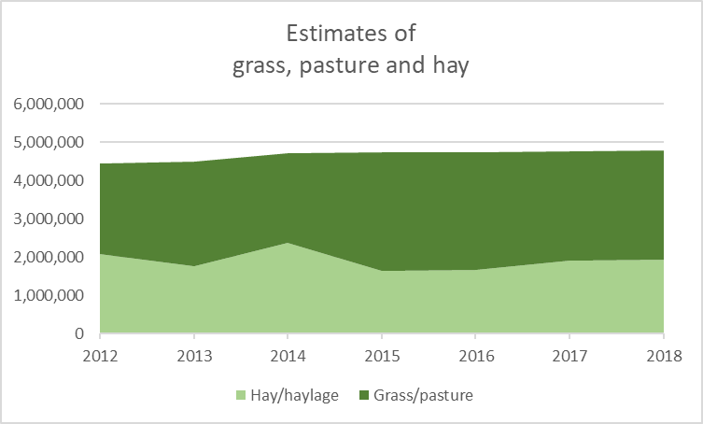

**Figure 37. Estimates of grass, pasture, and hay in Minnesota from 2012-18 (Cropland Data Layer).**

**Summary of Minnesota’s Progress on Living Cover Practices**

**Why important**

* The NRS anticipated that the first five years of living cover practices would be largely focused on research and development, and that larger changes would mostly occur after the first five to 10 years.
* Living cover practices are essential for meeting both milestone and long term NRS goals.

The NRS set interim targets of 2.2 million acres of new cover crops (largely on early harvest crops) and 440,000 acres of perennial crops and buffers in high priority areas.

**Findings**

* Some indicators suggest progress with living cover practices; however, adoption rates do not appear to be on track for meeting the needs outlined for 2014 NRS milestone scenario.
  + On average, 40,000 acres of cover crops have been added per year to major basins through government cost-share programs since 2014. Relatively little progress is being made with cover crops on corn/soybean rotations, with an estimated 1 to 1.5% of corn/soybean land currently with cover crops.
  + CRP enrollment remains over 1.1 million acres and has been fairly stable since 2015. However, CRP acreages during the past five years have been lower than most years since 1987.
  + Perennials added through government cost-assistance programs (apart from CRP) affected an average of 13,000 new acres per year between 2014 and 2018.
  + Statewide grass/hay/pasture perennial acreages have been fairly stable since 2014, with indications of slight decreases in hay and increases in grasses/pasture.

**Follow-up**

* Recent living cover initiatives need to continue while socio-economic information is evaluated to determine how to scale-up adoption rates.
* State water and climate resiliency plans and strategies should be integrated with 2014 NRS goals to work in concert toward new and expanded approaches to vastly increase living cover over the next five years.

### Field erosion control practices

As stated in the 2014 NRS, field erosion control is one of the most effective methods for limiting export of cropland total phosphorus, although certain practices in some places can increase losses of the dissolved portion of phosphorus. Field erosion control practices selected for phosphorus reduction analysis in Chapter 5 of the 2014 NRS emphasized conservation tillage and residue management, terraces, grassed waterways, and sediment control basins, while recognizing that many other practices are important and effective for reducing cropland field erosion and associated phosphorus losses.

**2014 NRS recommended agricultural BMPs**

Field erosion control, emphasizing:

1. Tillage practices that leave more than 30% crop residue cover or alternative erosion control practices that provide equivalent protection
2. Grassed waterways and structural practices for runoff control

Adoption levels of field erosion control practices implemented in Minnesota between 2014 and 2018 were assessed using information from government program data bases, along with overall indicators of adoption through satellite imagery and the U.S. Census of Agriculture.

#### Progress of field erosion control practice adoption through government programs

Figure 38 and Table 15 provide a summary of field erosion control practices installed through government programs from 2014 to 2018 by major basin as tracked in the MPCA Healthier Watersheds program (NRS version found at: [https://public.tableau.com/profile/mpca.data.services#!/vizhome/MinnesotaNutrientReductionStrategyBMPSummary/MinnesotaNutrientReductionStrategyBMPSummary](https://gcc01.safelinks.protection.outlook.com/?url=https%3A%2F%2Fpublic.tableau.com%2Fprofile%2Fmpca.data.services%23!%2Fvizhome%2FMinnesotaNutrientReductionStrategyBMPSummary%2FMinnesotaNutrientReductionStrategyBMPSummary&data=02%7C01%7Cdavid.wall%40state.mn.us%7C7dc1eae4861b4fb9231b08d7bba39e0a%7Ceb14b04624c445198f26b89c2159828c%7C0%7C0%7C637184183706432952&sdata=OzY0oWr3O9SLUI8y0VBPWTHRTn1VdWj7EBPCQNRwvZo%3D&reserved=0)). Most acres installed were residue and tillage management practices. Annual additions of new acreages of field erosion control practices decreased steadily from 2009 to 2013. In 2014, a slight recovery began, and in 2018 increases in agricultural loans for reduced tillage equipment increased the estimated new acres of adoption (Figure 39).

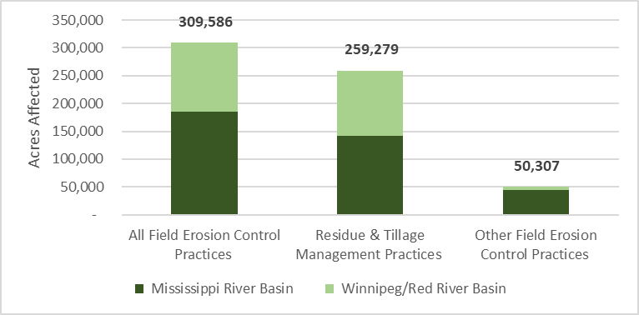

Figure 38. New acres for field erosion control practices enrolled through government programs, 2014 to 2018 (MPCA’s Healthier Watersheds BMP tracking system).

*Other erosion control include: alternative tile intakes, contour buffer strips, field borders, grassed waterways, mulching, sediment basins, stripcropping, terraces, water and sediment control basins. Residue and tillage management practices include no-till/strip till, reduced till, and ridge till practices.

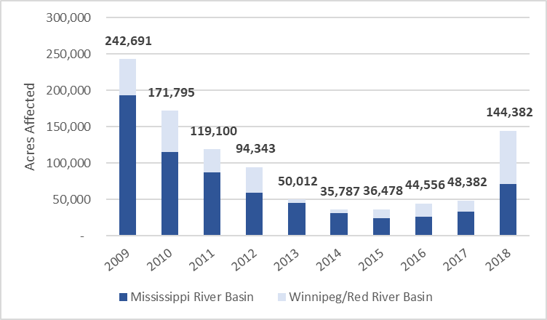

Figure 39. New acres of field erosion control practices added through government support programs 2009  
to 2018 (MPCA’s Healthier Watersheds BMP tracking system).

Table 15. Acres of field erosion control practices enrolled through government support programs, 2014 to 2018 (MPCA’s Healthier Watersheds BMP tracking system).

|  |  |  |  |
| --- | --- | --- | --- |
|  | **2014-2018**  **Residue and tillage management practices** | **2014-2018**  **Other field erosion control practices** | **Field erosion control – total acreage affected** |
| **Mississippi Basin** | 141,506 | 44,185 | 185,691 |
| **Red River Basin** | 117,773 | 6,122 | 123,896 |

#### Additional progress information on field erosion control practice adoption

Table 16 provides a comparison of tillage practices in Minnesota using the U.S. Census of Agriculture data from 2012 and 2017. The comparison of data from each census shows an increase in conservation tillage acres and a corresponding decrease of conventional tillage acres.

Table 16. Minnesota tillage practices (2012 and 2017).

|  |  |  |  |
| --- | --- | --- | --- |
| **Practice** | **2012 Acres** | **2017 Acres** | **Change 2012 to 2017** |
| No-Till Practices Used | 818,754 | 1,091,337 | Increased 272,583 acres |
| Reduced Tillage/Conservation Tillage | 6,109,886 | 8,214,896 | Increased 2,105,010 acres |
| Intensive/Conventional Tillage | 11,517,373 | 9,499,259 | Decreased 2,018,114 acres |

Source: USDA NASS U.S. Census of Agriculture, Table 47 – Minnesota Land Use Practices

No-till practices used. Using no-till or minimum till is a practice used for weed control and helps reduce weed seed germination by not disturbing the soil.

Reduced tillage. Conserves the soil by reducing erosion and decreasing water pollution. In 2012 this category was labeled conservation tillage. This is a wording change only; data are comparable.

Intensive/conventional tillage. Refers to tillage operations that use standard practices for a specific location and crop to bury crop residues. In 2012, this category was labeled conventional tillage.

Satellite imagery analysis conducted by the BWSR and University of Minnesota shows 2017 crop residue levels between 16 and 50% over most of the cropland regions of the state (Figure 40). The fraction of land with over 30% residue cover varies spatially and is lowest in south-central Minnesota and parts of northwestern Minnesota where land slope is generally lower.

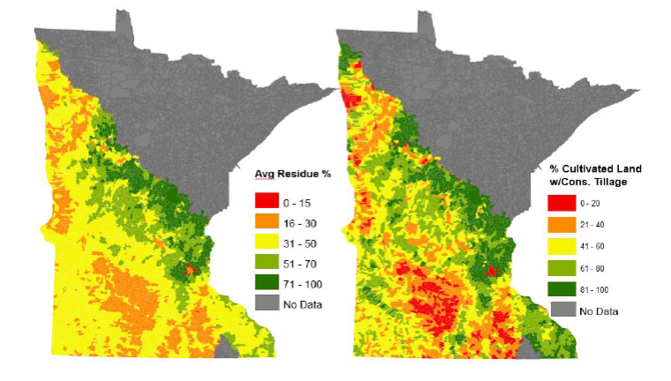

**Figure 40. Average crop residue and conservation tillage by subwatershed in 2017**

**Data source University of Minnesota (Soil, Water and Climate Dept.) and BWSR.**

Satellite imagery analysis conducted through the OpTIS program at the CTIC at Purdue University shows historical conservation tillage adoption data over time from 2009 to 2018 (Figure 41). The University of Minnesota compared the outputs of the remote sensing work shown above with the recently released information from the OpTIS program. For this comparison, the University of Minnesota used residue estimates for spring of 2017 based on Landsat 8 and Sentinel 2 imagery. Results between the Tillage and Erosion Survey Project estimates and the OpTIS estimates show relative consistency for cropland percentages falling in the four categories of residue cover, but OpTIS results reported higher acreage of crops grown, as shown in Figure 42. Future analysis will help explain the correlation between the estimates from each of these projects.

**Figure 41. Acres in conservation tillage in Minnesota based on satellite imagery (OpTIS).**

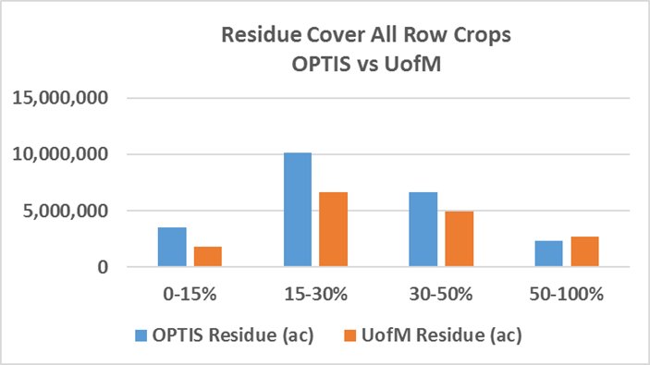

Figure 42. Comparison of residue cover on all row crops for 2016 (y-axis represents acres).

**Summary of Minnesota’s Progress on Field Erosion Control**

**Why important**

* Conservation tillage, reduced tillage and no-till are common practices throughout Minnesota, with conservation tillage (>30% residue) or no-till on nearly half of cropland acres.
* While considerable progress was achieved with soil erosion control through past decades, crop residue surveys conducted prior to the NRS indicated considerable room for additional progress. An additional 4.9 million acres of erosion control acreage increases was called for in the NRS scenario due to its importance for phosphorus loss reductions, relatively low cost, and multiple benefits for also soil health, carbon storage, and keeping sediment out of waters.
* Tracking progress with soil erosion control practices is important to better plan for future strategy implementation goals and approaches.

**Findings**

* The rate of new erosion control practice additions appears to have decreased in recent years. An average of 60,000 acres of field erosion practices have been added annually through government cost-share and equipment-funding programs. The vast majority of these affected acres are residue management practices. Not all of these acreages will continue with conservation tillage after the contracted period ends.
* Satellite imagery through OpTIS and University of Minnesota studies shows 8-9 million acres of land with over 30% residue cover. This is generally consistent with the U.S. Census of Agriculture findings in 2017 of 9.3 million acres of conservation tillage plus no-till.
* Satellite imagery suggests about the same acreage of conservation tillage in 2012 and 2017. However, 2017 census information shows a substantial increase in conservation tillage/reduced tillage (on average adding 475,000 acres per year) between 2012 and 2017. If the census information reflects a real increase, it is predominantly outside of government assistance programs, since the total acreage in government programs during that timeframe represents only a small fraction of the census reported increase.

**Follow-up**

* Minnesota will continue tracking residue cover practices with satellite imagery and reconcile differences between census survey information and aerial imagery techniques.
* Since initial work to map structural conservation BMPs using LiDAR imagery has proven successful in providing a more complete picture of cumulative practices over the years, continuation of this work to statewide levels should be explored.

### Tile drainage water treatment and storage practices

As discussed in the 2014 NRS, nitrogen is more mobile in the soil environment compared to phosphorus, and cycles within the air, land, and water. For example, 37% of the statewide nitrogen load to rivers in Minnesota moves through subsurface tile drainage systems on agricultural fields.

**2014 NRS recommended agricultural BMPs**

Tile drainage water quality treatment and storage, emphasizing:

1. Constructed and restored wetlands
2. Controlled drainage when expanding or retrofitting drainage systems
3. Water control structures
4. Research and development of bioreactors, two-stage ditches, saturated buffers and other ways to store and treat drainage waters

Subsurface tile drainage installation has continually increased in Minnesota during the past two decades. The 2017 U.S. Census of Agriculture showed 8,079,994 acres of land drained by tile in Minnesota, over 1.6 million acres more than shown in the 2012 census (Table 17). With approximately 20 million acres of row crops, small grains, and hay grown statewide, Minnesota tile-drains affect approximately 40% of the state’s cropland.

Table 17. Drained land in the state of Minnesota (2012 and 2017) from the U.S. Census of Agriculture.

|  |  |  |  |
| --- | --- | --- | --- |
| **Practice** | **2012 Acres** | **2017 Acres** | **Change 2012 to 2017** |
| Land Drained by Tile | 6,461,173 | 8,079,984 | Increased 1,618,811 acres |
| Land Drained by Ditches | 4,548,977 | 4,674,449 | Increased 125,472 acres |

Source: USDA NASS U.S. Census of Agriculture, Table 41 – Minnesota Land Use Practices

Methods for storing and treating agricultural drainage waters for nutrient removal have been researched and demonstrated for many years. Drainage water retention practices selected for nitrogen reduction analysis in Chapter 5 of the 2014 NRS include constructed wetlands, controlled drainage, bioreactors and two stage ditches. Saturated buffers also show promising results for tile-drainage nitrate removal. Reuse of stored drainage waters for surface or subsurface irrigation is another practice being studied; however, reuse is not widely practiced in Minnesota.

Adoption levels for tile drainage water treatment and storage practices since 2014 are determined in this progress report using information from the MPCA’s Healthier Watersheds BMP tracking system. Most of the tile drainage water treatment and storage practices are installed through government assistance programs because all require design and construction, and most have limited benefits for agricultural production. As such, the MPCA’s Healthier Watersheds BMP tracking system likely captures the majority of existing tile-drainage water treatment and storage practices and no additional tracking methods are used. It is important to note that the MPCA’s Healthier Watersheds BMP tracking system does not capture all locally-funded BMPs. Additional information on drainage-water storage practices implemented at the multi-state level in the Red River Basin is provided in Appendix A.

#### Progress of tile drainage water treatment and storage practice adoption through government programs

The majority of the government-assistance program BMPs for drainage water treatment were for wetland restoration, with drainage water management also constituting a significant portion of impacted acreages (Figure 43 and Table 18). A total of 15,074 acres were affected by these practices between 2014 and 2018. However, many of the wetland restoration and creation projects were not designed to treat tile drainage waters; therefore, the total acres of drained cropland affected by wetland restoration practices since 2014 is lower than the 9,879 acres noted in Figure 43. Since 2009, annual acreages of new tile drainage water treatment and storage practices has fluctuated (Figure 44). The Red River basin shows a sharp decline in state and federal government program supported implementation starting in 2016. In 2018, the Mississippi River basin experienced its highest rate of implementation since 2009, according to practices recorded in the MPCA Healthier Waters tracking system.

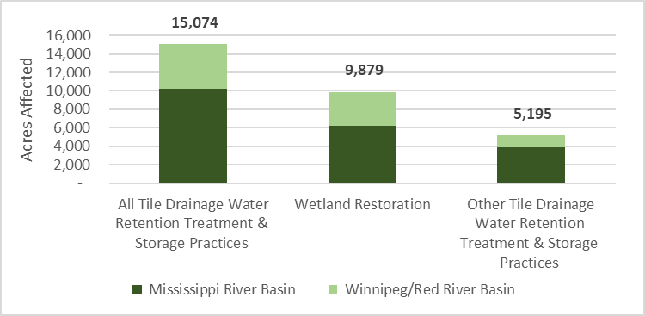

Figure 43. New acres of tile drainage water treatment and storage practices enrolled through government programs, 2014-2018 (MPCA’s Healthier Watersheds BMP tracking system).

*Other tile drainage water treatment and storage practices include denitrifying bioreactor, drainage water management, saturated buffers.

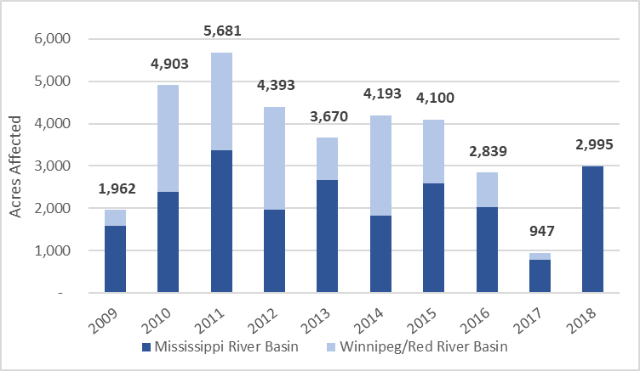

Figure 44. New affected acres of tile drainage water treatment and storage practices added through government support programs 2009 to 2018 (MPCA’s Healthier Watersheds BMP tracking system).

Table 18. New affected acres of tile drainage water treatment and storage practices added through government programs, 2014 to 2018 (MPCA’s Healthier Watersheds BMP tracking system).

|  |  |  |  |
| --- | --- | --- | --- |
|  | **2014-2018**  **Wetland Restoration** | **2014-2018**  **Other tile drainage treatment practices** | **Drainage treatment – total acreage affected** |
| **Mississippi Basin** | 6,257 | 3,926 | 10,183 |
| **Red River Basin** | 3,622 | 1,269 | 4,891 |

**Summary of Minnesota’s Progress on Tile Drainage Water Treatment and Storage Practices**

**Why important**

* Tile drainage waters are the largest source pathway of nitrate to rivers in Minnesota. In-field practices such as fertilizer/manure management and cover crops can reduce nitrate leaching to tile-lines. However, to achieve the nitrogen reductions in the NRS, additional measures are needed, including edge-of-field tile water storage and treatment.
* The NRS example milestone scenario calls for 620,000 acres of tile-drainage waters treated through edge-of-field practices (equivalent to 62,000 newly treated acres per year).

**Findings**

* Tile-drainage water treatment practices have not gained traction in Minnesota. Acreages affected are very low and are still mostly in demonstration mode. Few existing drivers or programs are expected to dramatically increase the use of these practices (i.e., saturated buffers, treatment wetlands, controlled drainage management and bioreactors):
  + The total amount of Minnesota tile-drained lands has increased by over 1.6 million acres between 2012 and 2017, based on the U.S. Census of Agriculture.
  + Tile water treatment for nutrient reduction is increasing by about 3,000 acres per year based on government program records over the past 5 years.

**Follow-up**

* A better understanding of the socio-economic barriers and opportunities is needed in order to implement more successful strategies for storage and treatment of tile-drainage waters. Emphasizing the multiple benefits of certain practices, such as constructed wetlands and two-stage ditches, may also help boost adoption.

## Are we on track to meet agricultural BMP milestones?

The 2014 NRS includes example cropland BMP scenarios that are predicted to achieve the nutrient reduction goals and milestones, as described in Section 4.1. The short timeframe of this progress report makes it difficult to draw conclusions around actual in-water progress during the past five years. While nitrogen and phosphorus water quality trend monitoring are ideal for long-term evaluation of NRS progress, short-term evaluation through river monitoring is complicated by patterns of climate variability, lag times, margin of error, and other complicating factors. To address these complexities, the 2014 NRS emphasizes the need to track BMP adoption across major basins, and to compare adoption levels with milestone BMP scenarios identified in the 2014 NRS. As was previously noted, considerable cropland acreages were affected by BMPs prior to the beginning of the 2014 NRS, especially reduced tillage and soil erosion control. The focus now is on practices above and beyond the BMP adoption that occurred historically. This section of the 5-year NRS progress report summarizes the progress detailed in section 4.2 concerning 2014 to 2018 changes in BMP adoption compared with NRS-identified benchmark acreages. The government assistance program progress is first summarized, followed by a summary of additional indicators of progress that include efforts outside of government programs.

Considering only BMP adoption tracked through government programs between 2014 and 2018, the recently added BMP acreages are not on a trajectory to meet the 2025 milestone scenario goals, as depicted in Figure 45.

Figure 45. Newly affected acreages of agricultural BMPs (2014-2018) implemented through government programs in the Mississippi River and Lake Winnipeg Basins toward the NRS milestone scenario outlined in the 2014 NRS for completion by 2025. Note: this depiction does not include private adoption of practices outside of government programs.

Progress with government program BMP adoption in the four NRS categories is summarized below.

**Nutrient management efficiency practices –** From 2014 to 2018, a total of 59,550 new acres of nutrient management efficiency practices were added to the Mississippi River basin under government-tracked programs, representing only 1% of the 6.1 million acres in the milestone scenario. A total of 3,900 acres was added to the Red River basin under government-tracked programs, less than 1% of the 700,000-acre 2024 milestone.

**Living cover practices –** In the Mississippi River basin, new acres of government program supported cover crops totaled 136,673 acres, 10.5% of the milestone outlined in the 2014 NRS. 71,588 acres of cover crops were added in the Red River basin, representing 10% of the milestone. Perennials in the CRP dropped from 2014 to 2015 and has remained stable since 2015. 65,104 newly affected acres of perennials were added between 2014 and 2018 through other government programs, compared to the milestone scenario 2024 target of 440,000 acres.

**Tile drainage water treatment and storage practices –** From 2014 to 2018, a total of 10,183 new acres of tile drainage water treatment and storage practices were added to the Mississippi River basin, only 1.6% of the milestone scenario of 600,000 acres. A total of 4,891 acres were added to the Red River basin, or 23% of the 20,000-acre milestone.

**Field erosion control practices –** 185,691 new acres of government program supported field erosion control practices were added in the Mississippi River basin from 2014 to 2018, representing 4% of the 4.5-million-acre milestone scenario goal by 2024. A total of 123,895 acres were added to the Red River basin, around 31% of the 400,000-acre milestone.

The scale of agricultural BMP adoption through government programs has not been on-pace during recent years to achieve the example NRS milestone BMP scenario. Living cover practices show potential to achieve the milestones, but the rate of adding those practices would need to increase considerably between 2020 and 2025. Two key follow-up questions need to be considered:

1. Are private industry BMP adoption efforts making up the difference between the government program BMPs and the NRS scenario levels of adoption?
2. Are the new and advancing programs (see Section 2) ramping-up enough to increase BMP adoption in 2020 to 2025, as compared to 2014 to 2019?

Both private industry efforts and full implementation of recently advancing state programs can potentially make a substantial difference in the rate of BMP adoption.

Indicators of overall BMP adoption rates (including adoption outside of government programs) during the past 5 to 10 years also suggests that Minnesota is likely to fall short of achieving the needed scales of adoption outlined in the NRS scenarios. This assessment is based on a combination of survey information, sales data, satellite imagery findings, soil testing and other sources that reflect the combination of government program and private industry influences. However, the metrics need improvement and further study to gain a greater understanding of overall progress. One area of conflicting information is progress with conservation tillage and residue cover. While the U.S. Census of Agriculture suggests a substantial increase in conservation/reduced tillage acreage, satellite imagery results show decreasing acreages of land with over 30% residue.

Based on the program advancements made during the past five years, it is anticipated that BMP adoption will accelerate in 2020 to 2024, as compared to 2014 to 2018. These program advancements include private/public partnerships, educational programs, watershed plans, BMP funding programs, research findings, rules in place, and other developments reported in Section 2 and Appendix A. While the full effects of these advancing programs won’t be apparent for several years, it seems unlikely based on the progress identified in this report that existing program advances alone will achieve the scale of BMP adoption needed to reach nutrient reduction strategy scenario targets.

To increase the likelihood for an improved NRS assessment in 2024, Minnesota should consider what additional information, advancements, and implementation efforts are necessary during 2020 to 2024 to make additional progress toward long-term nutrient reduction success. Section 6 describes recommended next steps for the 2020 to 2024 period.

# Wastewater and other sources – Is progress consistent with NRS direction?

The implementation strategies outlined in the 2014 NRS provided recommendations and guidance to also reduce phosphorous and nitrogen loading from non-cropland sources. This section examines the progress made in nutrient reduction from wastewater, feedlots, urban stormwater, and septic systems.

## Wastewater

According to the 2014 NRS, wastewater phosphorus and nitrogen loads account for approximately 18% and 11% of the phosphorus loads in the Mississippi and Red Rivers, respectively, and 9% and 6% of the nitrogen loads in the two respective rivers. In the Lake Superior drainages within Minnesota, the overall wastewater nutrient loads are much lower than in the Mississippi, but the fraction of the loads from wastewater is higher (24% for phosphorus and 31% for nitrogen). The 2014 NRS included goals and strategies for nutrient reductions from permitted wastewater sources based on the best available information at the time. Additional phosphorus and nitrogen monitoring data collected since 2014 are now available to refine existing nutrient loads from wastewater. This section presents the updated loading and goals, as well as recent progress on phosphorus and nitrogen reductions.

**2014 NRS recommended wastewater strategies**

1. Implementation of the Phosphorus Rule and Strategy
2. Implementation of River Eutrophication Standards
3. Influent and effluent nitrogen monitoring at wastewater treatment facilities
4. Nitrogen management plans for wastewater treatment facilities
5. Nitrogen effluent limits
6. Add nitrogen removal capacity with facility upgrade
7. Point source to nonpoint source trading

### Updated existing loading and goals

New effluent monitoring and data analysis methods result in a shift in the baseline loads attributed to wastewater compared to the baselines cited in the 2014 NRS. Table 19 summarizes the 2014 NRS loads and new phosphorus information along with the updated current load that represents an average over 2016 to 2018. Overall, using the updated values, there has been an approximate 70% statewide reduction in phosphorus loading from wastewater sources since 2000 to 2002, and a reduction of about 20% since the 2010 to 2012 average.

Baseline nitrogen loads for wastewater in the 2014 NRS were derived from the SPAtially Referenced Regression on Watershed Attributes (SPARROW) model and represent the 2005 to 2006 time period. Table 20 summarizes the new nitrogen information collected through increased monitoring initiated in 2010 and expanded after 2014.

Phosphorus reduction goals for the wastewater sector continue to be based on full implementation of the Phosphorus Strategy (codified as Minn. R. Ch. 7053.0255) and water quality-based effluent limits based on lake and river eutrophication standards. To meet the 2025 milestones for wastewater nitrogen, the reduction goals are based on a 20% reduction in overall nitrogen loading needed in the Mississippi River basin and a 13% reduction in the Red River basin.

Table 19. Revised existing phosphorus loads from permitted wastewater.

|  |  |  |  |  |
| --- | --- | --- | --- | --- |
| **Basin** | **Phosphorus** | | | |
| **2014 NRS wastewater baseline load (average 2010-2012) (MT/yr)** | **Updated wastewater baseline load (average 2010-2012) (MT/yr)** | **Current load (average 2016-2018) (MT/yr)** | **Change since updated baseline** |
| **Statewide** | 796 | 737 | 584 | -21% (153 MT/yr) |
| **Mississippi River** | Not defined | 620 | 490 | -21% (130 MT/yr) |
| **Red River** | Not defined | 73 | 54 | -26% (19 MT/yr) |
| **Lake Superior** | Not defined | 43 | 35 | -19% (8 MT/year) |

Table 20. Revised existing nitrogen loads from permitted wastewater.

|  |  |  |  |  |
| --- | --- | --- | --- | --- |
| **Basin** | **Nitrogen** | | | |
| **2014 NRS wastewater baseline load (SPARROW representing the 2005-2006 time period) (MT/yr)** | **Updated wastewater baseline load (average 2010-2012) (MT/yr)** | **Current load (average 2016-2018) (MT/yr)** | **Change since updated baseline** |
| **Statewide** | 10,879 | 13,824 | 14,327 | +4% (503 MT/yr) |
| **Mississippi River** | 9,363 | 11,718 | 12,593 | +7% (875 MT/yr) |
| **Red River** | 304 | 487 | 469 | -4% (18 MT/yr) |
| **Lake Superior** | 1,212 | 1,645 | 1,109 | -33% (536 MT/yr) |

### Phosphorus reduction

The total phosphorus load discharged by statewide wastewater sources decreased between 2010 and 2014, maintaining a relatively even trend since 2014, as shown in Figure 46. Statewide, there has been a 71% reduction in phosphorus for wastewater since 2000. Overall, 92% of wastewater phosphorus loads reported here are derived directly from effluent monitoring data, providing a high degree of confidence in these estimates.

**Importance of wastewater phosphorus loads by scale**

Wastewater phosphorus loads discharged by industrial facilities are relatively minor on a statewide basis (17% of statewide wastewater phosphorus load totals in 2018) but can be very important on a local watershed scale.

For example, in the Rainy River Basin (HUC-4 0903) the industrial phosphorus load for 2018 is 94% of the total wastewater load.

Phosphorus limits are required on 89% of the wastewater flow volume in the state. Phosphorus limits are derived from three different standards:

* Lake eutrophication standards – Water quality standards approved in 2008.
* River eutrophication standards – Water quality standards approved in 2015.
* State discharge restriction – Regulation-based effluent limitations that vary with facility size, location, and upgrade timing. These limits are largely the result of implementing the MPCA’s Phosphorus Strategy and are gradually being supplemented by limits set to meet lake and river eutrophication standards.

Table 21 summarizes the number of permits with phosphorus limits. A permit can contain more than one type of phosphorus limit. Table 22 shows the wastewater volume associated with each type of limit. While municipal wastewater facilities discharge the vast majority of statewide effluent phosphorus loads, industrial wastewater is an important local source of nutrient additions in certain areas and are also included in the assessment. Forty-six percent of industrial facilities monitor phosphorus and 9% of the facilities have phosphorus limits.

Table 21. Permits with phosphorus limits (August 2019).

|  |  |
| --- | --- |
|  | **Permits with phosphorus limits** |
| **Lake Eutrophication Standard limits** | 363 |
| **River Eutrophication Standard limits** | 113 |
| **State Discharge Restriction limits** | 121 |

Table 22. Permitted flows associated with different phosphorus limits.

|  |  |  |  |  |  |
| --- | --- | --- | --- | --- | --- |
| **Current limit type** | **2018 Flow (MG)** | | | **Municipal**  **% of total permitted flow** | **Industrial**  **% of total permitted flow** |
| **Municipal** | **Industrial** | **Total** |
| **Lake eutrophication standard** | 112,943 | 4,415 | 117,358 | 66% | 4% |
| **State discharge restriction** | 39,907 | 7,432 | 47,339 | 23% | 6% |
| **River eutrophication standard** | 578 | 196 | 774 | 0.3% | 0.2% |
| **No limit** | 17,122 | 105,088 | 122,210 | 10% | 90% |
| ***Total flow*** | *170,550* | *117,131* | *287,681* | *100%* | *100%* |

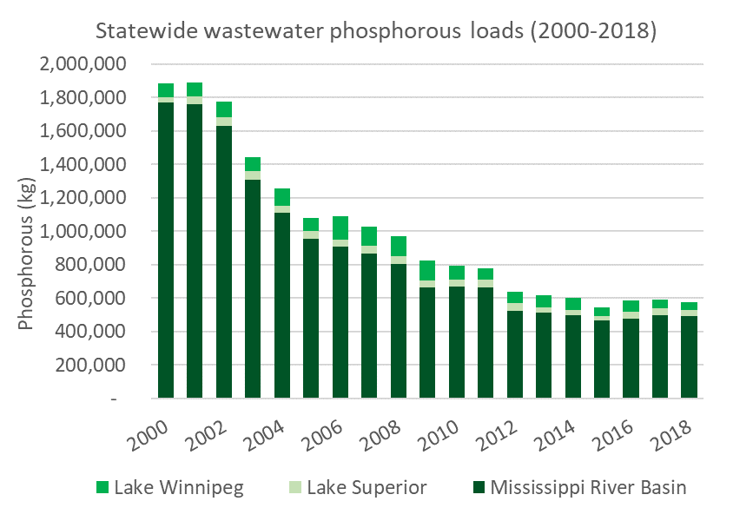

Figure 46. Statewide wastewater phosphorous loads (2000-2018).

Phosphorus loadings by major basin are provided in Figure 47 through Figure 49:

* **Mississippi River** – Between 2014 and 2018, 201 municipal and 82 industrial facilities made reductions. As noted earlier, there was a 21% reduction between the 2010 to 2012 period and the 2016 to 2018 period. From 2014 to 2018, the fraction of decrease was much smaller. The slight increase during the last three years in Figure 47 can be explained by population increases and wet weather, generating greater volumes of wastewater discharge (Figure 47).
* **Lake Winnipeg** –Industrial sources of phosphorus contribute a large fraction of phosphorus discharge. Decreases in phosphorus loading are due in part to actual reductions, and in part to better monitoring of industrial discharges (Figure 48).
* **Lake Superior** – Western Lakes Sanitary Sewer District (WLSSD) in Duluth is the largest wastewater discharger in the Lake Superior Basin and discharged 56% of the total permitted wastewater in this basin in 2018. The WLSSD and the City of Virginia Wastewater Treatment Plant started making phosphorus reductions in 2013, resulting in wastewater phosphorus reductions to Lake Superior between 2012 and 2015. Wastewater phosphorus increased from 2016 to 2018 in part due to increased phosphorus loading from WLSSD, however, total loading is still below the long-term 2000 to 2011 average (Figure 49).

Adoption and implementation of River Eutrophication Standards has generated resistance from some sectors of the wastewater community. This has taken the form of various legal challenges to the adoption of water quality standards (Minn. R. Ch. 7050.022) and implementation at the individual permit level. It is anticipated that RES TMDLs will also face similar legal hurdles. In general, opposition from point sources has centered around challenges to the technical basis for the standards, concern about the costs of implementation and concern that point source investment in further phosphorus reductions will not be effective unless non-point source reductions are also accomplished.

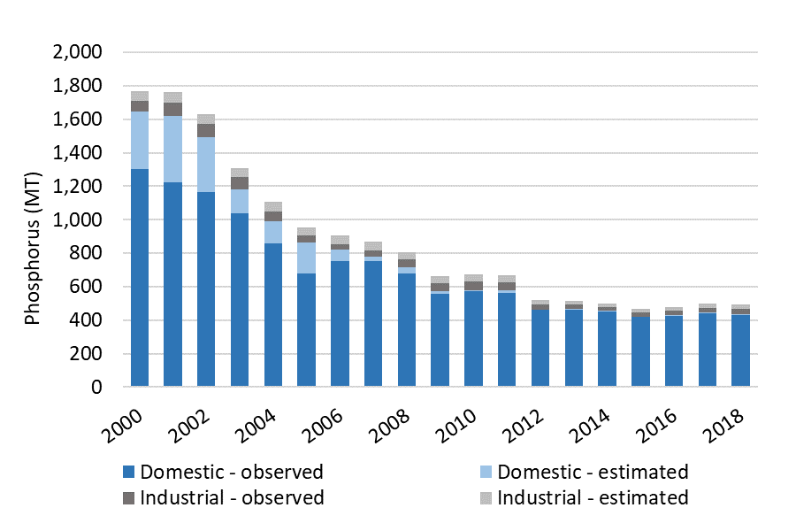

Figure 47. Mississippi River basin phosphorous loading.

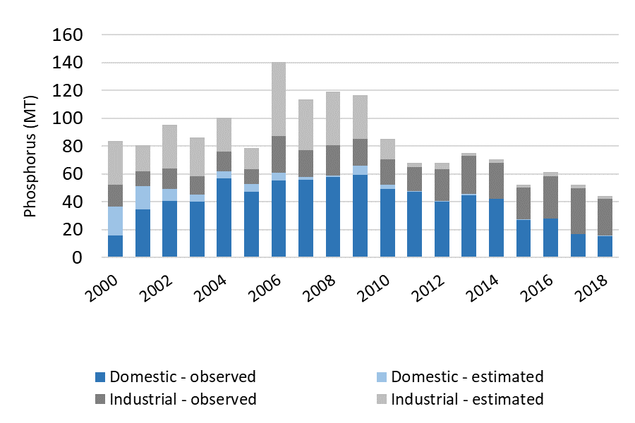

Figure 48. Lake Winnipeg basin phosphorous loading.

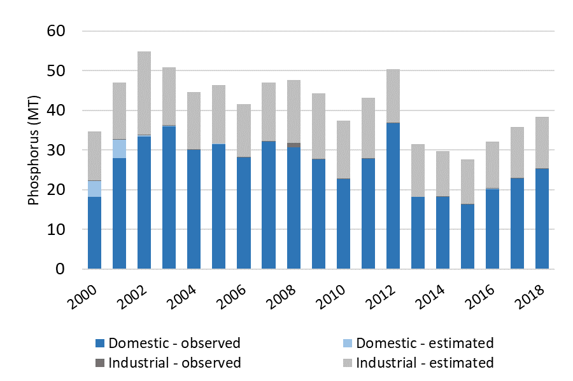

Figure 49. Lake Superior basin phosphorous loading.

### Nitrogen reduction

Nitrogen load reductions from wastewater were not expected within the first five years of NRS implementation. Instead, Minnesota focused on collecting new monitoring data from wastewater sources to better determine existing nitrogen loads. Table 23 summarizes updated nitrogen concentrations for treated municipal wastewater based on the new monitoring data. There are 205 facilities with continuous discharge (i.e., mechanical) and 50 facilities with controlled discharge (i.e., stabilization ponds) that monitor nitrogen in their wastewater (Figure 50).

Table 23. Updated average nitrogen concentrations for treated municipal wastewater.

|  |  |
| --- | --- |
| **Facility category** | **Nitrogen concentration assumptions (mg/L)** |
| Class A municipal – large mechanical | 21 |
| Class B municipal – medium mechanical | 21 |
| Class C municipal – small mechanical/ pond mix | 12 |
| Class D municipal – mostly small ponds | 6 |

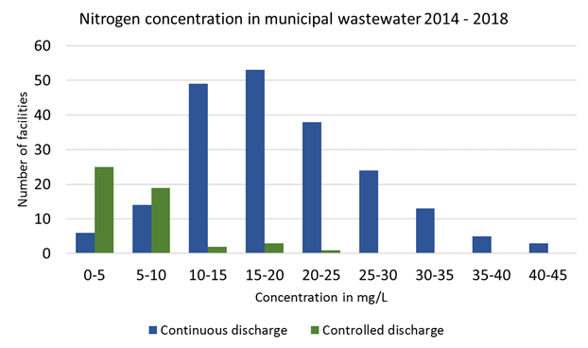

Figure 50. Effluent total nitrogen concentrations for facilities in Minnesota.

Figure 51 provides the best estimate of statewide nitrogen loading from wastewater. Since very few wastewater treatment systems remove nitrate or total nitrogen, statewide load reductions are not evident. Observed trends are due to a combination of improved monitoring information and population increases. The increase in nitrogen monitoring data is evident beginning in 2010 and ramped up considerably in 2016 (Figures 52 to 54). Pre-2016 nitrogen loading estimates are largely based on assumed concentrations; therefore, it is challenging to accurately determine changes in loading. Figures 52 through Figure 54 provide the best estimates of nitrogen loading by major drainage basin.

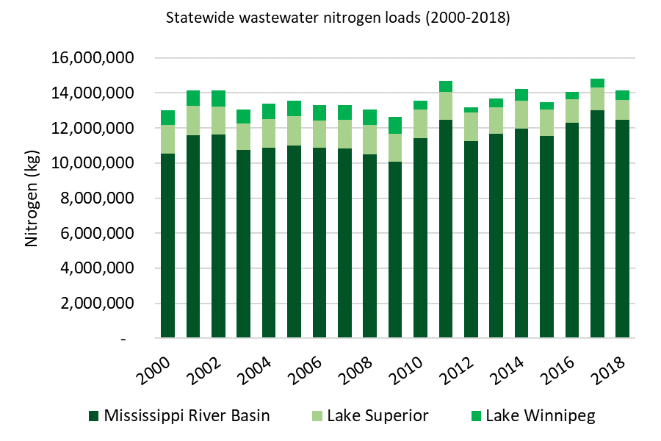

Figure 51. Statewide wastewater nitrogen loads (2000 – 2018).

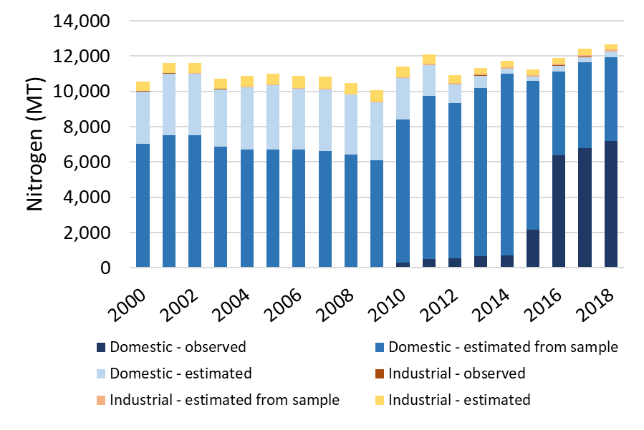

Figure 52. Mississippi River basin nitrogen loading.

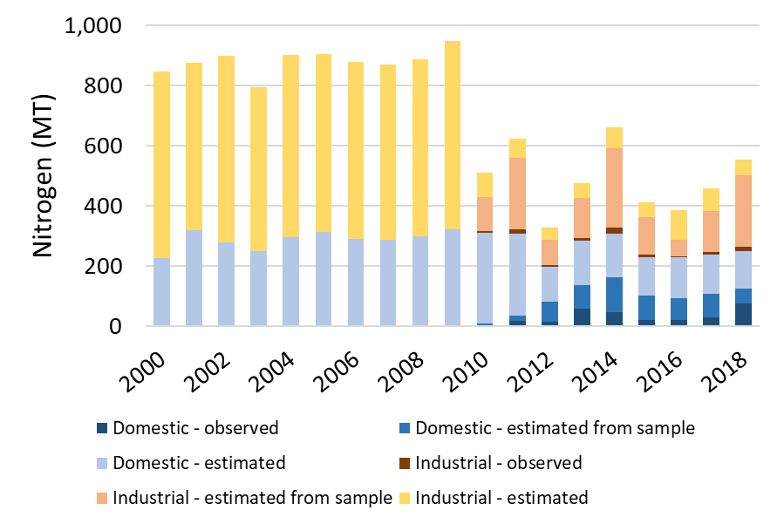

Figure 53. Lake Winnipeg basin nitrogen loading.

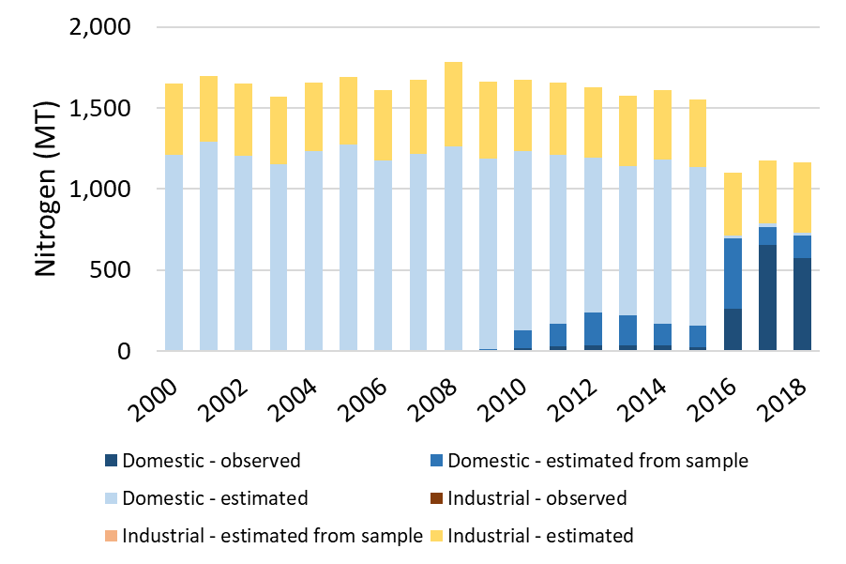

**Figure 54. Lake Superior basin nitrogen loading.**

**Summary of Minnesota’s progress on wastewater**

**Why important**

* Municipal and industrial wastewater represent the largest manageable nutrient source category following cropland. The relative proportion of river nutrient loads from wastewater becomes greater during times of low flow, and in areas where agricultural sources are minimal.
* The NRS called for continued phosphorus reductions through wastewater permit limits established to help achieve eutrophication standards, and it also outlines a series of steps to make progress with nitrogen treatment.

**Findings**

* NPDES phosphorus permit limits apply to approximately 90% of municipal wastewater flows and 10% of industrial wastewater flows (600 wastewater permits), as driven by the Lake Eutrophication Standards, River Eutrophication Standards and/or State Discharge Restriction Limits.
* While much of the 70% reduction in statewide phosphorus wastewater discharges occurred prior to the 2014 NRS, wastewater dischargers have maintained these improvements and achieved additional reductions in alignment with the direction set forth in the NRS.
* One of the first NRS steps for wastewater nitrogen was to increase monitoring.  Now, 255 facilities regularly monitor nitrogen in their effluent.
* Estimated statewide nitrogen loads from wastewater have generally remained steady, increasing slightly along with population and precipitation.

**Follow-up**

* Minnesota will continue taking the steps outlined in the NRS for achieving nitrogen reductions from wastewater, while at the same time maintaining and continuing the progress with phosphorus.

## Miscellaneous sources

The 2014 NRS provides recommended strategies for feedlots, urban stormwater, and septic systems to reduce their runoff and nutrient pollution. The following section outlines each source individually, summarizes the recommended strategies, and summarizes progress made from 2014 to 2018.

### Feedlots

Over 20,000 registered feedlots in Minnesota generate manure for land spreading on roughly 4 million acres of cropland. Runoff from feedlot sites (animal holding areas and manure storage systems) and from manure-treated cropland can be an impactful localized source of nutrients. Yet statewide, runoff from feedlot sites represent less than 1% of nitrogen and less than 2% of phosphorus. The 2014 NRS accounts for nutrients directly from feedlot sites in the total phosphorus load “miscellaneous” reductions.

Land application of manure from feedlots to cropland is a more important statewide potential pathway for nutrients than runoff from feedlot animal-holding sites. Proper crediting of nutrients from manure with high organic nitrogen content is challenging compared to inorganic nitrogen sources. Nutrient availability is highly dependent on the type and size of animal, climatic conditions and is influenced by bedding, storage, application method, and other practices. MDA (2014) reported that the average nitrogen rate from manure applied in combination with non-manure sources such as fertilizer is higher than when only non-manure sources are used (MDA 2014). Manure nutrient crediting requires that manure nutrient content be tested, and records shared with the fertilizer dealer so they can accurately adjust commercial inputs.

**2014 NRS recommended feedlot strategies**

Operational measures through the MPCA Feedlot Program:

* All large concentrated animal feeding operations (CAFOs) and feedlots with greater than or equal to 1,000 animal units should be in compliance with discharge standards at the time of inspection.
* All large CAFOs and feedlots with greater than or equal to 1,000 animal units should be in compliance with nitrogen and phosphorus management requirements at the time of inspection.
* All feedlots not covered by a National Pollutant Discharge Elimination System (NPDES) or State Disposal System (SDS) permit should be in compliance with discharge standards at the time of inspection.
* All feedlots not covered by a NPDES or SDS permit should be in compliance with nitrogen and phosphorus management requirements at the time of inspection, including management of land application of manure activities.

Land application of manure contributes about 25% of the added nitrogen to cropland throughout Minnesota (MPCA 2013), with the other dominant source being cropland fertilizer. The 2014 NRS includes land application of manure to cropland in the “fertilizer use efficiency” reductions for both phosphorus and nitrogen.

An overview of progress made in the feedlot program since 2014 is provided below. Progress since 2014 is determined using information from land application and feedlot inspections and compliance rates.

#### Land application of manure inspections and compliance

Inspection records prior to 2018 did not consistently distinguish between non-compliance due to nutrient related regulations and non-nutrient related regulations. Beginning in 2018, the feedlot regulatory program implemented an improved inspection checklist and developed a more rigorous quality assurance/quality control process for compliance rate data (available on MPCA’s feedlot website).

**Feedlot regulation in the State of Minnesota**

Feedlot runoff and storage and manure spreading onto cropland are regulated by the MPCA and 50 counties delegated by the State to administer the program for non-CAFOs. In Minnesota, all feedlots (CAFO and non-CAFO) must meet certain feedlot runoff and manure application requirements, including agronomic rates of application and setbacks from waters. As the size of the feedlot increases, additional requirements are added, such as record-keeping, manure and soil testing, manure storage, and nutrient planning.

The MPCA documented 1,697 land application of manure inspections between 2014 and 2018 (Table 24). In 2018, 97 inspections were of in-field land application of manure and 96 were of nitrogen and phosphorus management records. The inspected sites are not necessarily representative of all feedlots around the state and may depict a different rate of non-compliance than actual statewide averages.

Table 24. Number of land application of manure inspections, 2014-2018.

|  |  |
| --- | --- |
| **Year** | **Total number of land application inspections** |
| 2014 | 656 |
| 2015 | 445 |
| 2016 | 314 |
| 2017 | 89 |
| 2018 | 193 |
| *Total* | *1,697* |

Half of the 2018 land application of manure related inspections were in-field inspections and half were inspections of records documents. The 2018 inspection reports at sites selected for inspection showed the following percentages of inspections that were *non-compliant* with rules and requirements of land application of manure:

*In-field inspections of manure spreading practices*

* 33% of the 97 *in-field inspections* resulted in non-compliance due to inadequate phosphorus testing and or not complying with state requirements for phosphorus management.
* 10% of the 97 *in-field inspections* resulted in non-compliance due to application of manure within required setback zones to waters or discharging directly to waters.
* 29% of the 97 *in-field inspections* resulted in some level of non-compliance with manure applied at agronomic rates.

*Records inspections of manure spreading practices*

* 22% of the 96 nitrogen and phosphorus management *record inspections* resulted in non-compliance for one or more of the following: inadequate records, total nitrogen rates exceeding agronomic needs, or manure not incorporated into the soil where and when it is required.

#### Feedlot inspections and compliance (facility)

The MPCA and delegated counties documented 9,236 feedlot inspections between 2014 and 2018 (Table 25). Three percent (3%) of all feedlot inspections conducted in 2018 resulted in some level of non-compliance with feedlot facility requirements. These requirements include discharges from open lots, feed storage, process wastewater, stockpiles, mortality management areas, or liquid manure storage areas, and do not include land application of manure.

Table 25. Feedlot inspections (facility), 2014-2018.

|  |  |  |
| --- | --- | --- |
|  | **Conducted by Delegated Counties** | **Conducted by MPCA** |
| 2014 | 1,822 | 334 |
| 2015 | 1,736 | 234 |
| 2016 | 1,535 | 226 |
| 2017 | 1,465 | 206 |
| 2018 | 1,430 | 248 |
| *Total* | *7,988* | *1,248* |

Government assistance programs helped to fund construction of 194 manure storage facilities statewide between 2014 to 2018. Many of these storage facilities were constructed to reduce feedlot runoff and/or provide greater management flexibilities for applying manure at more optimal times of the year.

**Summary of Minnesota’s Progress on Feedlot Program**

**Why important**

* The NRS acknowledges that runoff from feedlot facilities contributes a very small percentage of nutrients on a regional scale, but locally can cause problems. Manure generated at feedlots and applied to cropland, however, is a significant potential source of nitrogen and phosphorus to waters and needs to be carefully and judiciously applied.
* Regulations for land application of manure generated at all Minnesota feedlots increased markedly in 2000.

**Findings**

* Inspections of land application of manure activities from in-field observations and farm-office records were conducted at 1,697 sites between 2014 and 2018. Inspections during 2018 show that more progress is needed to improve setbacks, rates of nitrogen applied, keeping records, and phosphorus testing and management.
  + Depending on the land-application requirement evaluated, compliance rates were between 67% and 90% at the targeted inspection sites; however, the inspected sites are not necessarily representative of all feedlots.
* The vast majority of feedlot facility sites meet feedlot runoff requirements, with compliance rates at 97% during 2018 inspections.

**Follow-up**

* Continued and increased emphasis on land application of manure practices is important for reaching NRS goals.
* Cover crops and other conservation and living cover practices should increasingly be used to reduce nutrient leaching and runoff stemming from manure application.

### Urban stormwater

Implementation of the MPCA stormwater program serves as the primary strategy to reduce nutrient loads from stormwater. The MPCA stormwater program regulates the discharge of stormwater and snow melt runoff from MS4s, construction activities, and industrial facilities, mainly through the administration of NPDES and SDS permits. For more information go to <https://www.pca.state.mn.us/water/stormwater>, or search “stormwater” on the MPCA webpage. Nutrients from stormwater (regulated and non-regulated) are accounted for in the “miscellaneous” reductions in total phosphorus load in the 2014 NRS.

**2014 NRS recommended urban stormwater strategies**

* Regulated stormwater source permitting (MS4, construction, industrial)
* Stormwater technical assistance in the form of the Minimal Impact Design Standards (MIDS) and the Minnesota Stormwater Manual
* Stormwater research and demonstration

An overview of progress made in the stormwater program is provided below. Progress since 2014 is determined using information collected from the stormwater permitting program. Additionally, many watershed organizations, particularly those in the Twin Cities Metropolitan area, have made progress beyond Minnesota’s permit requirements.

Three Minnesota general stormwater permits reduce and/or prevent new nutrient additions in stormwater: MS4 Permit, Construction Stormwater Permit (between 2,000 and 2,500 permits issued annually over the past five years), and Industrial Stormwater – Multi-sector General Permit (3,920 permits in 2019).

In addition to the above general permits, other regulatory mechanisms are in place to further protect local waters, such as permitting land-disturbing activities by municipalities or watershed organizations. In addition to regulatory requirements, many volunteer programs exist to encourage and incentivize stormwater treatment. Activities not associated with the MPCA’s stormwater program are not tracked at the state level, and therefore are not included in this NRS progress tracking. However, these additional activities do contribute to overall nutrient reduction.

The MPCA only collects and tracks data for regulated (permitted) MS4s. Currently, there are 247 regulated small MS4s in Minnesota, and 2 large permitted MS4s (Minneapolis and St. Paul). Approximately 4% of the land area in the state is covered under a MS4 permit as shown in Figure 55.

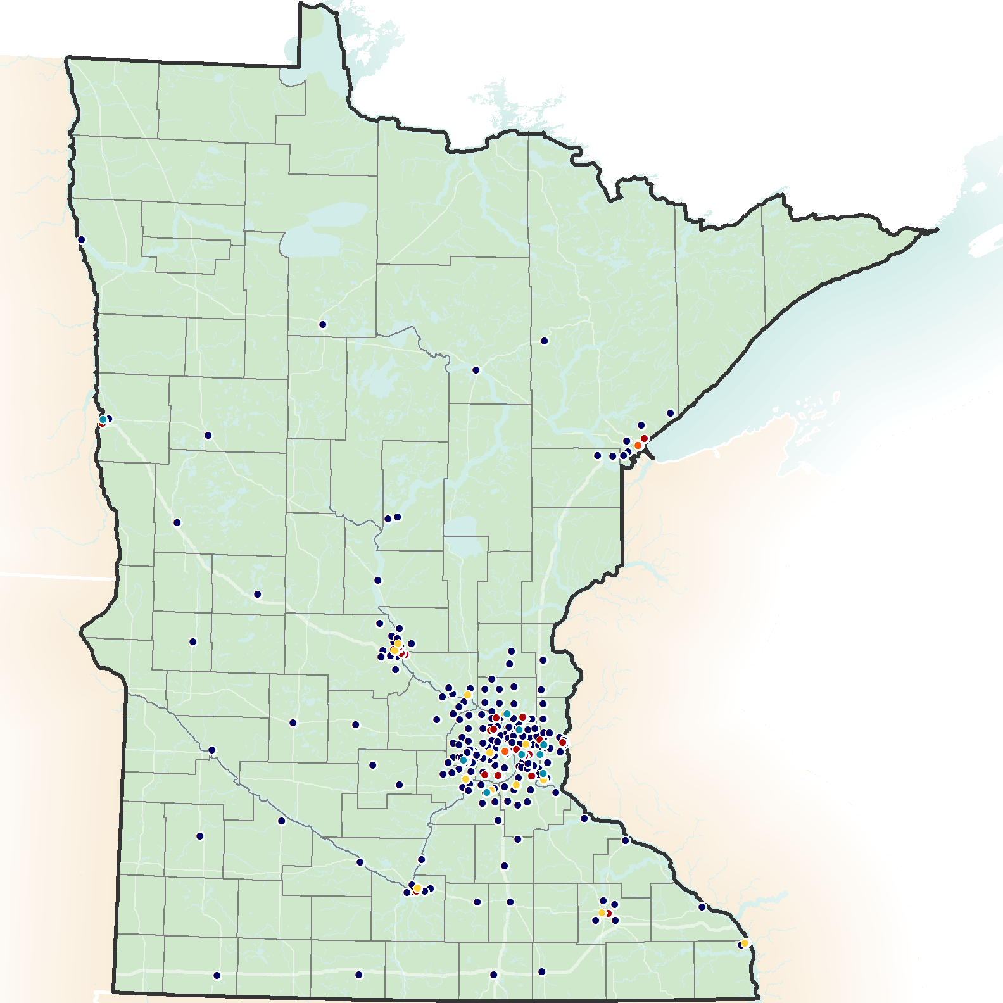In addition to making progress towards meeting pollutant load reductions needed to comply with water quality standards and TMDLs, regulated MS4s are also required to meet post-construction volume requirements that will also reduce nutrient loads. The most common method for controlling runoff volume at a site is infiltration or other treatment of the first one inch of runoff from impervious surfaces.

The MPCA collects and tracks data for regulated (permitted) MS4s. Data on structural and non-structural BMPs is provided in required MS4 annual reports. The MS4 permittee must provide a summary of the progress toward achieving TMDL wasteload allocations (WLAs). The summary must include a list of BMPs implemented, the implementation status of BMPs that were included in the permittee’s compliance schedule, and an estimate of cumulative total sediment and total phosphorus load reductions.

Figure 55. Regulated MS4s.

MS4 permittees with TMDL WLAs were first required to report the BMPs implemented in 2014. Note that the MS4 permittees self-report the data to MPCA and MPCA does not necessarily conduct thorough quality checks of the data reported. The year in which a BMP was reported does not necessarily indicate which year the BMP was implemented.

*Structural BMPs*

MS4 permittees assigned a WLA in a TMDL approved by the U.S. Environmental Protection Agency (EPA) prior to issuance of the most current MS4 permit (August 1, 2013), and who were not meeting that WLA(s) when they applied for permit coverage, must annually complete a TMDL Report to demonstrate progress toward meeting the WLA(s). Currently, of the 247 regulated small MS4 permittees, 78 permittees are required to complete the TMDL Annual Report under the 2013 MS4 permit. This requirement will continue when the new MS4 permit is re-issued in 2020. When the new MS4 permit is re-issued, 228 regulated MS4s will have a nutrient or sediment WLA and will be required to report progress on meeting these WLAs annually. The data collected from these reports includes the number and type of structural and nonstructural BMPs implemented since the baseline year to make progress towards meeting MS4 WLAs.

From 2015 to 2017, a total of 418 structural BMPs were reported by 78 MS4 permittees (Table 26). The data provided in “pre-2015” represents all BMPs implemented up to and including the year 2014. As of 2017, 1,764 structural BMPs were reported by 78 permittees. The most commonly implemented BMPs include:

* Constructed basin BMPs (e.g., ponds, wetlands) comprised 52% of all BMPs implemented. Wet ponds accounted for 55% of the reported constructed basin BMPs.
* Filter BMPs (e.g., biofiltration, sand filter, permeable pavement, and iron enhanced filter) comprised 10% of all BMPs implemented. Biofiltration (rain garden with an underdrain) accounted for 64% of the reported filter BMPs.
* Infiltrator BMPs (e.g., bio-infiltration, infiltration basins/trench, underground infiltration, tree trench) comprised 33% of all BMPs implemented. Bio-infiltration (rain garden with no underdrain) accounted for 55% of the reported infiltrator BMPs.
* Swale or Strip BMPs (e.g., filter strip, dry swale, and grass channel) comprised 5% of all BMPs implemented. Grass channel/waterway accounted for 69% of the reported swale/strip BMPs.

Table 26. Structural BMPs reported by regulated MS4s

Data provided under “pre-2015” represents all BMPs implemented up to and including the year 2014.

|  |  |  |  |  |  |
| --- | --- | --- | --- | --- | --- |
| **Structural BMP** | **Reporting Year** | | | | |
| **pre-2015** | **2015** | **2016** | **2017** | **Grand Total** |
| Constructed basin | 827 | 25 | 46 | 27 | 925 |
| Filter | 88 | 29 | 38 | 21 | 176 |
| Infiltrator | 403 | 55 | 63 | 59 | 580 |
| Swale or strip | 28 | 4 | 4 | 47 | 83 |
| **Grand Total** | **1,346** | **113** | **151** | **154** | **1,764** |

*Non-structural BMPs*

In addition to structural practices, MS4 permittees also reported implementing 2,887 non-structural BMPs. Non-structural BMPs include enhanced street sweeping, employee or public education and outreach, establishing ordinances, enhanced road salt management (which can affect phosphorus), improved lawn care practices, etc. Pollutant load reductions associated with non-structural BMPs are difficult to quantify. Properly implemented, however, they will lead to reductions in pollutant loading.

For example, from 2014 to 2017, 42 permittees reported implementing enhanced street sweeping BMPs. These practices included increased frequency of sweeping and implementing vacuum sweeping.

Another example is supplemental public education and outreach, which includes activities such as developing and distributing publications (650), giving presentations (244), and conducting workshops/clinics (126).

**Summary of Minnesota’s Progress on Urban Stormwater**

**Why important**

* Stormwater runoff contributes relatively little nitrogen to regional surface waters but is a more important source of phosphorus.
* The NRS called for continued attention to phosphorus reduction through the MPCA and local community stormwater program. The MS4 general permit requires reductions in sediment and phosphorus by regulated entities subject to WLAs.

**Findings**

* Once the 2020 MS4 general permit is issued, 228 regulated MS4s will be required to report progress on sediment and phosphorus reductions annually, compared to 78 permittees reporting under the 2013 general permit.
* Prior to 2015, constructed basins were the most prevalent BMP installed for compliance with MS4 permit requirements. However, since 2015 practices that focus on infiltration, have more commonly been constructed, providing benefits in addition to water quality treatment (e.g., volume control, groundwater recharge, etc.).

**Follow-up**

* Minnesota will continue improving its tracking of the specific practices implemented to reduce nutrients from urban stormwater runoff.

### Septic systems

Implementation of Minnesota’s SSTS program serves as the primary strategy in the 2014 NRS to reduce nutrient loads from septic systems. Nutrients from septic systems are accounted for in miscellaneous reductions for total phosphorus in the NRS. Implementation of the SSTS program emphasizes continued progress to reduce the number of failing SSTS and imminent public health threats. An overview of progress made in the SSTS program is provided below. Progress since 2014 is determined using information from SSTS inspections and compliance rates.

**2014 NRS recommended** **Subsurface Sewage Treatment Systems (SSTS) strategies**

* Implement existing SSTS Program to reduce the percentage of failing SSTS to less than 5%
* Implement the Large Subsurface Sewage Treatment System Groundwater Nitrogen Policy

SSTS inspections have been occurring at a consistent rate since 2014 (Table 27). Of the reported 575,726 existing systems in Minnesota, 14,923 systems or 2.6 % of existing systems were evaluated for compliance in 2018. Inspections are triggered most commonly during a point of sale of the property. There are currently 166 local government units (80%) that have a point of sale inspection requirements included in their local SSTS ordinance. This includes 61 (71%) county SSTS programs.

Table 27. SSTS compliance inspections.

|  |  |  |
| --- | --- | --- |
| **Year** | **Number of systems inspected** | **% of systems inspected** |
| 2014 | 12,805 | 2.4% |
| 2015 | 14,543 | 2.7% |
| 2016 | 14,847 | 2.7% |
| 2017 | 15,250 | 2.8% |
| 2018 | 14,923 | 2.6% |

Since 2002, local government units have issued over 96,000 SSTS construction permits for replacement SSTS, or systems that replace an existing sewage system that was identified as non-compliant for either failing to protect groundwater or an imminent threat to public health and safety (ITPHS) through an inspection (Figure 56). While inspection rates have remained fairly steady since 2014, the number of compliant systems has increased and the number and fraction of septic systems that fail to protect groundwater or are otherwise considered ITPHSs has dropped to less than 5% (Figure 57). The number of estimated compliant systems has increased from 424,000 systems in 2014 to roughly 463,500 systems in 2018. Compliance rates in 2018 were estimated at 81%.

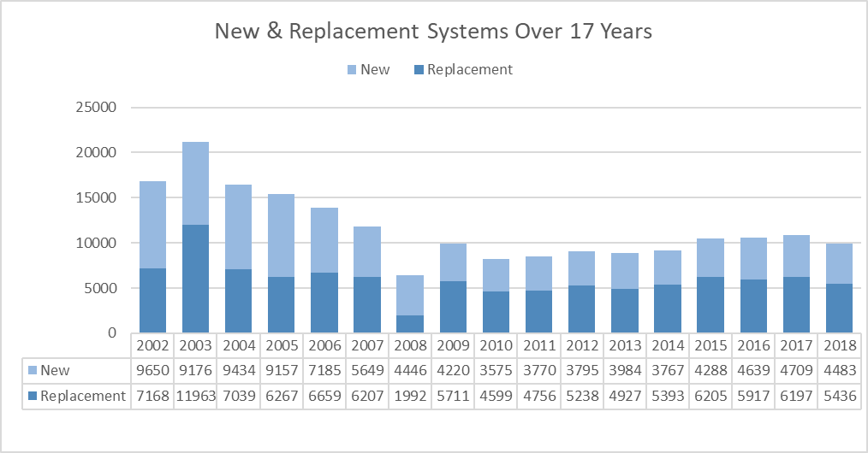

Figure 56. New and replacement SSTSs over time (2002-2018).

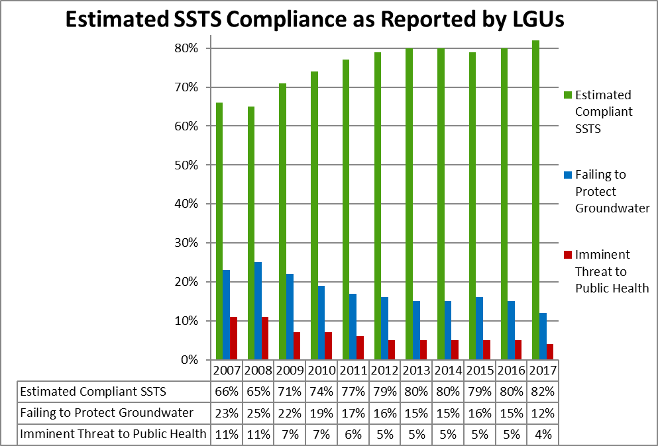

**Figure 57. Estimated compliance (2007-2018)**.

**Summary of Minnesota’s Progress on Subsurface Sewage Treatment Systems**

**Why important**

* Septic systems are a small nutrient contributor statewide but can create local groundwater and surface water problems when improperly sited, constructed and maintained.
* The NRS called for continued progress with Minnesota’s regulatory program for Septic Systems.

**Findings**

* Between 2014 and 2018, over 13,000 annual inspections of septic systems occurred each year.
* The number of septic systems considered imminent public health threats has dropped to less than 5%, thus meeting the NRS strategy target.
* During 2014 to 2018, between 12 and 15% of inspected septic systems failed to protect groundwater.

**Follow-up**

* Continued implementation of the SSTS program to better protect groundwater and surface waters.

# What are the next steps for the NRS (2020-2024)?

All Minnesotans are part of the nutrient reduction solution. Only with large-scale collaboration at all levels, in all sectors, among all citizens, can Minnesota achieve the scale of change needed to significantly reduce nutrients and meet NRS goals.

Minnesota has advanced most of the numerous program areas identified in the 2014 NRS intended to achieve nutrient reductions. However, as discussed in previous sections, more time is needed for the programs to reach their full potential to significantly reduce nutrients. During the next five years, it is necessary for Minnesota partner agencies to continue developing, advancing and implementing the NRS programs identified in Section 2 and Appendix A. Yet, based on our indicators of progress thus far it is likely that continuation of existing programs alone won’t be sufficient to achieve the scale of BMP adoption needed to reach nutrient reduction goals.

Achieving NRS goals depends on large-scale, multi-million acre new adoption of practices such as:

* Cover crops and other continuous living cover vegetation;
* Nitrogen and phosphorus fertilizer (and manure) applied at times, forms, rates and methods that maximize economic efficiencies along with environmental outcomes (i.e., such as split N based on in-field monitoring, sufficient crediting of N from manure and legumes, phosphorus fertilizer banding/incorporation, etc.);
* Increasing crop residue cover through innovative systems, such as strip till, along with other traditional soil conservation practices;
* Treatment-wetland construction and other tile-drainage water storage and treatment systems; and
* Other BMPs proving to be the most promising for *multiple agricultural and ecosystem benefits.*

In addition, wastewater treatment for nitrogen removal is important for meeting the NRS long-term goals.

To further move us toward increased scales of BMP adoption and to set the stage for the 2024 NRS republishing, four next steps are recommended, as follows:

1. Maximize the multiple benefits of NRS practices by coordinating efforts with other plans and strategies that use similar practices to achieve resiliency to climate change and ecosystem improvements. For example, soil health and living cover strategies in the EQB State Water Plan not only help us to become more resilient to precipitation increases but also help us reduce nutrients in water. We need to increase these practices in ways that can best meet both needs.

2) Identify and remove social, economic, and other human-dimension barriers to scaling-up BMP implementation,

3) Use the latest research to continue refining the optimal combination of practices that will achieve the needed nutrient reductions in our waters,

4) Optimize wastewater nitrogen treatment.

Each of these next steps are described in more detail below.

1) Maximize the multiple benefits of NRS practices by coordinating with other plans and strategies that use similar practices to achieve resiliency to climate change and ecosystem improvements.

NRS implementation should be increasingly coordinated and integrated with EQB’s State Water Plan, Minnesota Clean Water Council’s Strategic Plan, and other water and climate resilience plans and strategies. These plans and strategies can work in harmony to maximize the multiple benefits and increase adoption of practices providing continuous living cover, soil carbon build-up and crop nutrient efficiencies.

Many of the practices identified in the Nutrient Reduction Strategy will result in benefits beyond nutrient reduction. Public agencies and private organizations responsible for administering programs that affect nutrient reductions to waters should integrate planning efforts and prioritize practices and locations to achieve multiple benefits, including:

* Greenhouse gas reduction;
* Sediment reduction in rivers and downstream lakes;
* Resiliency to climate variability;
* Long-term agricultural sustainability and profitability;
* Soil health;
* Wildlife habitat and pollinator increases;
* Lake and river health;
* Nutrient reductions for drinking water source protection (public and private wells), and
* Other ecosystem benefits.

The cost and effort to increase nutrient-related practices to waters can often be further justified when considering the multiple benefits of the practices. For example, if all of the milestone NRS BMPs were implemented, the agricultural cropland portion of greenhouse gas emissions in Minnesota could be expected to be reduced by roughly 10%, and meeting final NRS goals would result in an even greater reduction (based on typical greenhouse gas reductions for BMPs as reported in MPCA, 2019).

***Implement soil health and living cover measures in water and climate change plans*** - The strategy of improving soil health incorporates many of the practices and changes critical to meeting the long-term goals of the NRS, including reduced tillage, cover crops, and perennial crops. Soil health and living cover strategies in Minnesota’s 2020 State Water Plan coordinated by EQB and Clean Water Council’s (CWC) Strategic Plan are generally consistent with NRS goals and should be a high priority for implementation.

A monumental movement toward building soil health in Minnesota will not only work toward meeting NRS goals, but will also help achieve the other goals outlined above. An important component of building soil health and meeting NRS goals is the addition of cover crops on millions of row crop acres. The CWC’s 2020 draft strategic plan sets a goal of adding 5 million acres of cover crops or continuous living cover to row crop agriculture by 2034. This goal is generally consistent with the pace of cover crop additions needed to meet NRS 2025 milestone goals and estimates of what it will likely take to achieve NRS 2040 final goals.

Additionally, Minnesota’s Executive Order 19-37 establishes the Climate Change Subcabinet and the Governor’s Advisory Council on Climate Change to promote coordinated climate change mitigation and resilience strategies in the state of Minnesota. Strategies for natural and working lands and for resiliency and adaptation to meet the goals are closely related to many of the NRS strategies for increasing living cover, crop residue and overall soil health. Implementing the recommendations of climate action team strategies will have co-benefits to achieving nutrient reductions in waters, along with several other benefits.

***Prioritize local watershed efforts to achieve multiple benefits*** *-* The NRS emphasized Minnesota’s local watershed management approach for implementing state-level programs at the local level, in ways that are prioritized, targeted and measurable. Local watersheds are a scalable unit for planning, priority setting, and implementation, and provide a good place to try approaches that can lead to scaling-up multi-beneficial practices across the landscape.

Minnesota has been developing watershed-scale science-based strategies and plans (i.e. through WRAPS and 1W1P, as shown in the maps below), but has had only a few years to implement the plans. As watershed-scale planning and implementation progresses, it is important to optimize practices and strategies to achieve the multiple benefits identified above. Prioritizing local water planning and implementation efforts to achieve such multiple benefits should increase the probability of success and maximize the use of limited resources.

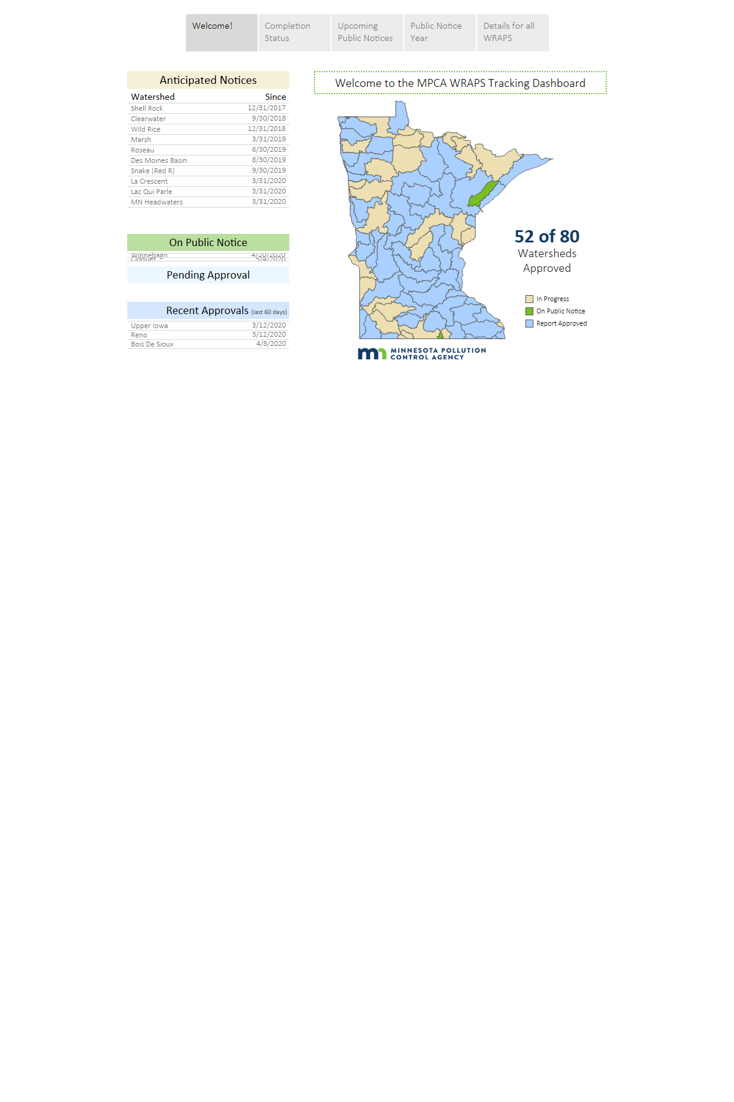

Figure 58. Completion status of Watershed Restoration and Protection Strategies (WRAPS).

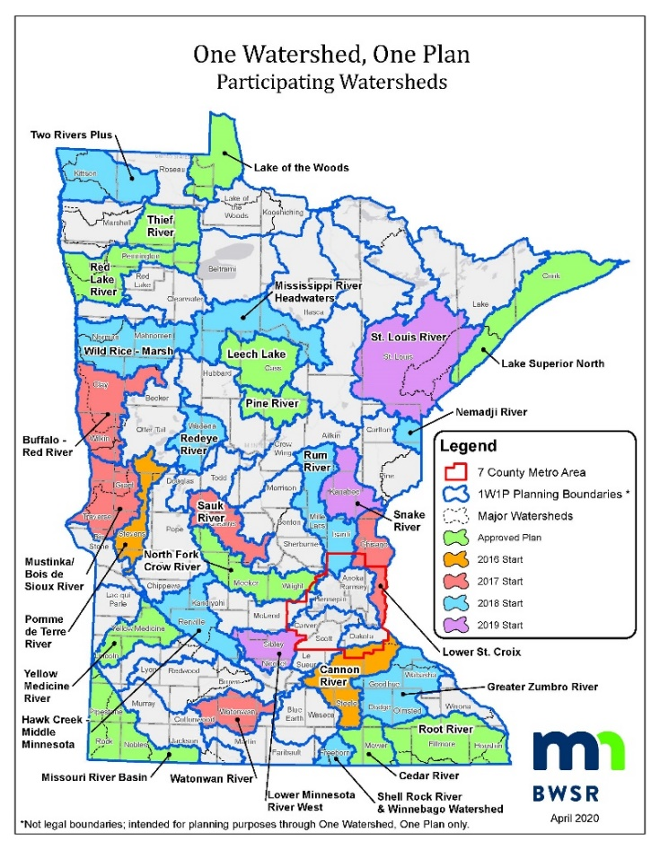

Figure 59. Watersheds participating in the One Watershed, One Plan program.

*Specific actions*

1. State agencies and partner organizations should seek opportunities to prioritize full implementation of strategies in the CWC Strategic Plan, EQB State Water Plans, NRS, and Climate Change Subcabinet plans that will result in significant increases in living cover and soil health for multi-purpose benefits. The combinations of strategies and plans will work toward:

* Two million acres by 2025 on our way to over 10 million acres by 2040 of a combination of the following:
  + Cover crops with short-season crops;
  + Cover crops with full-season crops;
  + Expansion of grass-fed meat and dairy;
  + Strategic long-term permanent placement of perennial crops and plants in high-priority areas;
  + Perennial growth and harvesting of perennials for food, livestock feed, biomass and other uses;
  + Combined systems of perennials and annual row crops; and
  + High value winter annuals for incorporation into existing row-crop systems.
* Increasing soil health practice incentives by adding more market-based funding approaches, carbon market linkages, soil water retention goals, crop insurance rebates, and connections to climate change and agricultural resiliency;
* Implementing the Nitrogen Fertilizer Management Plan and its associated Alternative Management Tools;
* Supporting private-public partnerships, research and demonstration to promote 4R nutrient management stewardship and increase the adoption of fertilizer and manure BMPs;
* Investing in perennial crop research and development, including sustainable market and supply chain development;
* Multi-million acre enrollment in Minnesota’s Agricultural Water Quality Certification Program; and
* Protecting approximately 400,000 acres of vulnerable land surrounding drinking water wellhead areas by investing in living cover and other strategies.

1. State agencies, working in conjunction with the University of Minnesota, should provide guidance and tools to comprehensive local water planners for evaluating and increasing multi-purpose benefits. Supplement or modify tools (i.e. HSPF-SAM, PTMApp) used for nutrient and sediment reduction planning to also include an assessment of other benefits such as resilience to climate change. Additionally, provide guidance on ways to concurrently achieve both downstream and local nutrient reduction goals.

### 2) Identify and remove social, economic and other human dimension obstacles to scaling-up BMP implementation

Recognizing the challenges of scaling-up practice adoption to the levels needed for NRS nutrient reduction goals, Minnesota should gain more clarity about the factors influencing decisions to adopt BMPs, barriers to adoption, and effective ways to overcome obstacles. At the same time that Minnesota progresses with its many nutrient-related programs that have advanced during recent years, we need to continue developing a better understanding of the human dimension associated with BMP adoption and how that varies across the state.

*Specific actions*

1. Minnesota should establish a multi-organizational socio-economic team focused on agricultural nutrient BMP adoption. This socio-economic team should build upon existing information from local, regional and national sources and develop recommendations on how to overcome obstacles and barriers to making large-scale changes across the landscape similar to those outlined in the Nutrient Reduction Strategy. The University of Minnesota should work in partnership with state and federal agencies, stakeholders, and national groups such as the Gulf of Mexico Hypoxia Task Force.
2. The above team should develop a report that includes recommendations to state, federal and local organizations on how to overcome identified barriers and achieve large-scale adoption of NRS practices. Where socio-economic information gaps are identified, plans should be made to obtain the needed information, where possible. The findings and recommendations will help Minnesota refine effective, socially acceptable, and financially feasible approaches for programs, policies, and incentives that drive increased BMP adoption. The recommendations and supporting documents from this assessment should be completed by December 2023, so that it can be used for the 2024 NRS revision process.

During the development of this progress report, contributing organizations identified several examples of possible impediments and solutions to increasing practice adoption. The socio-economic evaluation will provide greater insight on how to best resolve potential needs and gaps that might include:

* **Reducing risk when trying new practices** – Increase farmer (and city) protections, assurances and confidences when taking on real or perceived risk to adopt practices (i.e., use a crop insurance supplement for such practices).
* **Building trust and community** – Build stronger relationships, trust and community (landowner to renter, rural to urban, farmer to conservation professional, farmer to financer, etc.).
* **Equipment barriers** – Identify and help provide for equipment needs that include personally-owned, shared, and rented equipment. Also, address the timing of jointly-shared equipment availability.
* **Rented land challenges** – Identify and reconcile rented land obstacles and solutions for making long-term investment in conservation, and develop options for renters to be more involved with increasing conservation and living cover practices.
* **Practice maintenance** – Identify and address management obstacles and solutions related to maintaining practices.
* **Economics** – Understand costs, markets, funding and economic information for short-term (1-5 years) and long-term (over 10 years) practice adoption, including:
  + How to best support practices that have a public benefit but little to no short or long-term economic benefit to farmers;
  + Quantifying benefits of practices such as cover crops and reduced tillage that can lower costs (e.g. fertilizer, fuel, chemicals and labor) and increase resiliency, and include those quantified benefits in farm-profitability decision support tools;
  + Market-based pollutant trading (i.e. urban-rural trading);
  + Market development for crops providing continuous living cover; and
  + Shifting mindsets to longer-term economic planning horizons.
* **Moving beyond crop yields** – Increasingly shift from a crop-yield goal mindset to such things as increasing farmer competitiveness on metrics that focus on return on investment, community building, soil health, and ecosystem gains.
* **Self-assessment tools** – Provide landowners with more affordable tools and on-farm trial approaches to self-assess soil health progress, tile water nitrate, and other ways to independently obtain feedback on how their practices are working for soil and water protection.
* **Farmer Innovation** – Support on-farm innovative farmer-driven practices, tools and technologies for soil and water protection.
* **Farmer-to-farmer learning** – Develop innovative ways to communicate and showcase farm nutrient loss reduction success stories. Communicate stories and narratives of how farmers shifted from long-standing ways of farming and cultural norms to different ways that are good for agriculture, farmers, and ecosystem services.
* **Policy barriers** – Identify and minimize federal and state policy barriers and challenges for farmers, as well as private industry influences. Identify how government and industry programs can offer greater management flexibility. This could involve adjusting current policies to allow more flexibility in conservation practices, such as “working wetlands,” that may be utilized to cut hay or for other profit-generating activities. Also, assess potential differences between fertilizer retailer recommendations and long-term optimization of farmer economic and environmental return.
* **Private/public partnerships** – Initiate additional private/public partnerships that build off past successes and also involve coop and independent crop advisors, and potentially bankers.
* **Confidence in the solutions** – Increase local knowledge of the key practices and confidence in their effectiveness, including an understanding of how well individual practices can resolve multiple environmental issues.
* **Addressing downstream waters** – Identify barriers and solutions for individuals and watershed planners to increase consideration of downstream impacts outside of their jurisdiction.

The identification and resolving of barriers to success should be addressed by processes that welcome and support culturally diverse voices and different ways of knowing and relating to water issues.

### 3) Use the latest research to continue refining the optimal combination of practices that will achieve the needed nutrient reductions in our waters

The NRS BMP adoption scenarios outline a combination of agricultural and urban practices that will achieve nutrient reduction milestones and goals. While most of this information is still applicable and relevant at this time, our scientific understanding has continued to evolve. The BMP science used to develop the 2014 NRS reflects information generated largely from 2004 to 2012. To maintain the highest level of NRS credibility into the future and to most effectively achieve multi-benefit goals, Minnesota needs to begin working toward updating and improving the BMP adoption scenarios while using the most updated and relevant scientific understanding.

*Specific actions*

1. An agricultural nutrient water-science team from the University of Minnesota and scientists from agencies and other organizations should be established to evaluate the collective body of recent findings around Minnesota and the upper Midwest to set the stage for an updated strategy in 2024. The team should assess and document the following:

* **BMP selection** – Identify which BMPs should be central to an updated BMP scenario, especially emphasizing BMPs that provide multiple benefits and that have a relatively low cost to benefit ratios. An updated BMP effectiveness assessment should be included that uses the latest research to update and refine expected water quality improvements afforded by the BMPs.
* **BMP suitability** – Update GIS-based suitable acreage estimates of potential lands that are well-suited for additional adoption of BMPs, accounting for where BMPs already exist and land limitations for BMP adoption.
* **BMP combination scenarios** – Use updated tools, models and inputs (such as updated precipitation patterns) to re-assess best combinations of practices and associated adoption acreages to meet nutrient load reduction goals and at the same time achieve other ecosystem and agricultural sustainability benefits.
* **BMP costs** – Include cost estimates for the BMP scenarios developed, focusing on net cost to landowners with and without existing government cost-share assistance.
* **BMP progress tracking** – Building from this NRS progress report and recent advancements at the University of Minnesota and elsewhere, recommend the best ways of tracking progress toward adoption of the BMPs outlined in the scenarios, including metrics and measures to assess progress with each BMP category.

The recommendations and supporting documents from this assessment should be completed by December 2023, so that it can be used for the 2024 NRS revisions and republishing. This effort, along with the socio-economic analysis, should lead to a 2024 NRS update that is most consistent with the latest socio-economic and water-science findings and set the stage for increased scaling-up of highly-effective and feasible BMPs between 2025 and 2035.

1. Where scientific information gaps are found, the team should recommend where to focus future research and data collection efforts so we can develop the most promising technologies for significantly reducing nutrients in waters. Examples of existing research needs identified through this progress report development process include: advanced precision nutrient management for crops; best ways to store and retain water across the landscape; economically sustainable continuous living cover cropping options and building associated markets and supply chains; solutions to in-channel sediment phosphorus sources; and ways to combat detrimental effects of precipitation extremes.

### 4) Optimize wastewater nitrogen treatment

Minnesota will continue working toward wastewater nitrogen reductions by developing and implementing a detailed strategy consistent with the direction established in the 2014 NRS.

*Specific actions*

1. MPCA will work with U of MN, Met Council and others to complete more specific steps and considerations for the next five years that will move us further toward increased wastewater nitrogen reduction. Action steps will emphasize pollution prevention and facility optimization of nutrient removal through the use of existing infrastructure.
2. MPCA will analyze and distribute nitrogen monitoring data reported by wastewater dischargers, continue work towards development of a water quality standard for nitrate based on aquatic life toxicity, and work with others to develop nitrogen management plan templates for use by wastewater permittees.
3. U of MN will model and evaluate the potential for optimizing wastewater total nitrogen reductions, while at the same time maintaining phosphorus reduction progress.
4. Depending on the outcome of the above efforts, the MPCA may establish total nitrogen effluent limits in certain locations for attainment of water quality standards and nitrogen reduction goals. Development of nitrate standards and related effluent limits could result in the need to upgrade some wastewater treatment facilities by adding denitrification capacity. Water quality trading and other funding alternatives should continue to be developed.

# References

Barr Engineering. 2004. Detailed Assessment of Phosphorus Sources to Minnesota Watersheds. Prepared for Minnesota Pollution Control Agency, by Barr Engineering Company, Minneapolis, MN.

Bierman, P., Rosen, C., Venterea, R., and Lamb, J. 2011. Survey of Nitrogen Fertilizer Use on Corn in Minnesota. University of Minnesota and USDA-ARS. St. Paul. MN. www.mda.state.mn.us/sites/default/files/inline-files/nfertilizersurvey2011_0.pdf.

Blann, K. 2019. Personal communications. The Nature Conservancy, Minnesota.

BWSR (Board of Water and Soil Resources). 2019. Climate Change Trends and Action Plan. Available online at: <https://bwsr.state.mn.us/practices/climate_change/index.html>.

IPNI (International Plant Nutrition Institute). 2012. 4R Plant Nutrition Manual: A Manual for Improving the Management of Plant Nutrition. North American Version (Bruulsema, T., Fixen, P.E., Sulewski, G.D., eds.) International Plant Nutrition Institute, Norcross, GA.

IPNI (International Plant Nutrition Institute). 2019. Soil Test Levels in North America. Online. International Plant Nutrition Institute [<http://soiltest.ipni.net/>]. Last accessed September 16, 2019.

Kaiser, Kim, Brennon Schaefer, and Bill VanRyswyk,. (2019). Nitrate Results and Trends in Private Well Monitoring Networks 2008-2018. Minnesota Department of Agriculture. <https://wrl.mnpals.net/islandora/object/WRLrepository%3A3395>.

Keeler, B., J. Gourevitch, S. Polasky, C. Tessum, J. Hill, and J. Marshall. 2016. The social costs of nitrogen. Published 5 October 2016, Sci. Adv. 2, e1600219 DOI: 10.1126/sciadv.1600219.

Keeler, B. and S. Polasky. 2014. Land-use change and costs to rural households: a case study in groundwater nitrate contamination. Environ. Res. Lett. 9 (2014) 074002, 10pp.

Limno Tech. 2019. Draft Memorandum: Draft Task A-1 Summary: Review of WRAPS and 1W1P. Provided to the Minnesota Pollution Control Agency, December 27, 2019.

Met Council (Metropolitan Council Environmental Services). 2018. Regional Assessment of River Water Quality in the Twin Cities Metropolitan Area (1976 – 2015). Metropolitan Council, Saint Paul, MN.

MDA (Minnesota Department of Agriculture) 2014. Fertilizer and Manure Selection and Management Practices Associated with Minnesota’s 2010 Corn and Wheat Production. Minnesota Department of Agriculture. 193 pp.

MDH (Minnesota Department of Health). 2018. Nitrate Report: Community Public Water Systems. Minnesota Department of Health. 16 pp.

Meyer, R.L., R.J. Zeng, V. Giugliano, and L.L. Blackall. 2005. Challenges for Simultaneous Nitrification, Denitrification, and Phosphorus Removal in Microbial Aggregates: Mass Transfer Limitation and Nitrous Oxide Production. *FEMS Microbiology Ecology*, 52: 329-338.

MPCA (Minnesota Pollution Control Agency). 2013. Nitrogen in Minnesota Surface Waters. Saint Paul, MN. Document number: wq-s6-26a.

MPCA (Minnesota Pollution Control Agency). 2014. The Minnesota Nutrient Reduction Strategy. September 2014. Document number wq-s1-80.

MPCA (Minnesota Pollution Control Agency). 2019a. DRAFT Lake Pepin Watershed Phosphorus Total Maximum Daily Loads. Saint Paul, MN. Document number: wq-iw9-22b.

MPCA (Minnesota Pollution Control Agency). 2019b. The Condition of Minnesota’s Groundwater Quality, 2013-2017. Saint Paul, MN. Document number: wq-am1-10.

Nustad R.A. and Vecchia A.V. 2020. Water-Quality Trends for Selected Sites and Constituents in the International Red River Basin, Minnesota and North Dakota, United States, and Manitoba, Canada, 1970-2017: U.S. Geological Survey Scientific Investigations Report 2020-5079, 75 p., <https://doi.org/10.3133/sir20205079>.

U of M Extension. 2019. Fertilizing Corn in Minnesota. Online. University of Minnesota Extension. [[https://extension.umn.edu/crop-specific-needs/fertilizing-corn-minnesota#phosphorus-and-potassium-rate-tables-1087910](https://extension.umn.edu/crop-specific-needs/fertilizing-corn-minnesota%23phosphorus-and-potassium-rate-tables-1087910)]. Last accessed September 16, 2019.

USDA NASS (National Agricultural Statistics Services). 2012 and 2017. 2012 and 2017 Census of Agriculture. State level data for Minnesota.

USDA NASS CDL (National Agricultural Statistics Services Cropland Data Layer). 2012-2018. Data available: <https://data.nal.usda.gov/dataset/cropscape-cropland-data-layer>.

# Appendices

Appendix A – State-level Nutrient Reduction Program Advancements

Appendix B – External Factors Affecting Nutrients in Waters

Appendix C – River Nutrient Trends in Minnesota

Appendix D – Maximum Return to Nitrogen (MRTN) Values